Day 1

HTML, CSS & SASS/SCSS

HTML: Hyper Text Markup Language - Display the content

CSS - Cascading Style Sheet - Style

HTML file

Lists & headings

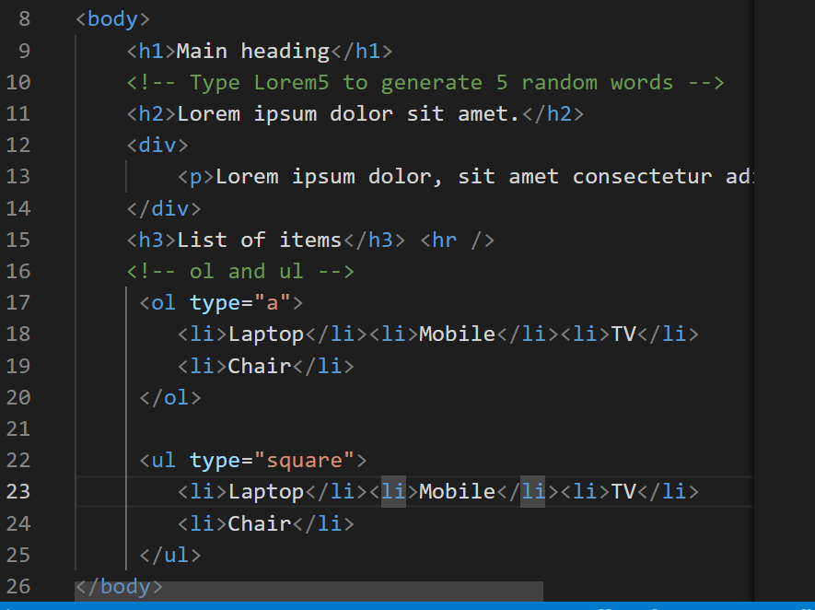

Output:

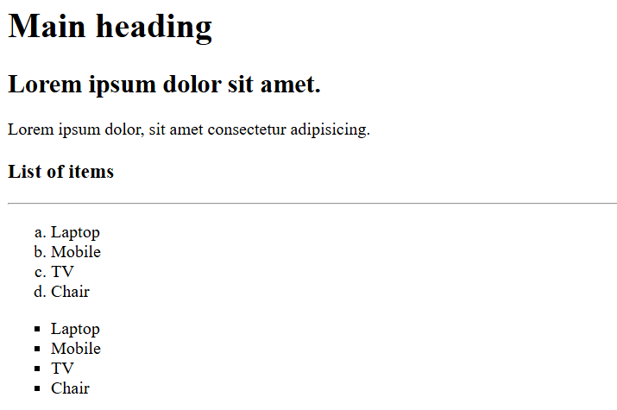

You can create HTML tables, forms and other elements

CSS:

It is used mainly to add the styles to HTML elements

RWD

It helps to fit your web page to all types of devices it could be desktop, mobiles, printing devices, tablets

Same HTML content to render differently in different devices

Medi Query: it applies the styles based on the conditions.

Grid: It arranges the elements in row & column format

Flex: It automatically arranges the elements based on the size like horizontally or vertically.

{display: flex }

SASS

Syntactically Awesome Style sheets

It avoids lot of boiler plate code which you write in CSS

SASS -> SCSS (this resembles css syntax), but sass follows indentation syntax

SASS syntax  
$font-style: arial;  
$color: blue

h1   
 color: $color;  
 font-family: $font-style

SCSS syntax:

$color: blue;  
$font-style: arial;  
h1 {   
 color: $color;  
 font-family: $font-style;  
}

Install sass

npm install -g sass

To compile scss to css

sass input.scss output.css

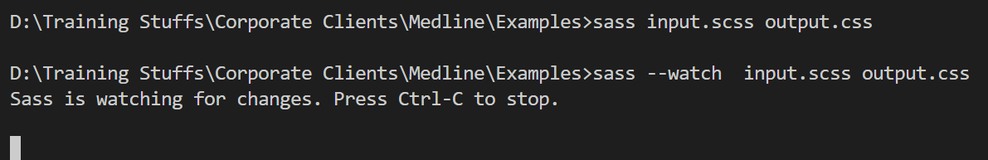

--watch lets you to automatically compile scss to css

Mixins

These allow you to reuse the group of CSS declarations.

@mixin shape($color, $width, $height) {   
 width: $width;  
 height: $height;  
 background-color: $color;  
}   
.square {  
 @include shape(blue, 400px, 400px);   
}  
.rectangle {  
 @include shape(red, 400px, 200px);  
}

Parent selector

It is used in nested selector to refer the outer selector

.alert {  
 &:hover { color: red }  
}

In CSS you write

alert : hover { color: red; }

Placeholder

It is to reuse some selectors using inheritance

%name {  
 // css selectors  
}

.primary {  
 @extend %name;  
 color: blue;  
}  
.secondary {  
 @extend %name;  
 color: grey;  
}

How to compile multiple SASS files

sass --watch file1.scss : file1.css file2.scss : file2.css

day2/mystyle.scss

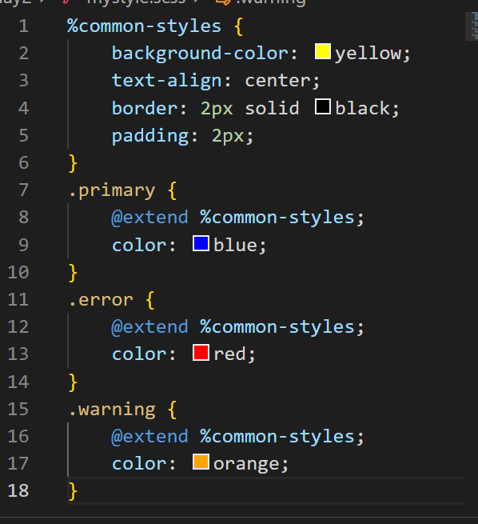

index.html

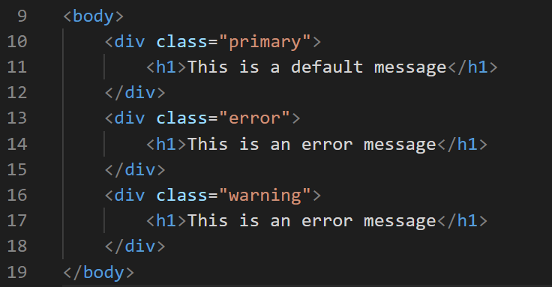

Output:

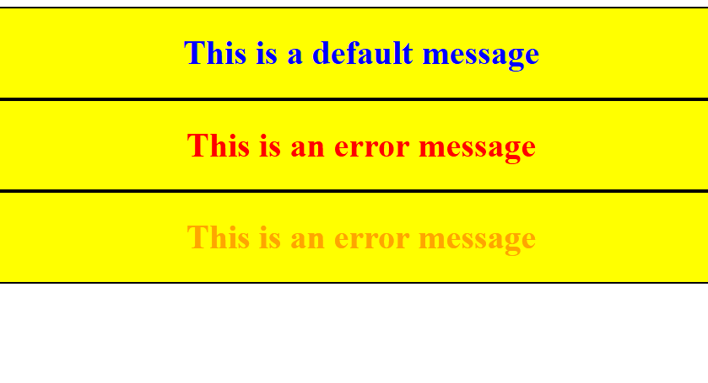

Special functions:

SCSS provides various functions to perform complex operations

$colors: red, green, blue;  
.error { color : nth($colors, 1) }

.warning { color: nth($colors, 2) }

Mixing colors using mix()

.mixed-color { color: mix(red, green, 60%) }

Here 60% red & 40% green

Note: You can only mix two colors, however you can get the reference of two colors and pass the color again to the mix

mix(mix(red, green, 60%), blue, 50%)

Round up the numbers

font-size: round(19.6px); // font-size: 20px

scss

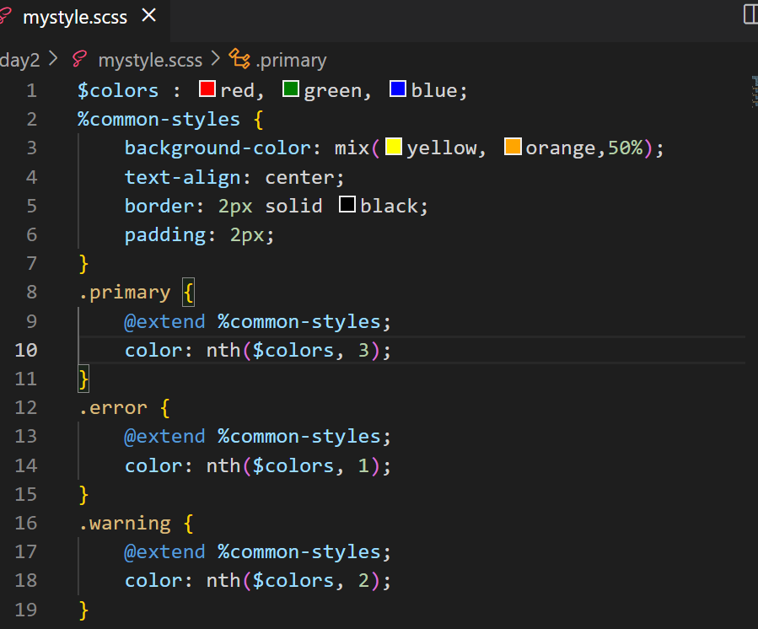

Output:

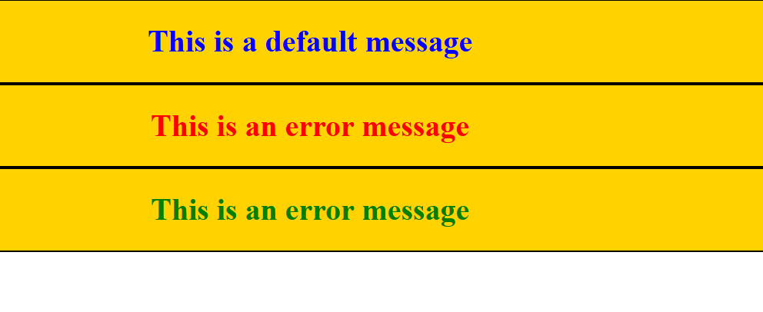

SASS official document

@if & @else if : these are used to apply the CSS on a conditional based

!default: to provide a default values when the property doesn’t have a value

<https://sass-lang.com/guide/>

Javascript

HTML - displaying the content

CSS - styling the HTML

Javascript - It adds effects the web page by dynamically accessing HTML & CSS, it has various features like

* variables
* operators
* datatypes
* functions
* objects
* arrays
* conditional statement
* loops
* form validations

There are two ways you can execute Javascript

1. Using browser at the front-end
2. Using Node.js at the backend

Strings in Javascript: You can either use single or double quotes

Note: single quote is not treated as character it is treated as string itself

Note: semicolon is optional in Javascript as long as you keep the statements in the new line

JS hello world program

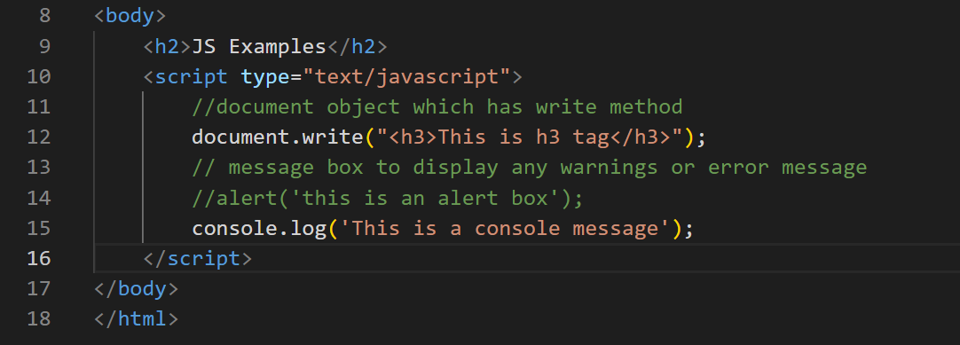

Output:

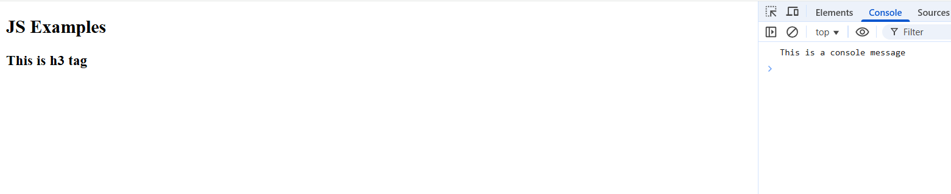

Fundamentals of Javascript

1. Variables
2. Datatypes
3. Operators
4. Conditional Statements
5. Loops

Variables: It is to store the data in Javascript

old approach is to use var keyword

var employeeId = 1234;  
var employeeName = “Siddharth”;

I can assign different values to the same variable with different types

employeeId = “12345” or employeeId = true

Datatypes in Javascript

In Javascript variables get the types based on the type of value, you can use an inbuilt function in javascript typeof(variableName) to get the datatype

document.write(typeof(employeeId); // number or string or boolean

jsdemo.html

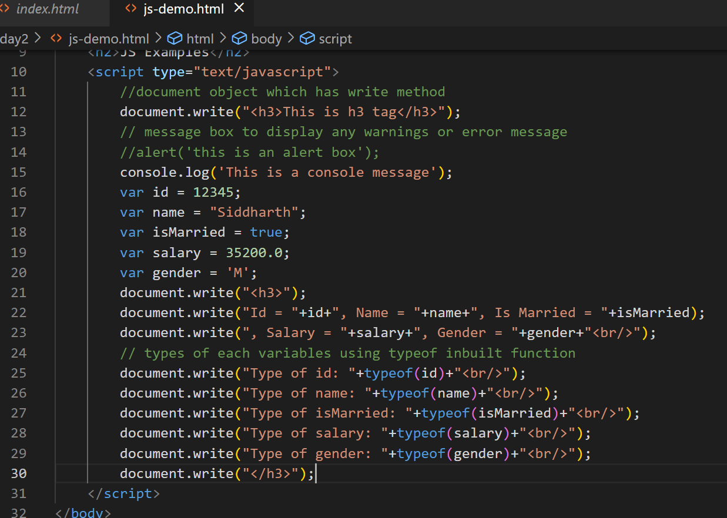

Output:

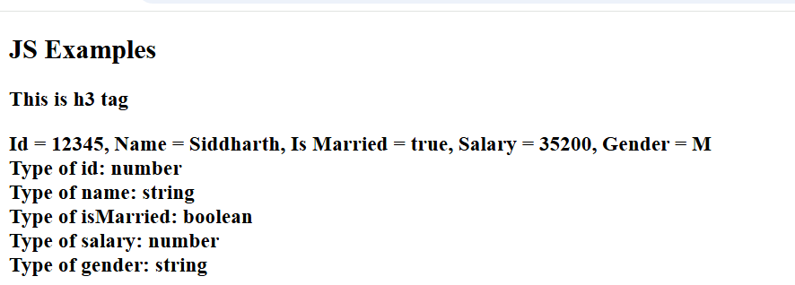

Javascript operators

Arithmetic operators: +, -, *, /, %

Assignment operator: =

Comparison operators: <, >, <=, >=, !=, ==, ===

Increment & Decrement operators: ++, --

Logical operators: &&, ||

Operators Demo

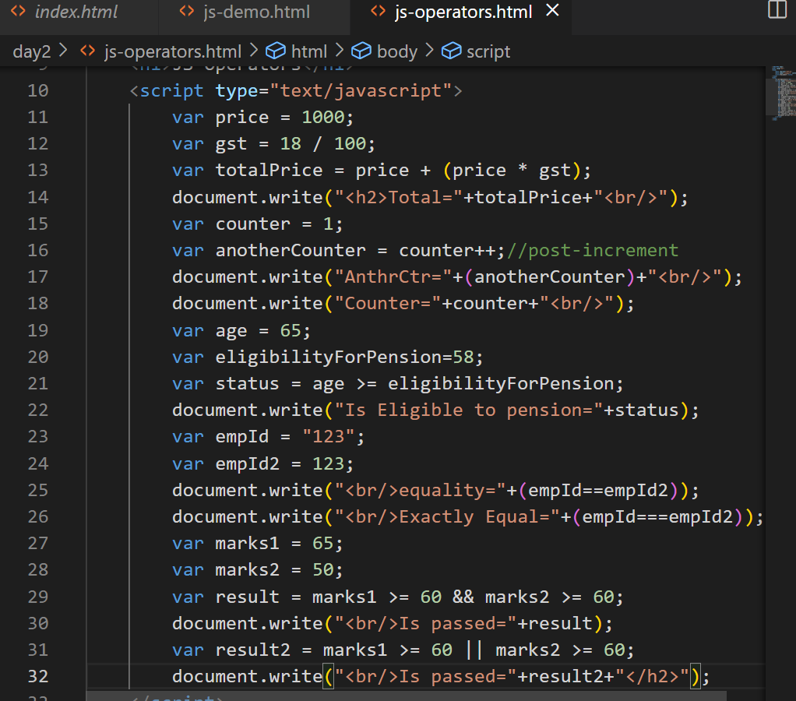

Output:

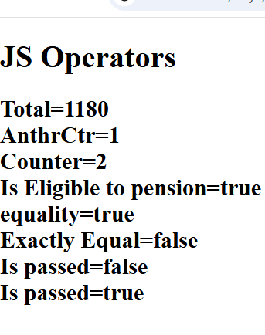

Conditional statements:

Statements that you want to execute only if its true or false

In Javascript we have following conditional statements

1. if
2. if else
3. if else if else if … else
4. switch

Conditional Statements demo

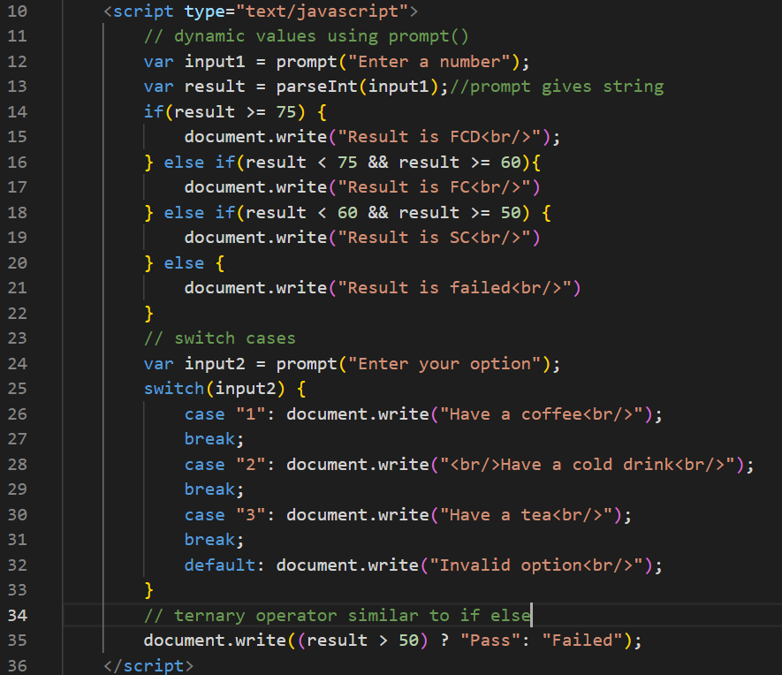

Output:

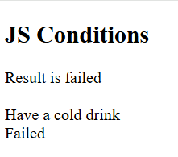

Day 3 agenda

**Loops**

* While Loop
* For Loop
* For...In Loop
* Loop Control

**JavaScript Functions & Objects**

* JavaScript Functions
* The Object Constructor
* Defining Methods for an Object
* JavaScript Boolean
* JavaScript String
* JavaScript Arrays
* JavaScript Arrays Method
* JavaScript Arrays Sort

Loops: Same statements to execute until certain condition is true, there 3 types of loops

1. for loop
2. while
3. do-while

for loop: When you want to iterate fixed set of iterations then you can use for loops, it is used while reading array elements also.

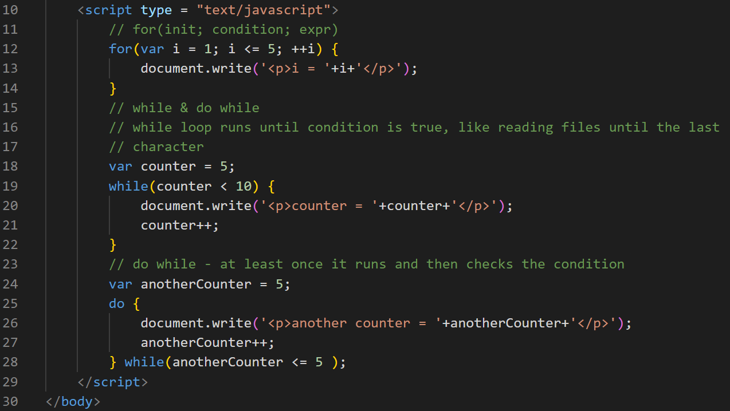

Output:

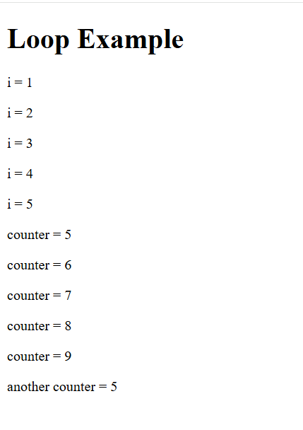

Objects in Javascript

In Javascript you can create objects that will have properties & functions/methods, there are many ways you can create objects in Javascript

1. Literal style
2. functional style with object constructor
3. class style (modern syntax)

Literal style: This is better when you want one or two objects to be created or when you want some mock objects to be created

{ property : value, property : value, property : function() { } }

Function style: When you want multiple objects to be created with the same template then this is better, this style is more preferred in Javascript

function FunctionName(parameters) { … }

js-objects.html

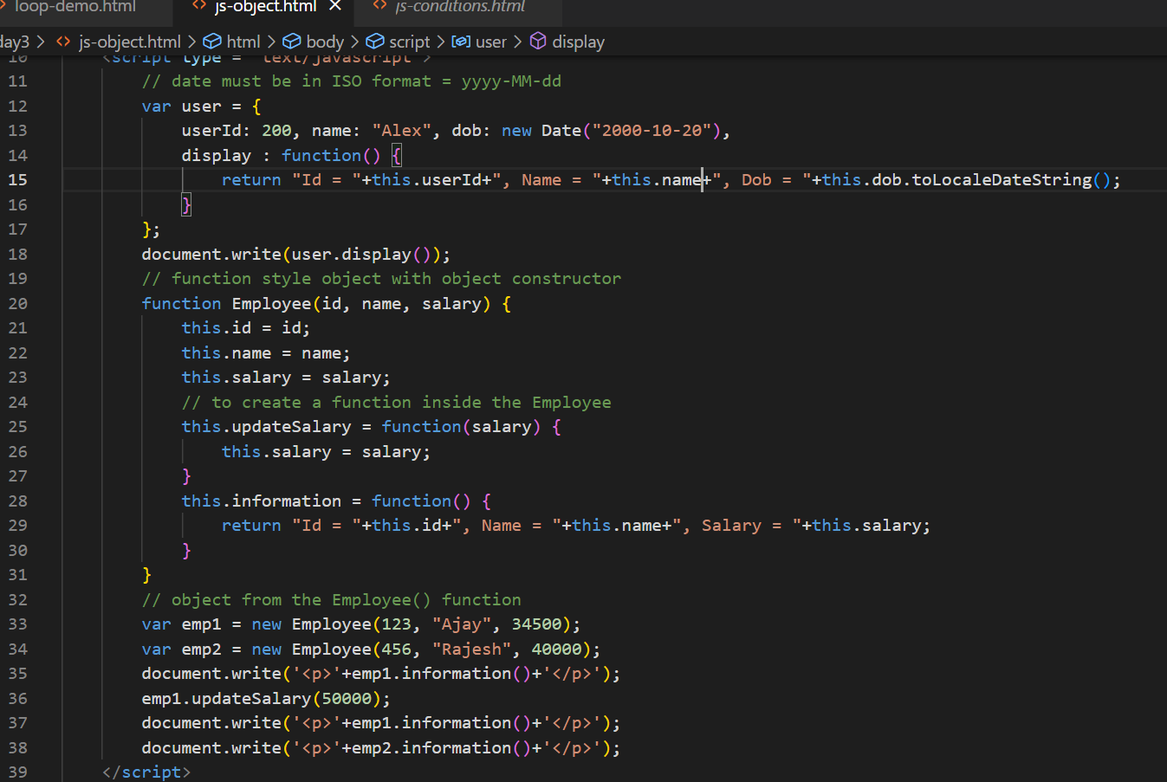

Output:

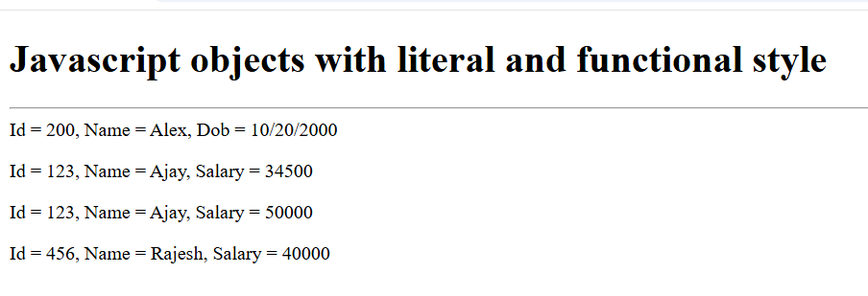

How to achieve inheritance in javascript

We can achieve inheritance with prototype if you are using old syntax, and a newer syntax uses classes & extends keyword

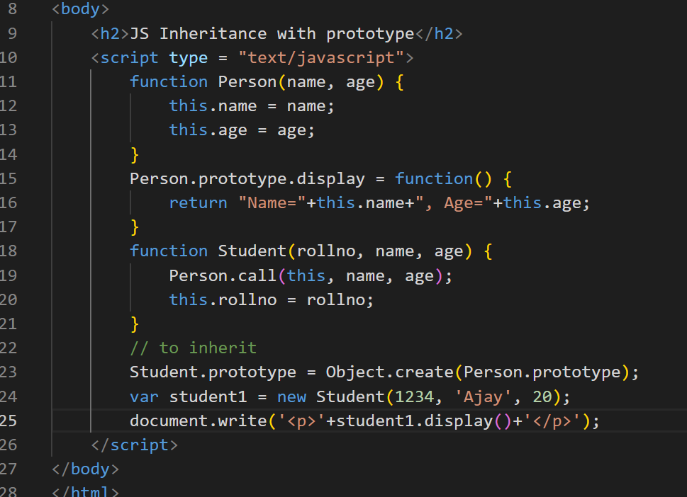

Output:

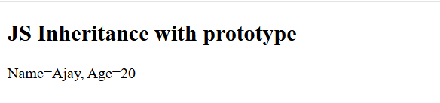

Arrays: It is a container object to store multiple values of same types or different types (in javascript it is allowed)

You can create simple to complex arrays

In Javascript you have lot of inbuilt functions in arrays like

push(): to add the element in the array  
pop(): to delete the element from the array  
sort(): to sort the elements  
slice()  
splice()

sort(): by default it sorts in ascending order, to sort in descending order you must use a function as a parameter that returns an int value to the sort to arrange the elements

sort(function(x, y){   
 return   
})  
Arrays methods & sorting with comparator anonymous function

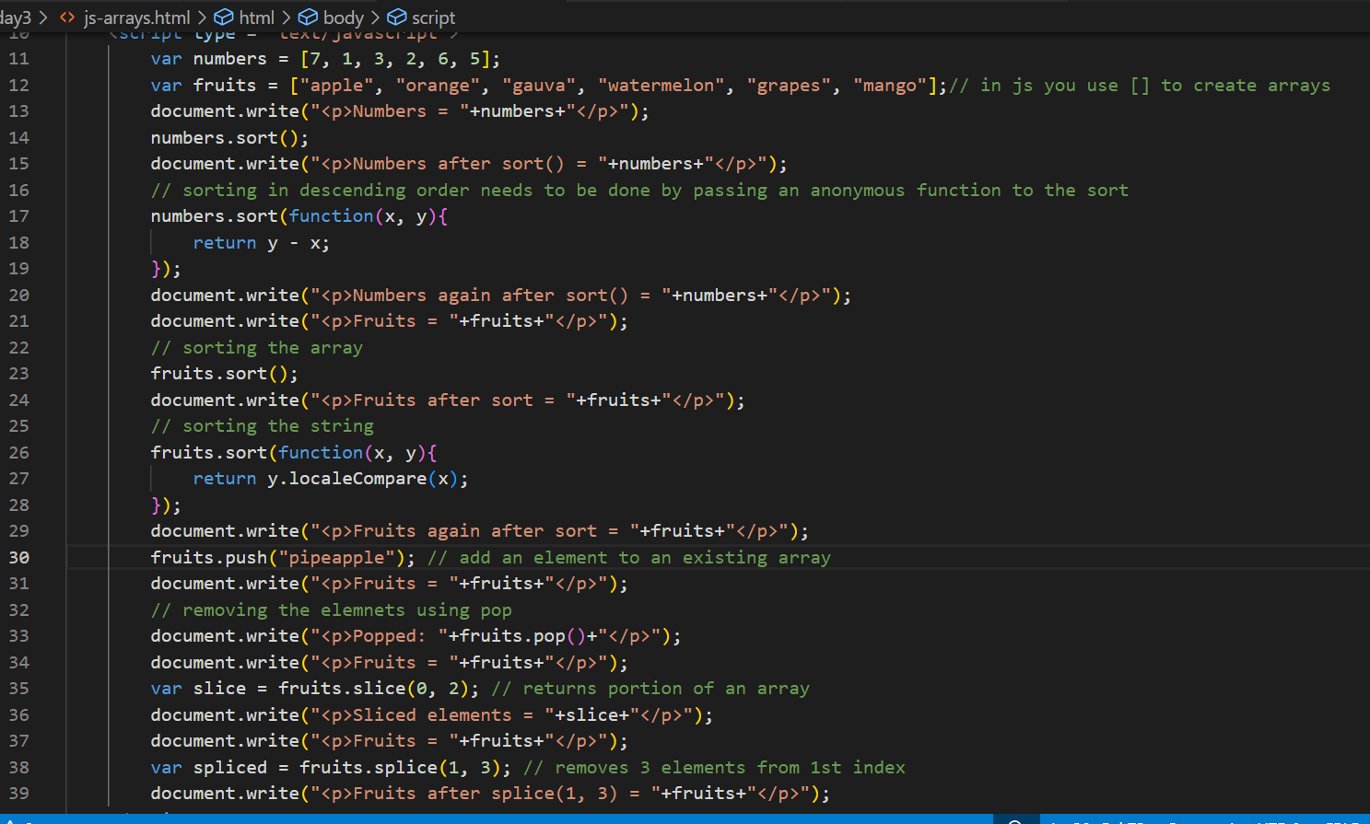

Output:

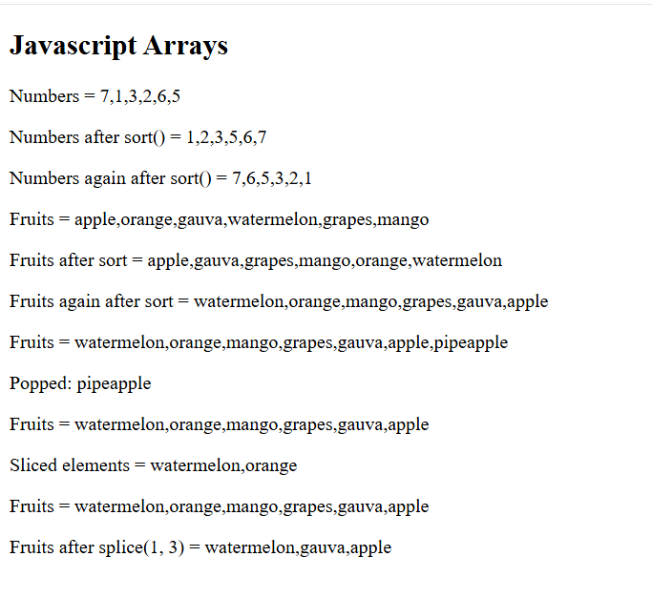

How to sort complex objects

You must use the same anonymous function and access the property of the objects and compare them.

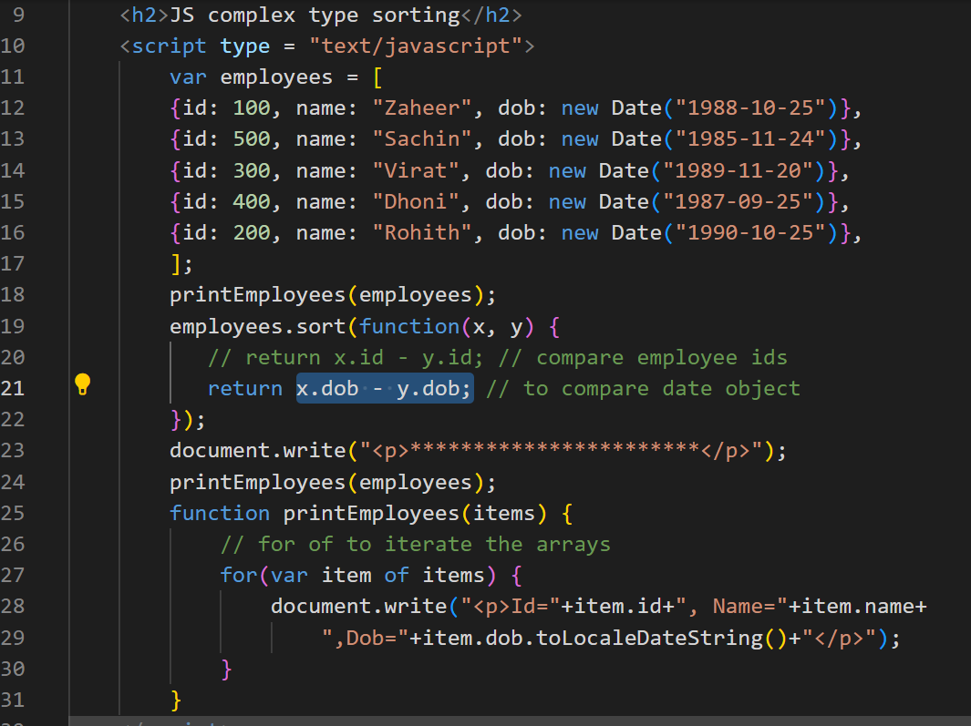

Output:

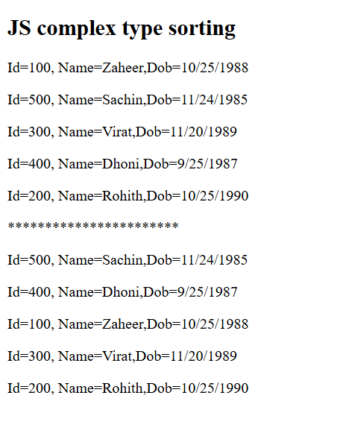

String methods:

In String there are various inbuilt methods like-

toUpperCase(), substring(), concat(), indexOf(), lastIndexOf()

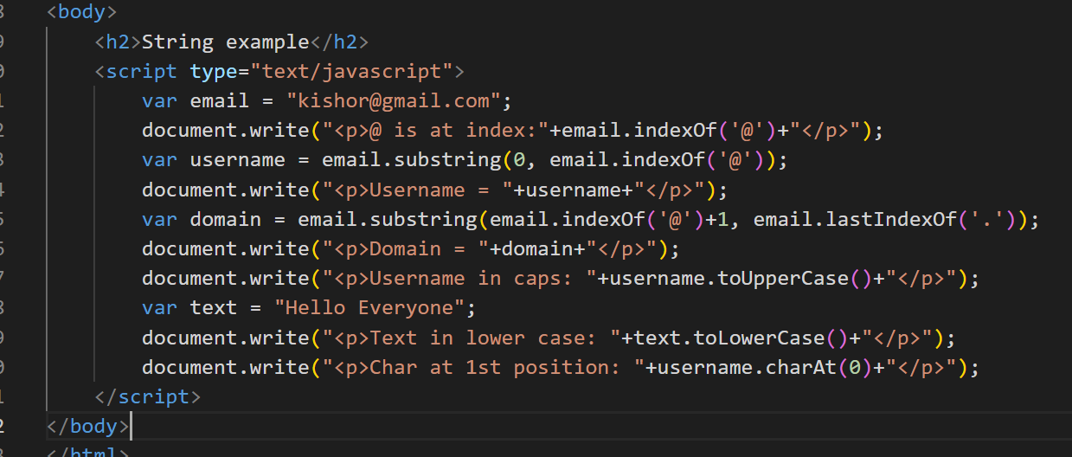

Output:

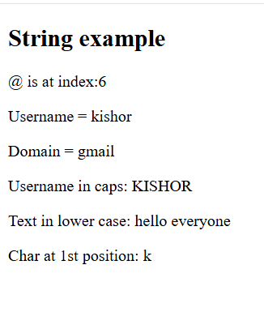

Day 4 Agenda

**JavaScript HTML DOM**

* Introduction
* DOM Elements
* DOM EventListener

**JavaScript Form Validation**

* Create Form
* Styling Form
* Validate Username Input
* Validate E-Mail Input
* Validate Password & Radio Button

For in Loop

It is used to iterate the properties of an object.

let employee = { id:101, name:”Raj”, phone:939933, dob:”2004-10-22” };

let name = employee[“name”];

for(var key in employee) {   
 // key will be the property of an object

employee[key]  
}

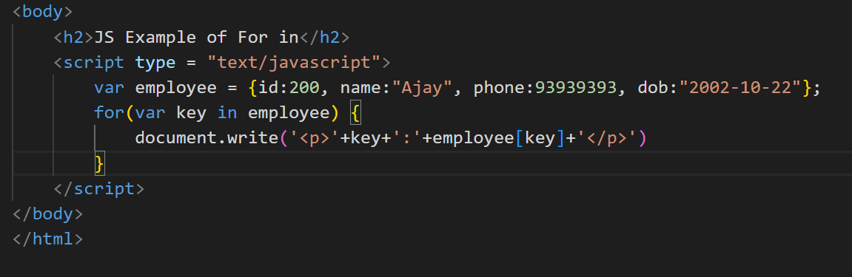

DOM events

DOM stands for Document Object Model, it is a tree structure of HTML elements loaded in the browser, HTML elements would generate events when you do something with the element like mouseover, click, onchange, onsubmit

<button onclick=”fun()”>Click</button>

js-event-demo.html

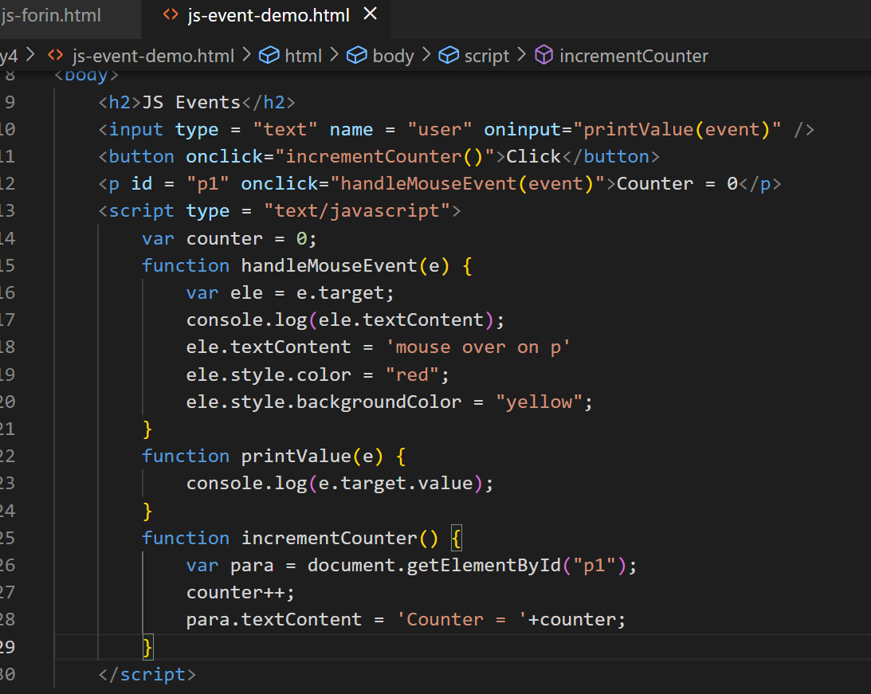

Output:

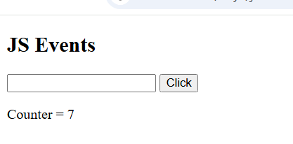

Changing the images based on the image you select

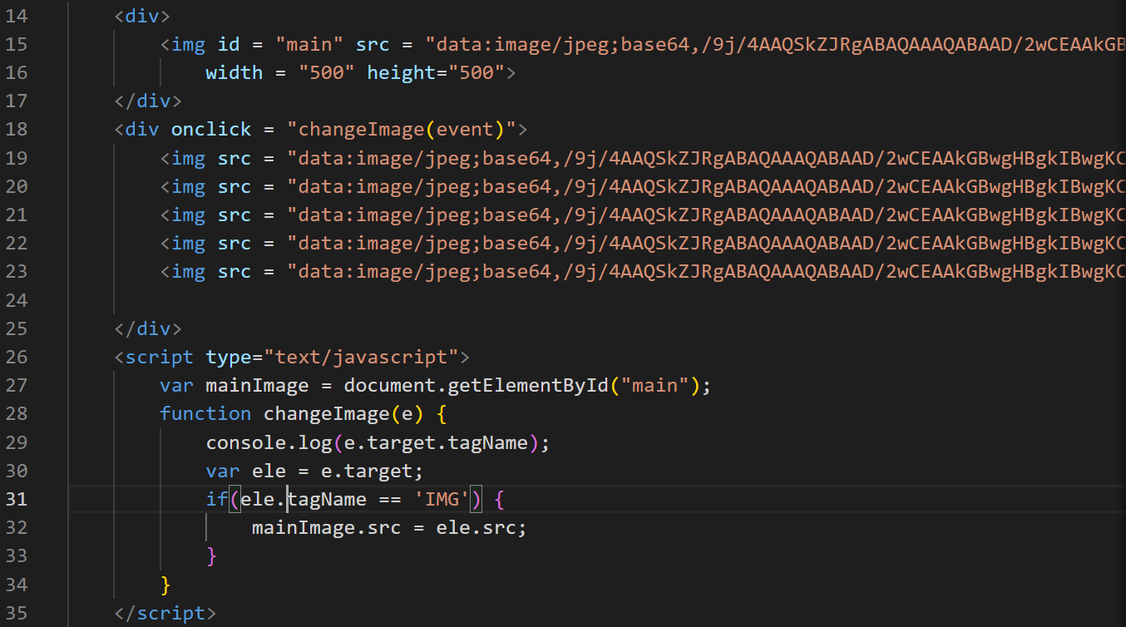

Output;



List of ways to access the element

1. document.getElementById(“id”): Pass the id to get the element
2. event.target: Get the element who generated the event
3. document.getElementsByTagName(“tag”): You get all the elements having the tag name in the form array
4. document.getElementsByClassName(“className”): You get all the elements having the class name in the form array
5. document.querySelector(“selector”): You can use a single method to get the elements by passing the id or class name or tag name.
6. document.querySelectorAll(“selector”): You can get all the elements having the same selector

ex: document.querySelector(“#p1”): gets the element whose id is p1d

ex: document.querySelector(“.p1”): gets the elements which has the class name p1

ex: document.querySelectorAll(“.p1”): get array of elements using the same class name

ex: document.querySelectorAll(“p”): gets all the p

ex: document.querySelector(“p”): gets the first p element in the DOM

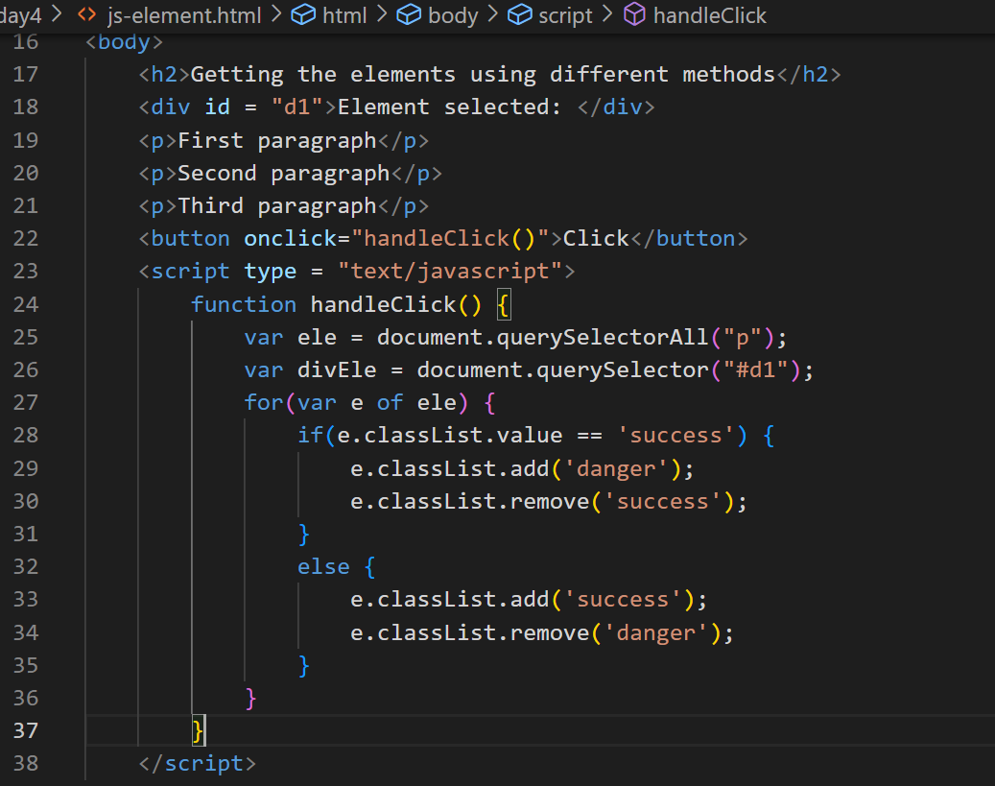

Output:

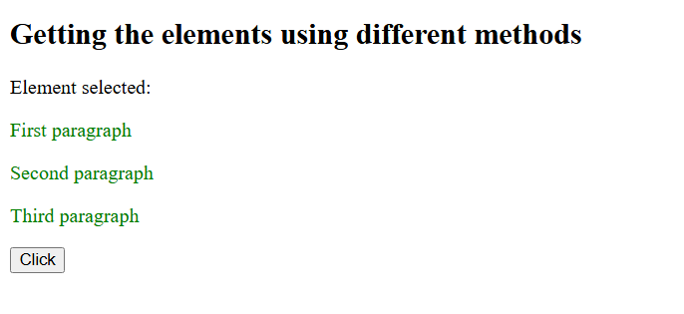

Form Validation

When user enters input sometimes he/she can enter invalid inputs like empty username or weak password, not selecting the gender or entering an invalid email in that case you don’t have to submit the form to the server, you can do a client side validation and prevent the form submission.

Activity:

Create password input box and validate for stronger password it must have digits, lowercase, uppercase, special character

Create radio button and mandatorily one should be selected

Create an input box for the email and validate for the valid email

Day 5

**Modern Javascript (ES6, ES7 and others)**

* Classes
* Let & Const
* Template String literals
* Arrow Functions
* Spread syntax & Rest parameters
* Destructuring
* Promises
* Async/Await
* Generators
* Optional Chain
* Nullish coalescing
* String padding

Modern Javascript simplifies the Javascript syntax so that most of the codes looks easy to understand.

Old Javascript syntax

var name = “Ajay”;  
var age = 35;  
var phone = 993920393;  
var gender = “Male”;

var information = “Name = “+name+”, Age = “+age+”, Phone = “+phone+”, Gender = “+gender;

Modern Javascript syntax

information = `Name = ${name}, Age = ${age}, Phone = ${phone}, Gender = ${gender}`;

Javascript is derived from a specification called EcmaScript, it has released ES6 version which changed Javascript syntax to look much easier to understand, following are the features introduced in ES6 or later.

1. let, const, class, extends, super keywords
2. Template strings
3. Arrow functions
4. Spread & Rest parameters
5. Destructuring
6. Promises
7. Exponential operator
8. async/await
9. Generators
10. Trailing commas
11. Optional chain
12. Nullish coalescing

let & const: These allow you to create block scoped variables, which you can use instead of the var keyword, because var is not block scoped

if(…) {   
 var price = amount * total;  
 var price = amount * total; // you are allowed to declare more than once  
}  
console.log(price); // but it will be accessible

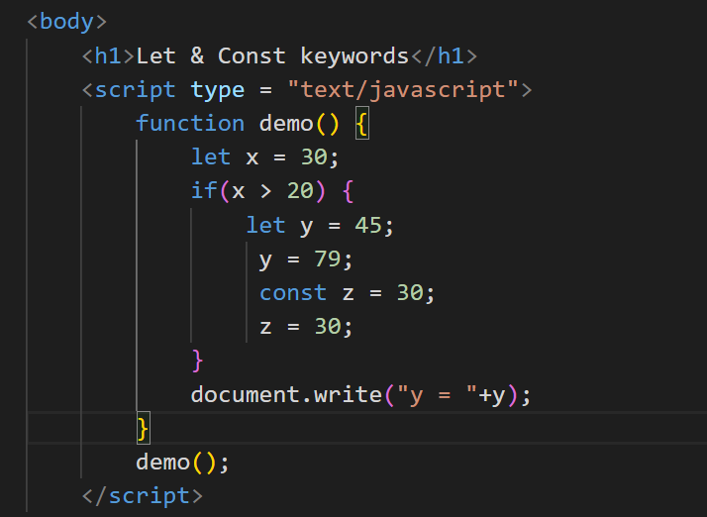

Output:

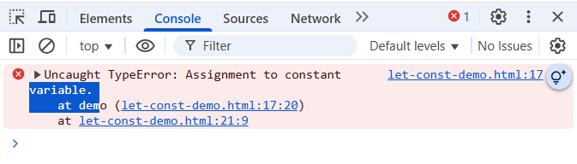

Achieving inheritance

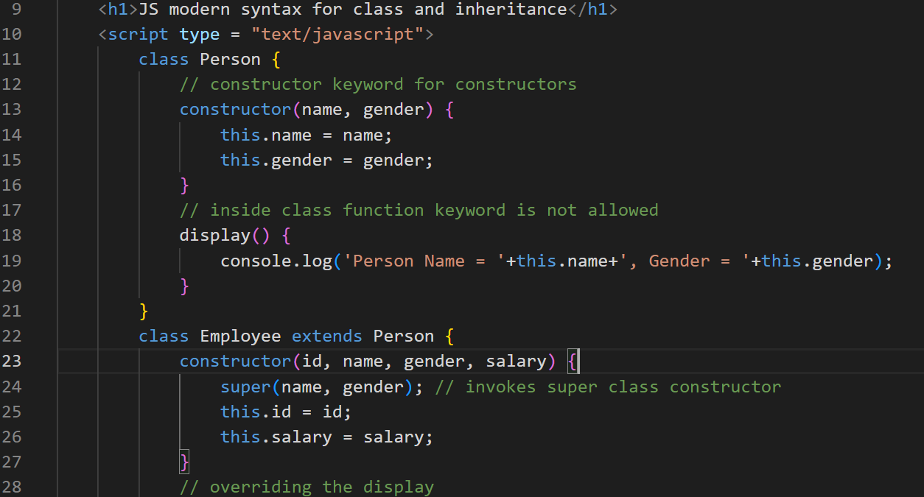 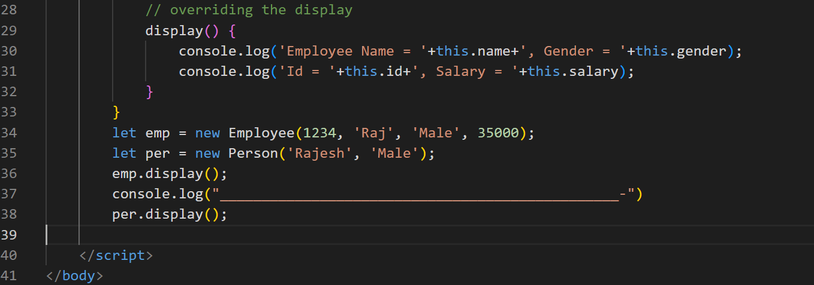

Output:

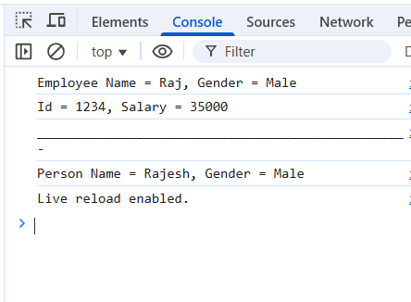

Template Strings

It helps to create strings with js expressions in a simple without breaking with + operator

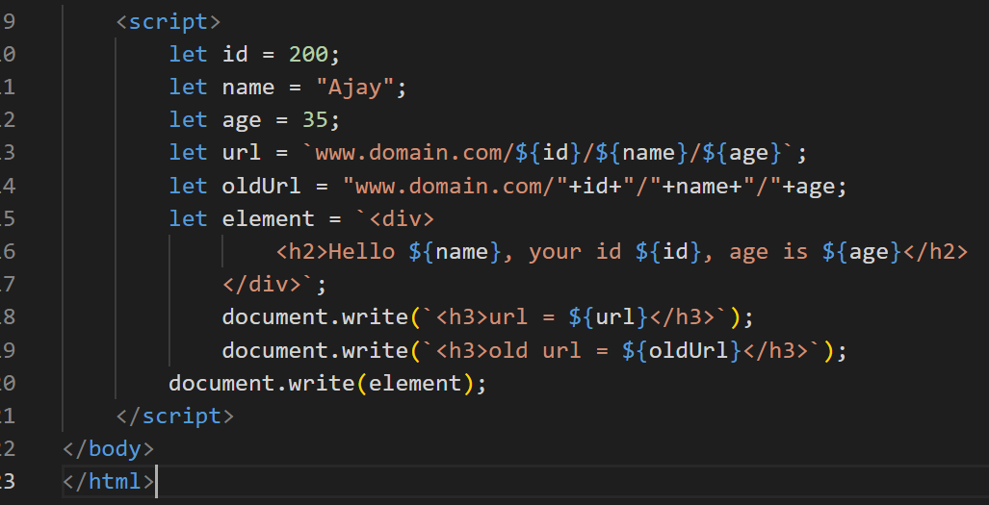

Output:

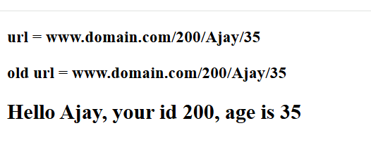

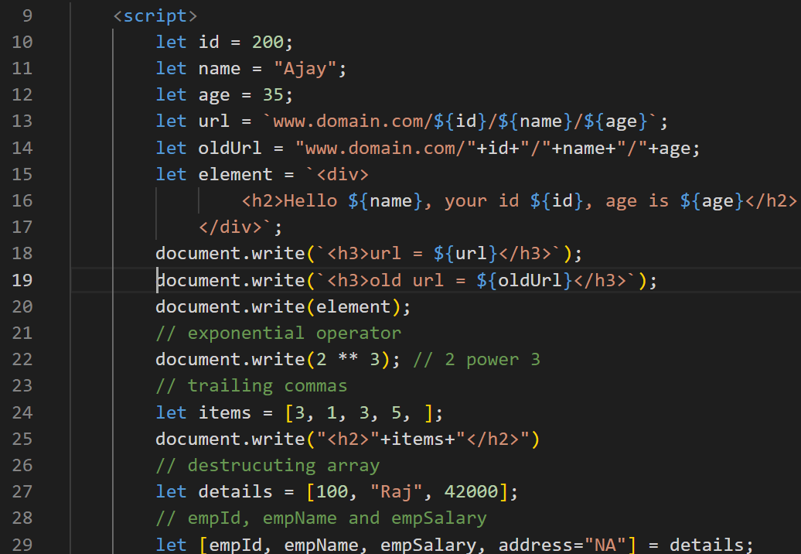 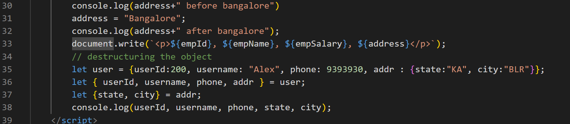

Day 6

Rest & Spread parameters

In order to avoid a function losing the data we have these parameters

Rest: You can create a function that can accept any number of parameters

function sum(x, y) { }

sum(2, 3, 4, 5); // error or takes only few parameters

Since 4, 5 is lost we can create a Rest parameter that will be … (3 dots) before the variable name

function sum(x, …y) { }  
sum(2, 3, 4, 5); // x = 2, y = 3, 4, 5

Rest parameter

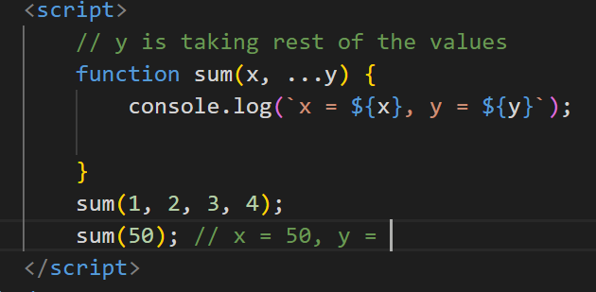

Output

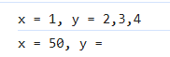

Spread operator

You want to distribute the array of values to multiple parameter, then you can use spread operator, it is used at the time of invoking the function, even spread also uses 3 dots

let items = [2, 3, 5];

function max(a, b, c) {   
}

max(items); // a = [2, 3, 5]

max(…items); // a = 2, b = 3, c = 5

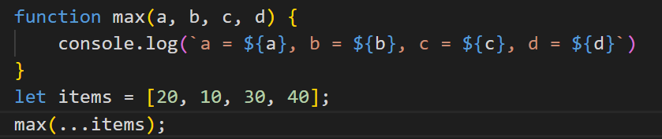

Output:

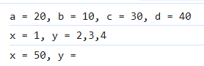

We can combine rest & spread both as below

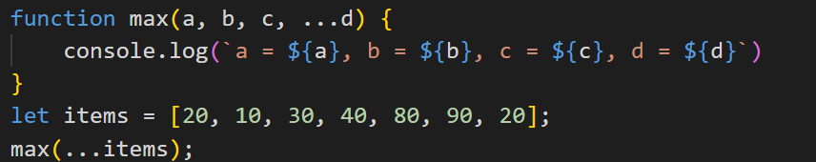

Output:



Optional Chain & Nullish coalescing

Optional chain

This is used to avoid errors while accessing the deeply nested properties

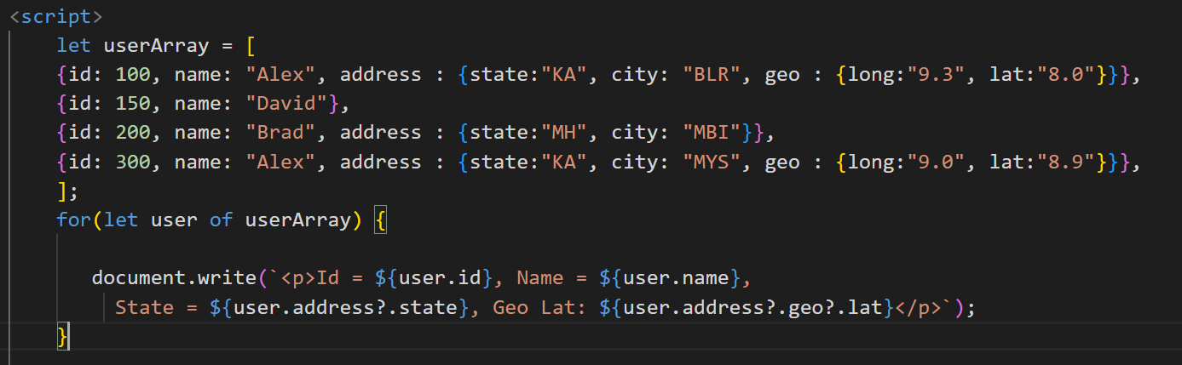

Output:

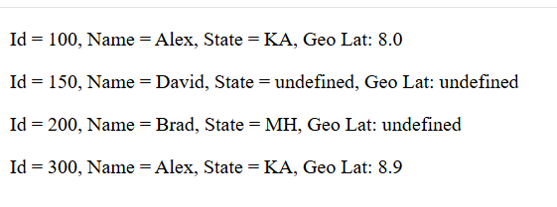

Nullish coalescing ??

You want to check the value is undefined or null & assign a different value when it is null or undefined

let x;  
let y;  
let z = x ?? y ?? ‘Anonymous’;

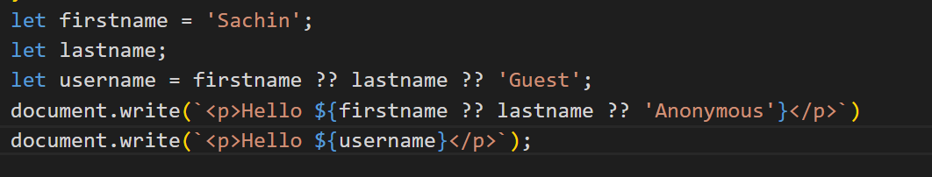

Output:

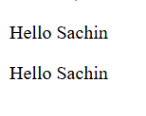

Generators

These are special type of functions which can pause the execution of the function and resume, when it pauses it can return a value as well using the yield keyword

function* generateNumbers() {   
 yield 1;  
 yield 2;  
 …  
}

let gen = generateNumbers();  
gen.next() // it executes until it finds the yield & pauses there

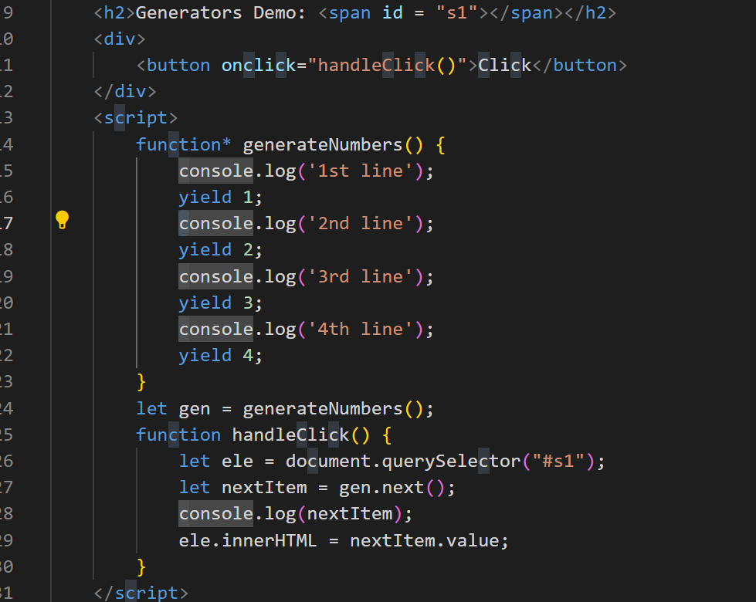

Output:

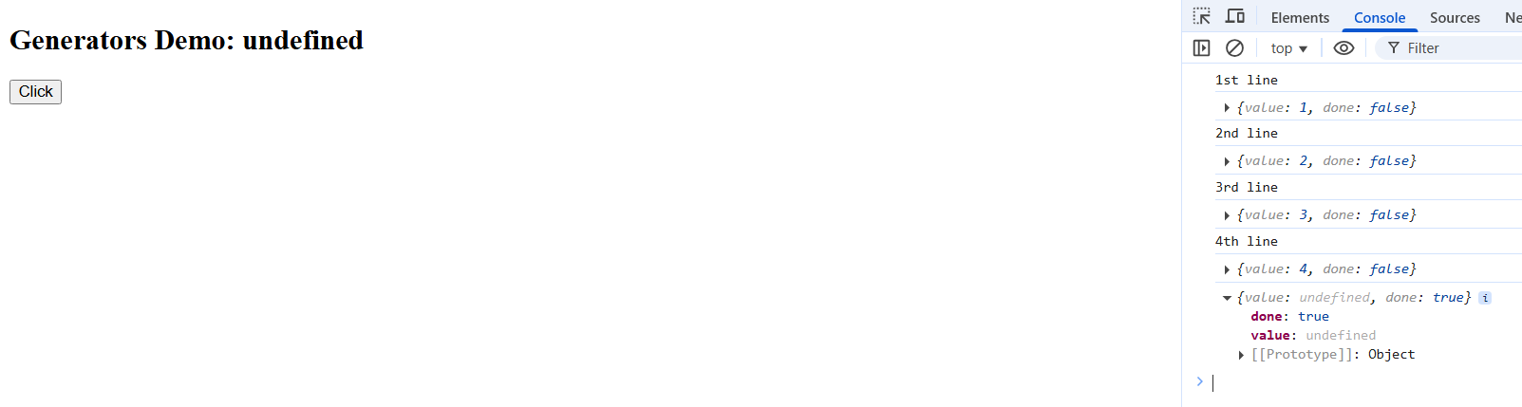

We can yield some other type of values also

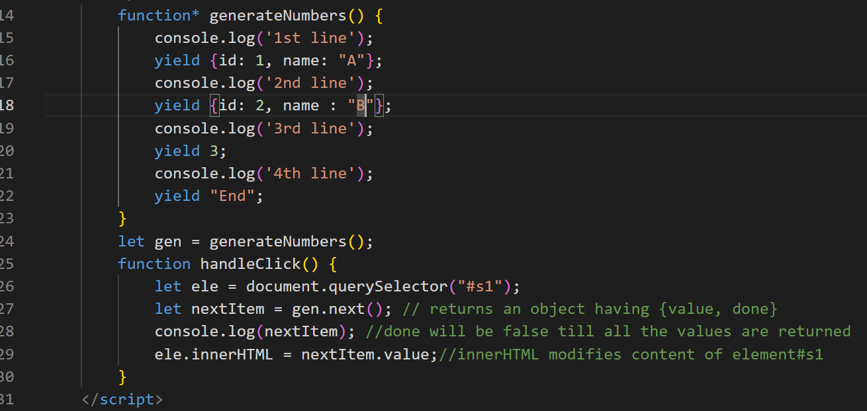

Output:

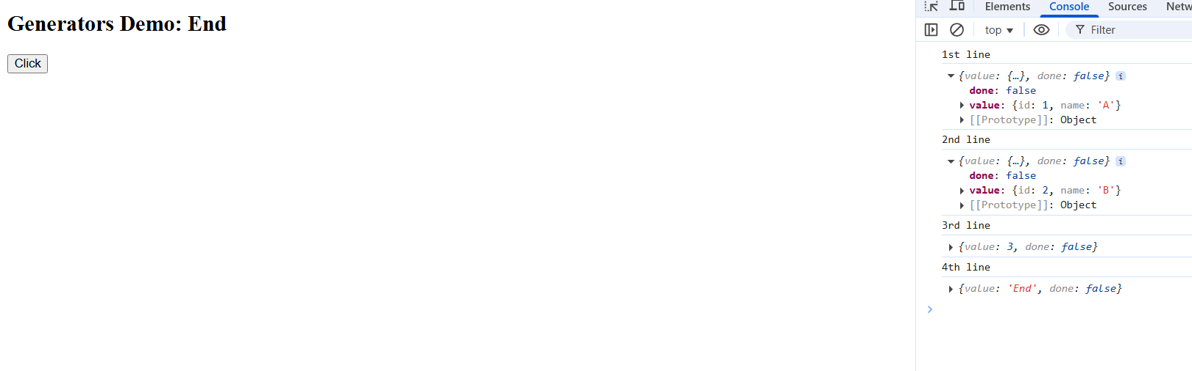

Arrow functions

These are the simplified functions for anonymous functions or callbacks

Callback functions are not immediately executed, they will be initiated immediately but will be called later.

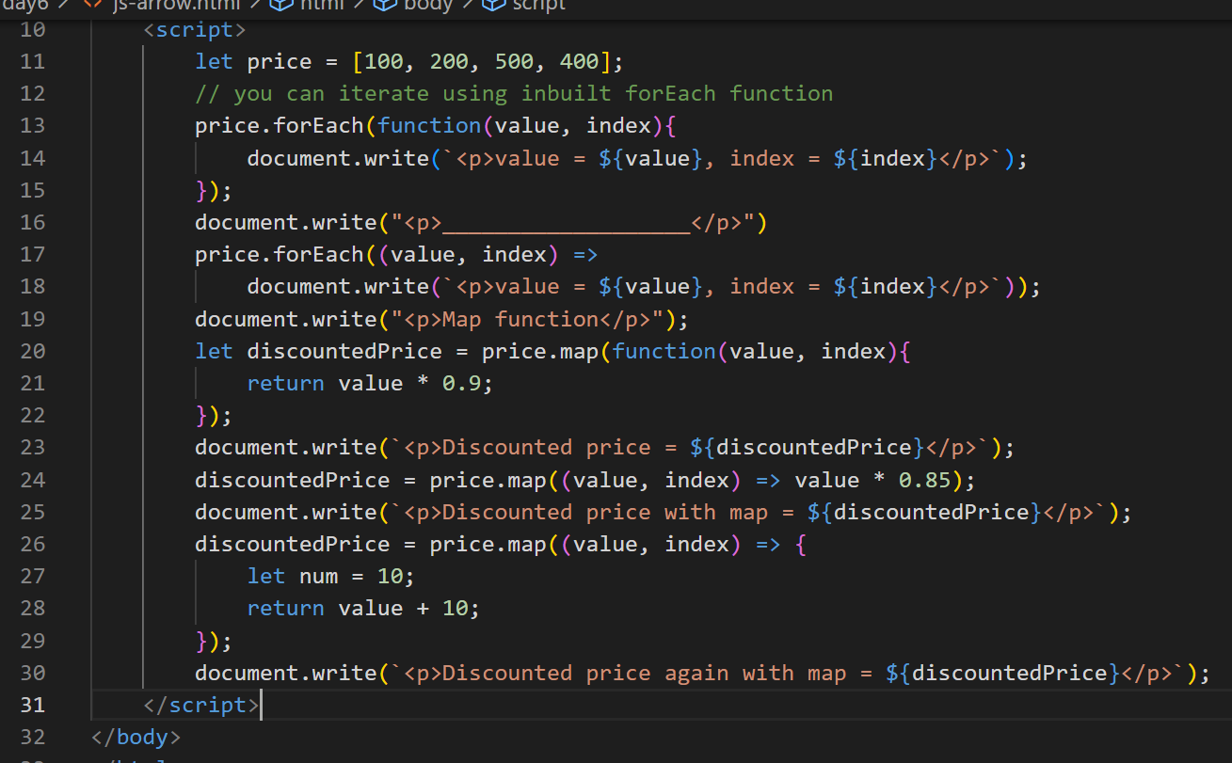

Output:

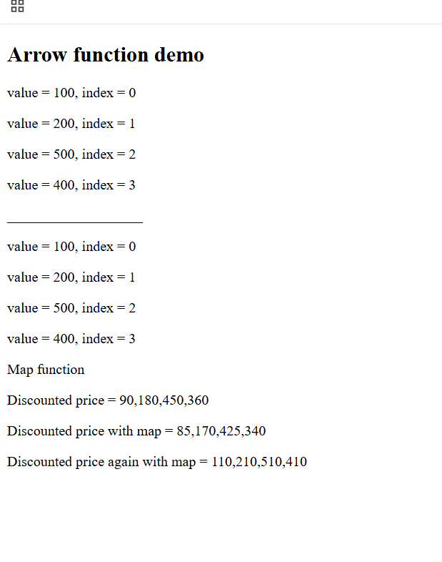

Day 7

* Promises
* Async/Await
* String padding
* NPM basics
* Installing packages
* package.json
* Node Event Loop
* Core Module
* Local Module
* Reading & Writing Files
* Third party Module

Asynchronous actions:

These are the operations which you initiate but they are finish later, they should not block the user when the operations are performing behind the scene

ex: timeouts, event handling, calling the backend apis

XMLHttpRequest: This is used to make an HTTP requests.

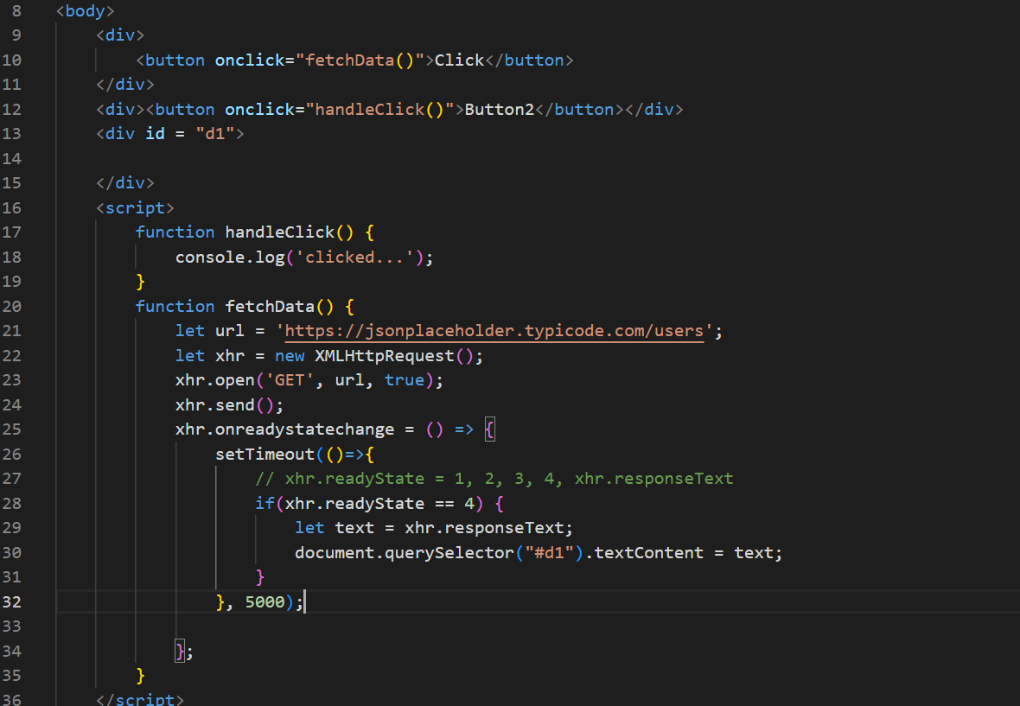

Output:

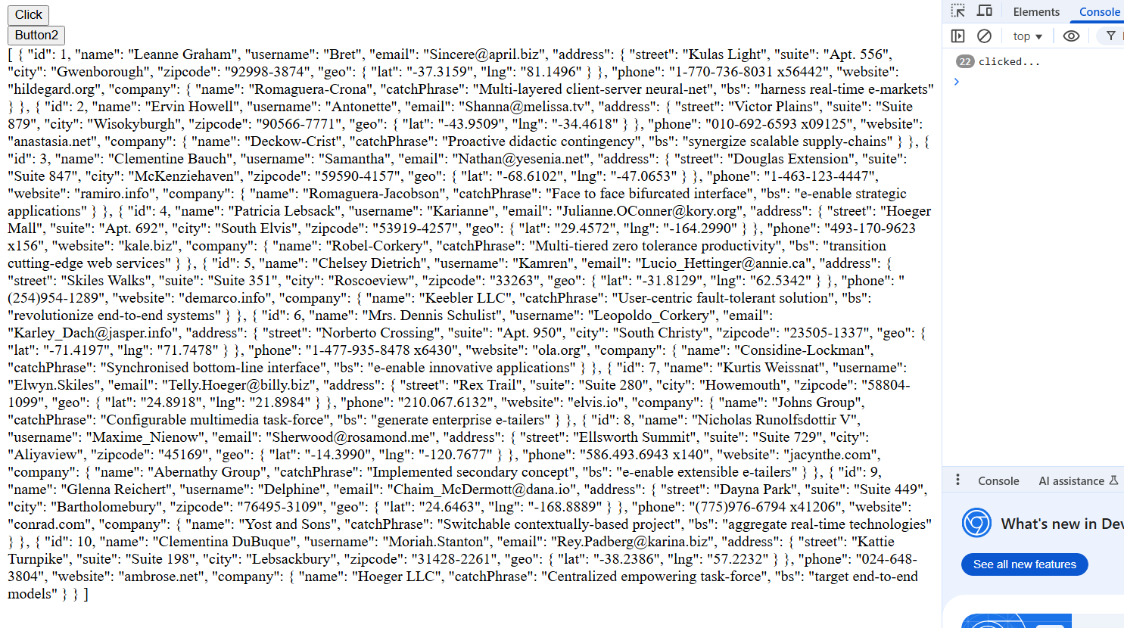

Promises:

They can perform asynchronous operations by providing separate functions to handle success and failures, it also avoids nesting the callbacks when current result is dependent on the previous result, Promise has 2 states

1. Pending state: Initial state, neither successful(resolved) nor failed (rejected)
2. Settled state: Resolved or Rejected

ex: axios library in React.js, fetch() which is supported in Javascript & Node.js (21 or later)

We can create our own Promise using the Promise constructor

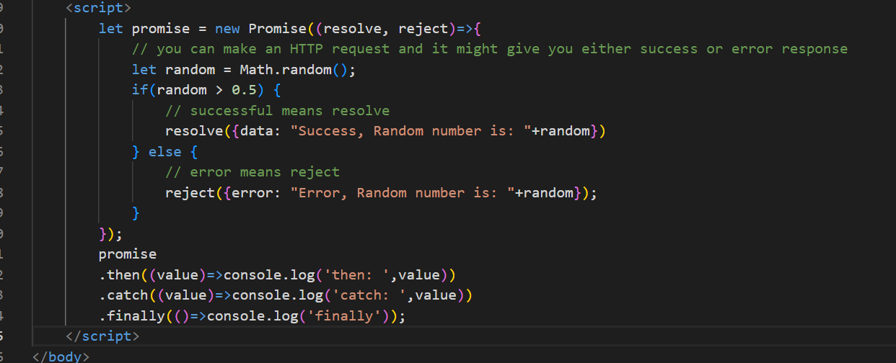

Output:

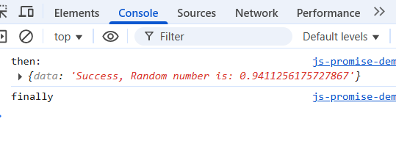

Previously we sent the request using XMLHttpRequest, but modern javascript provides an inbuilt method called fetch() that can send the Http Request but it returns the promise

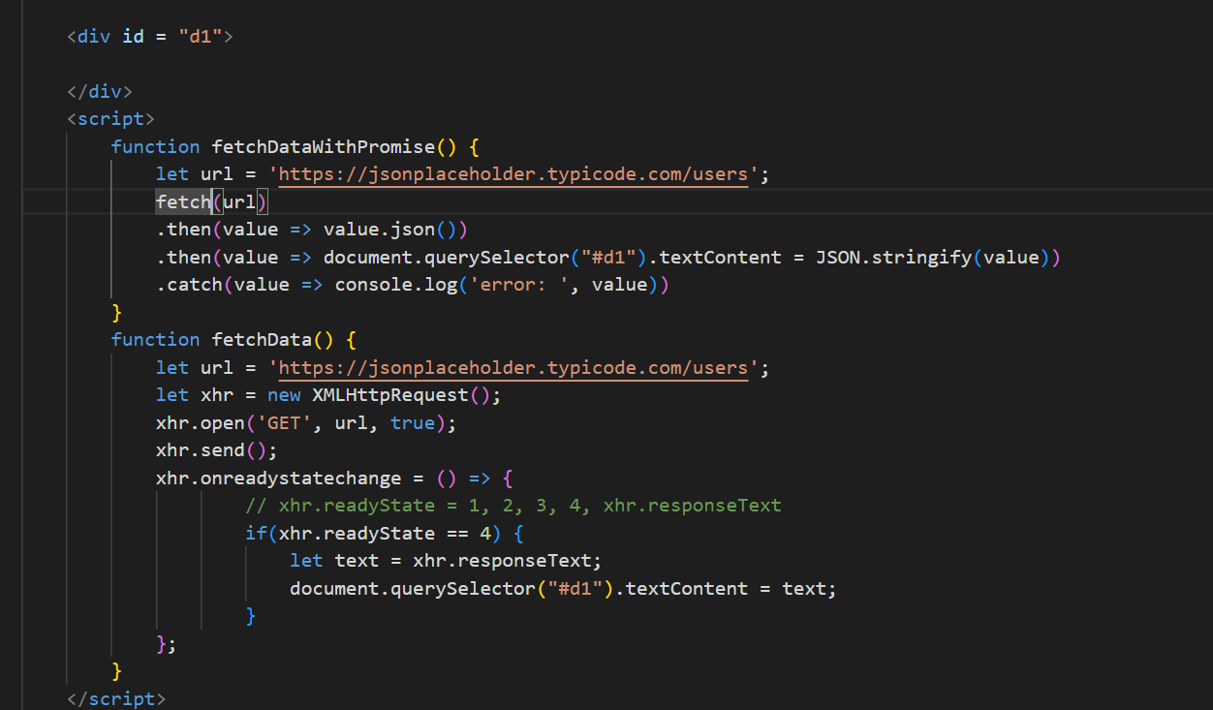

Output:

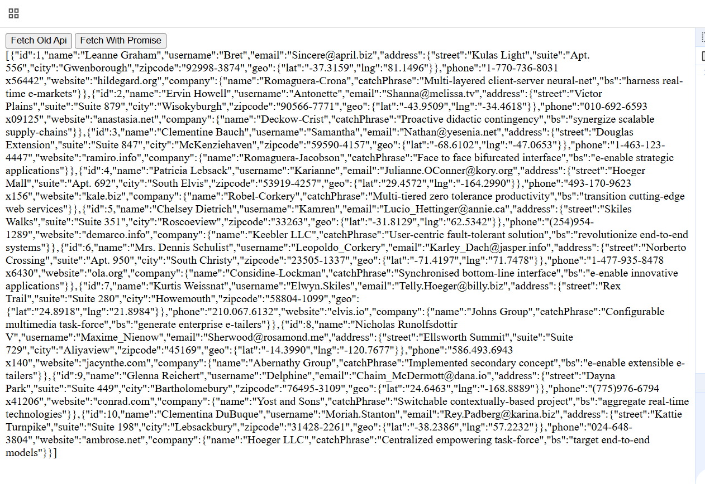

Promise can also perform multiple asynchronous operations and settle these operations in many ways, it provides various methods to take multiple promises in the form an array and settles based on the methods you use, below are the Promise methods which are static

1. Promise.all([p1, p2, p3])
2. Promise.allSettled([p1, p2, p3])
3. Promise.race([p1, p2, p3])
4. Promise.any([p1, p2, p3])
5. Promise.resolve()
6. Promise.reject()

Promise.all([p1, p2, p3]): It takes multiple promises & returns a promise only if all are successful, but if any one fails it will return the failed promise and rejects the remaining promise

ex: Loading the restaurant details, menu details, ratings and so on

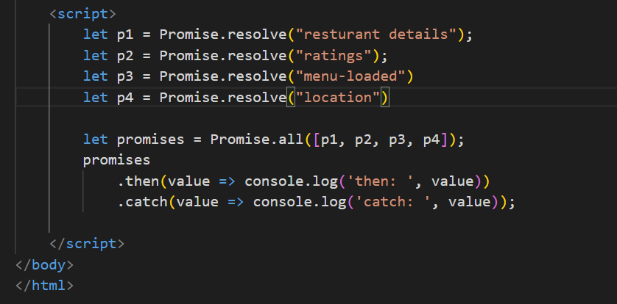

Output: Since all are successful you get all the fulfilled promise

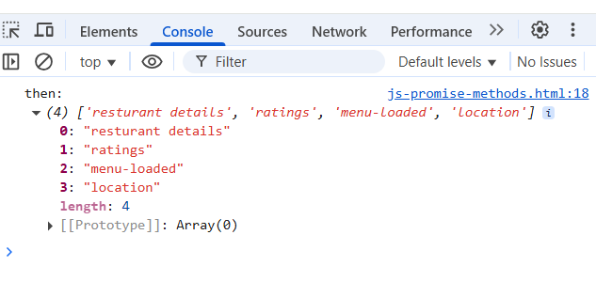

Change the Promise.resovle to Promise.reject you will see it only gives the rejected promise even though other promises are fulfilled, it gives the very first promise that is rejected & ignores the other promises

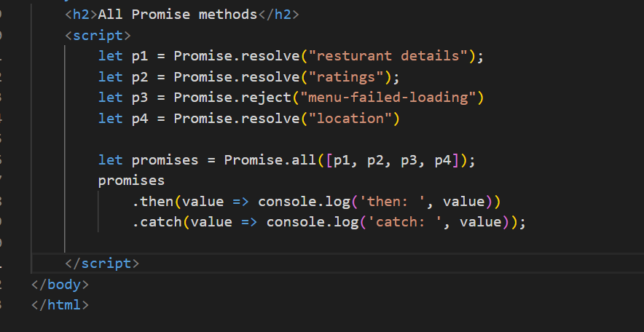

Output:

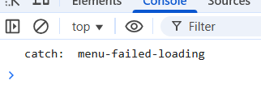

Promise.allSettled([…]): It settles all the promises both resolved & rejected one and returns a promise that will have all the promises result with which is resolved & rejected status

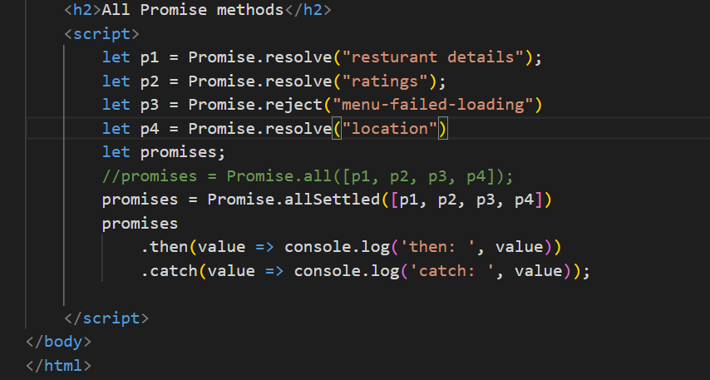

Output:

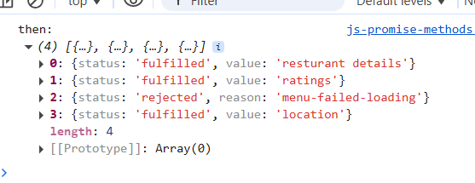

ex: You want multiple async operations to perform like rating the food, rating the delivery guy, rating restaurant

Promise.race([…]): Gives the promise whichever is settled first either rejected or resolved

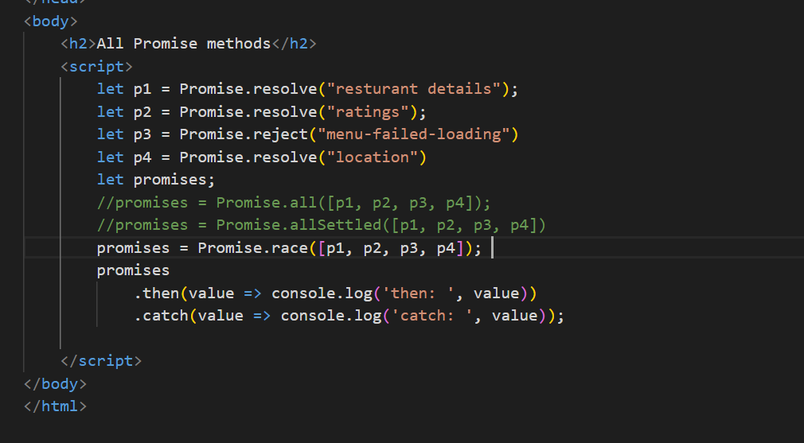

Output:

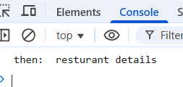

Here always the first promise itself will be the output, but in real time, when you pass multiple promises which might finish first we will not have an idea, use race() when you want the earlier one to finish first and it doesn’t matter it fails or succeeds

ex: You want to make an API call and also you want a timer to run, then whichever is finished first you want to consider

Promise.any([..]): This always gives the promise that is resolved by ignoring any failed promise

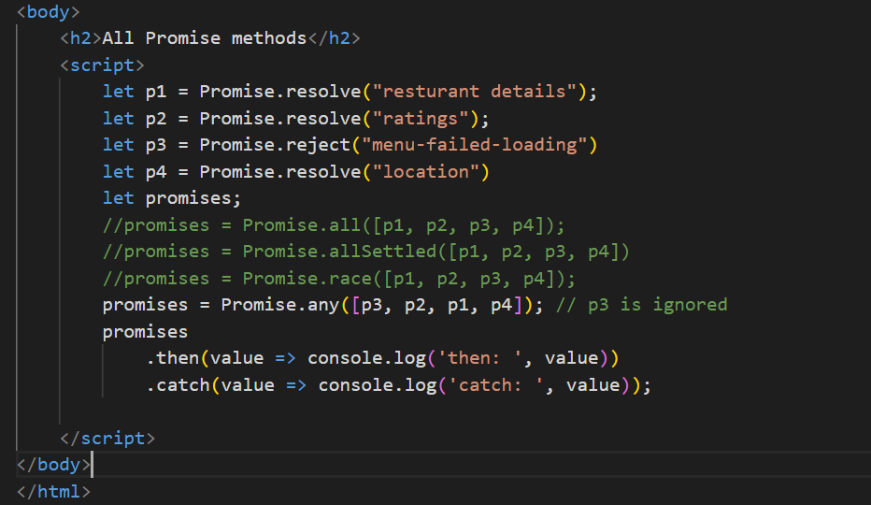

Output: Since p3 is rejected it is ignored & p2 is resolved it is considered and rest of the promise is ignored

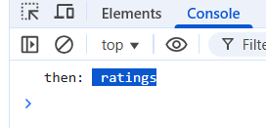

Ex: When you have some common resource getting from multiple end points, you can consider the first promise that resolves

Async/Await:

This is built on top promise to wait for the promise to settle and proceed with the next task, a function with async keyword can return a promise so that while calling you can use .then & .catch.

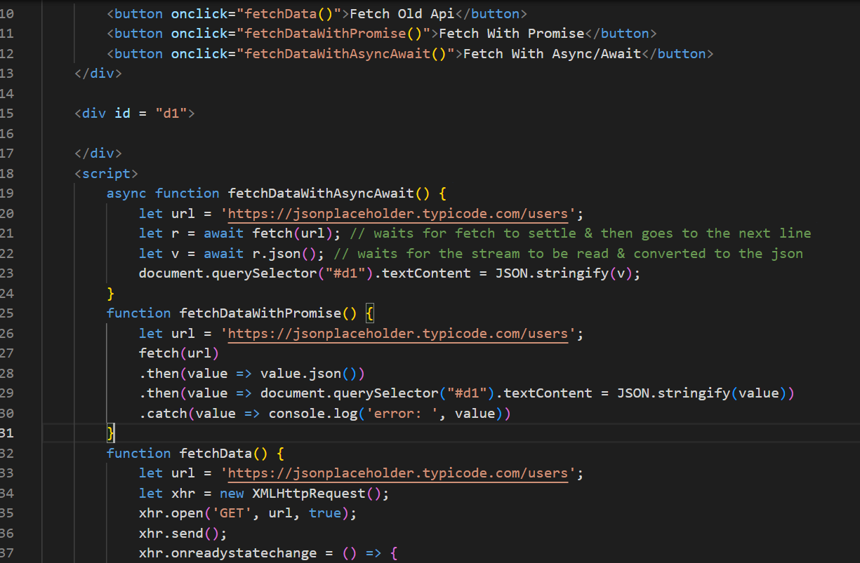

Output:

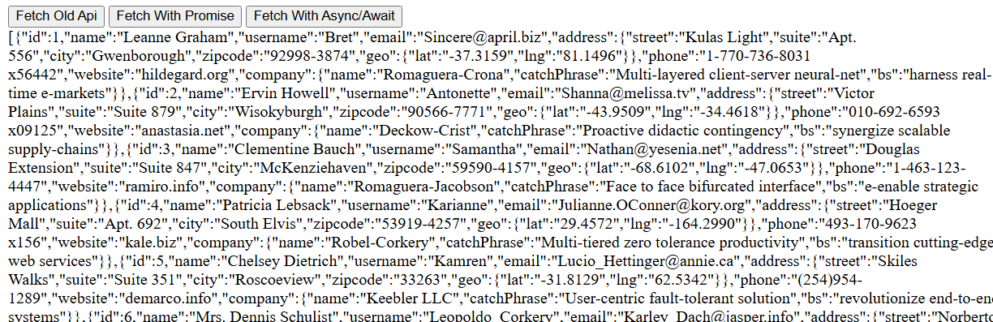

String padding

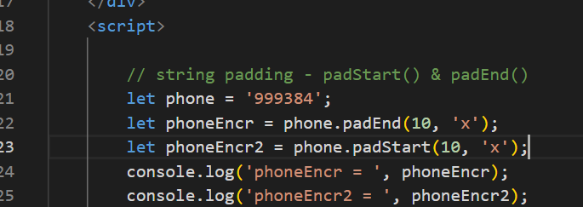  
output:

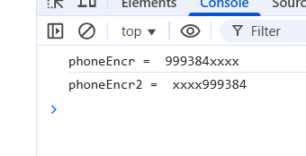

Day 8

* Node.js
* Typescript

Node.js is a runtime environment to run JavaScript’s at the backend so that you can do more operations related to backend services like connecting to DB, access files, working with OS related resources

node.js gives two commands

1. node: This is used to run the javascript files and also gives you REPL terminal, where you can test javascripts & also many tools that supports JS integrates REPL ex: mongodb shell
2. npm: Node Package Manager this is used to manage the modules which are libraries

basics.js

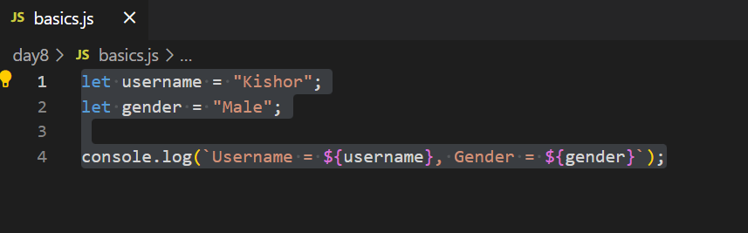

Output:



package.json

It is the heart of node.js it will have all the project meta-data like versioning, dependencies, scripts

Java -> pom.xml

Node.js -> package.json

To create the package.json you can enter npm init command or npm init -y

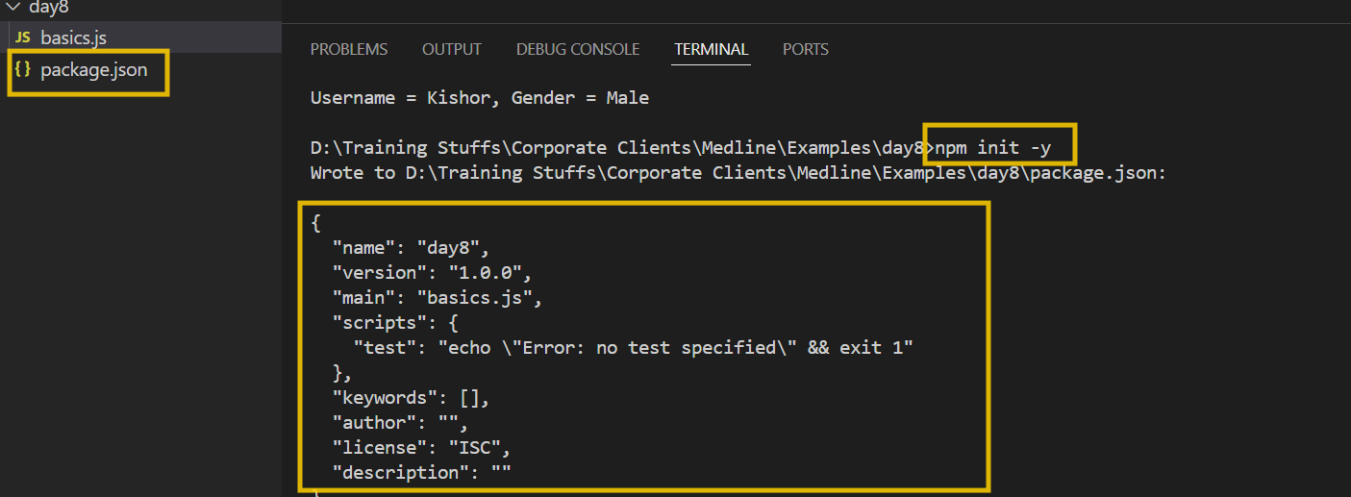

You can add start script & run using npm

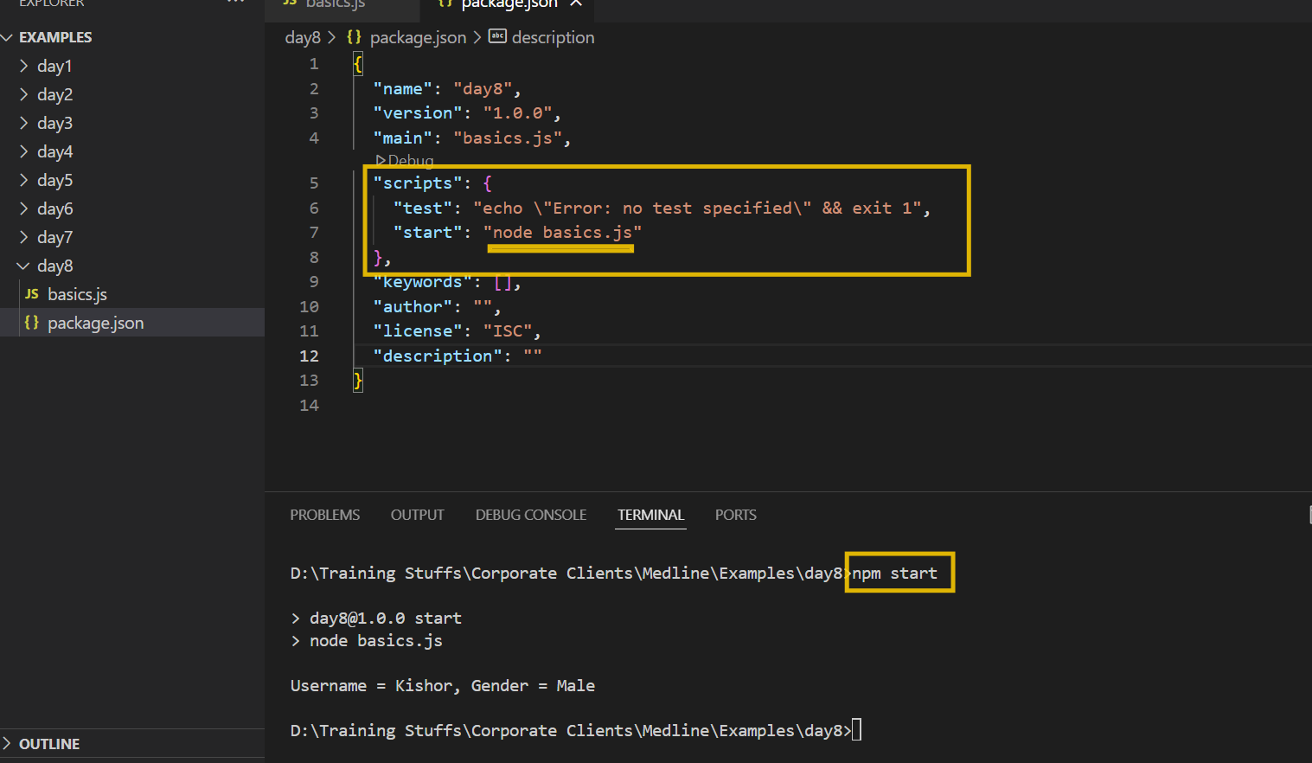

Importing & Exporting the modules

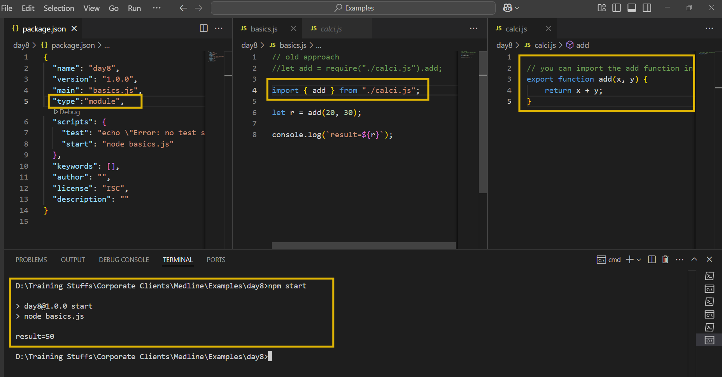

Node.js uses Event loop mechanism to run the script

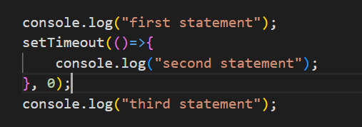

Local modules:

These are inbuilt modules part of the node.js, which can perform various operations like

reading files/ writing files

creating web application using http

os module

fs-demo.js to read & write files

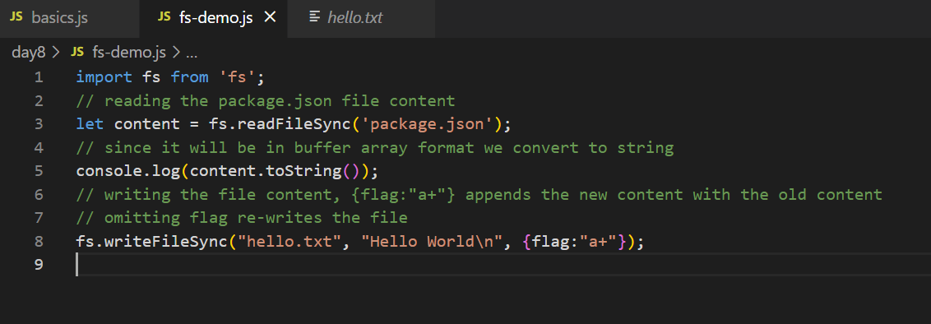

os-module

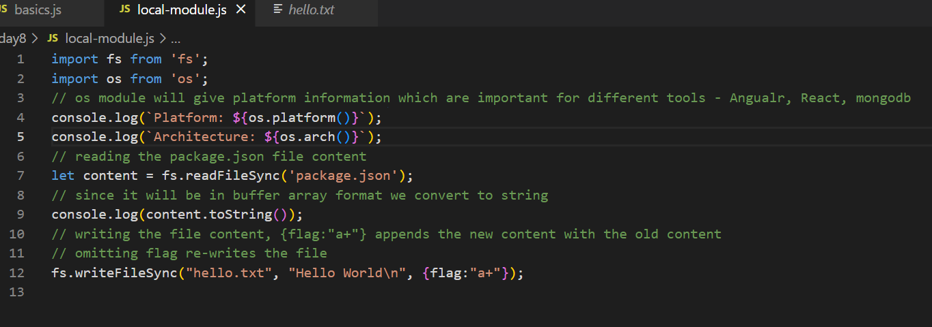

Output:

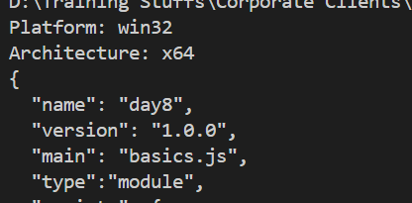

You can install 3rd party modules using npm, npm maintains libraries in a node repository you must use following command like

npm install library-name library-name library-name [or]

npm i library-name library-name # local installation

npm install -g library-name # for global installation

Typescript

It is a programming language which is a super set of javascript, it supports everything of javascript & extra features, it makes code more reliable & predictable because it adds types to the data

function add(x, y) { } // add(“hello”, “world”), add(true, false), add(20, “hello”);

function add(x : number, y: number) { } // add(30, 40);

To install typescript

npm install -g typescript

npm i -g typescript

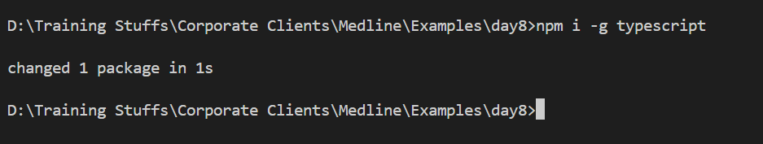

Types in typescript

1. number
2. string
3. boolean
4. custom type
5. arrays
6. union
7. intersection
8. generics
9. void
10. conditional & mapped types

Compiling & running

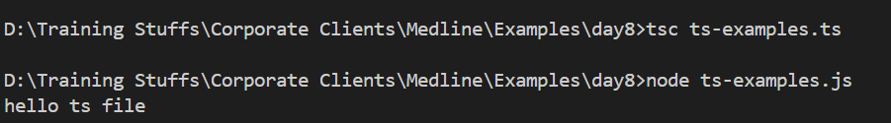

you will write all the code in ts file but run the js file by using tsc filename.ts you will compile.

Using some types in typescript

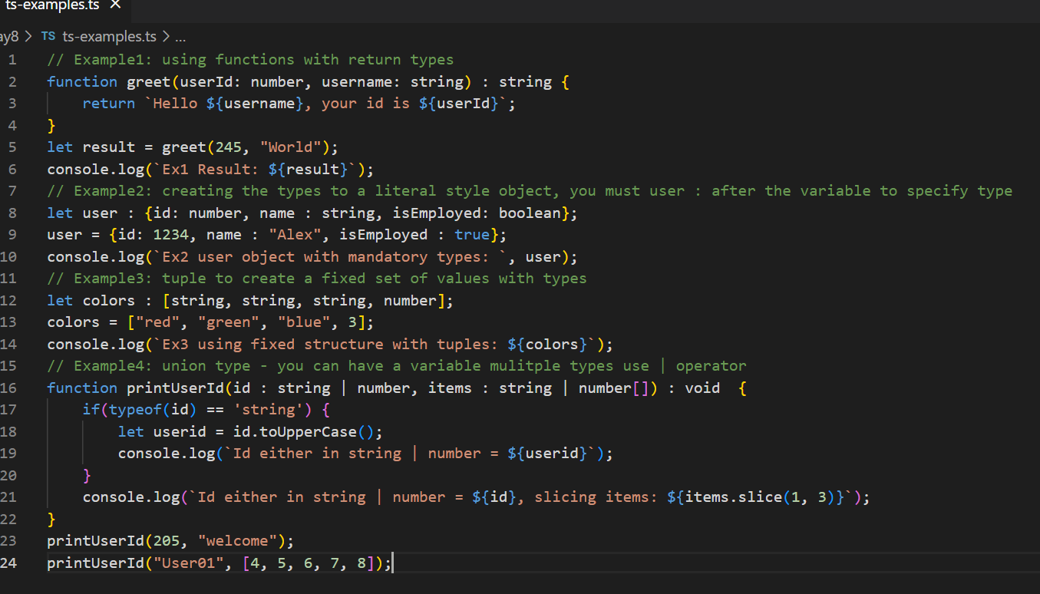

Output:

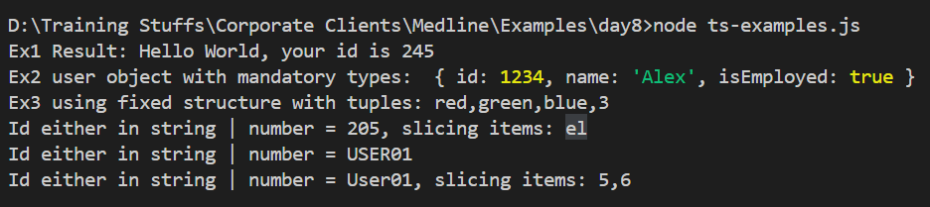

Type aliases

type Point = { x : number, y : number};

let pt : Point = { x : 40, y : 50}

interfaces

interface Person {   
 name : string;  
 age : number;  
}

interface Employee extends Person {   
 salary : number;  
 id : number;  
}

let emp : Employee = {name, age, salary, id }

interface A {   
 test() : void;  
}

class X implements A {   
 void test() { .. }  
}

classes:   
class Employee {   
 //  
}

private, public, protected & optional parameters

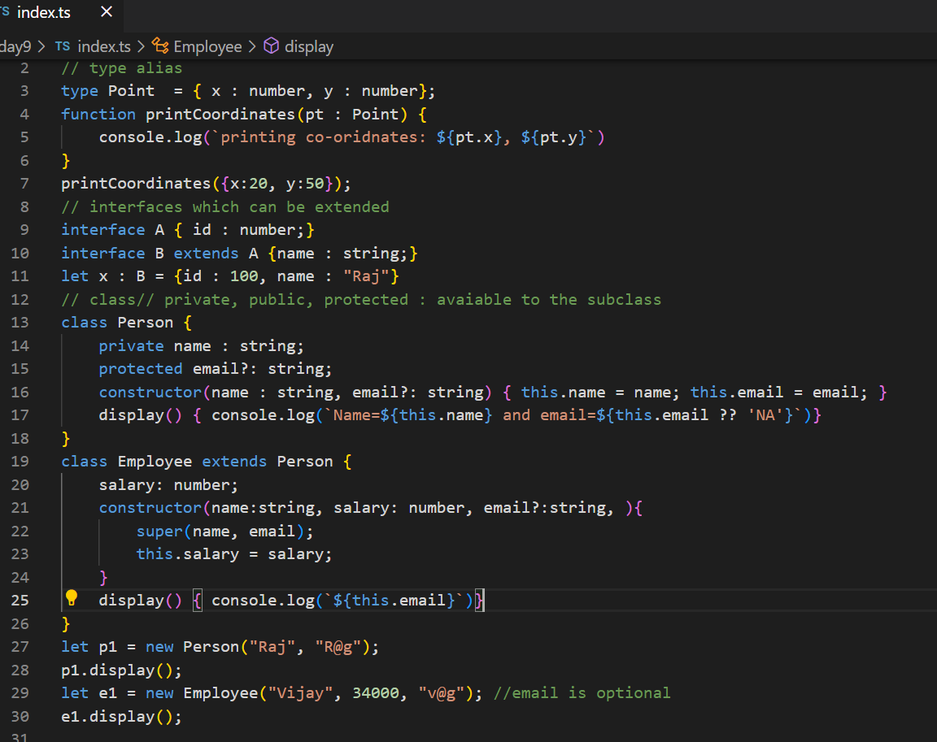

We have other features in typescripts like

1. short-cut constructor initialization
2. generic types
3. promises for the function return types
4. conditional types
5. mapped types

Promises: Before ES6 i.e., ES2015 there was no promise, hence the typescript compiler doesn’t compile it because by default it converts the TS to ES5 compatible Javascript

We must use --target flag to say typescript compiler that compile to ES6 Javascript

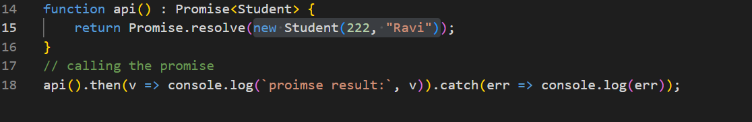

Compiling this without --target ES6 gives error.



Short-cut constructor syntax & Promises

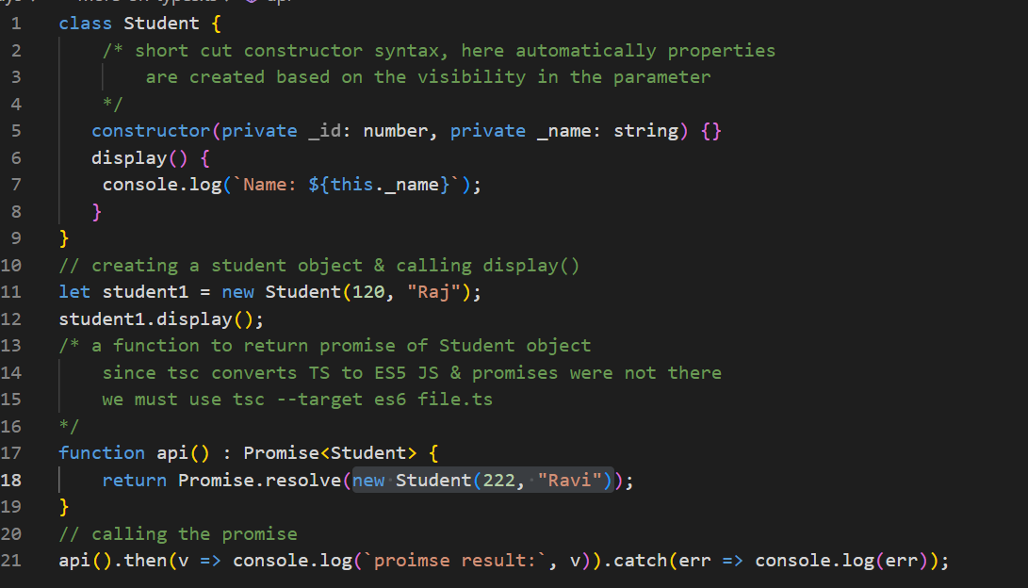

Output:

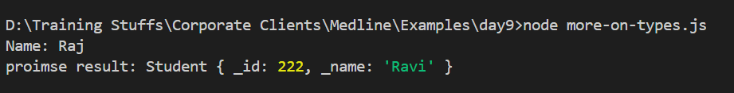

Decorator: It is mainly used to provide meta information on a class or variable or a method

Angular has many decorators to change the behavior of the class or a variable or a method.

ex:  
@Component ({})  
class App { }

Mapped types

You want to create new types by transforming the properties of an existing type

ex:   
age : number >> transform this to age : string

or

age : number >> transform this to age ?: number

RxJs

Reactive programming allows you to react to the events or for asynchronous tasks, RxJS is nothing but ReactiveX for Javascript, it is a library for composing asynchronous & event based programs by using Observables.

Promise for asynchronous tasks, but it will only get one data at a time & it executes always for completion, it doesn’t wait for continuous data, to the receive the data continuously we need to use Reactive programming which provides Observables.

Key components in RxJS are:

1. Observable
2. Observer
3. Subscriber
4. Subject
5. Operators

Observable

These define the stream of data or collection of future values that can be emitted overtime.

Subscribers: These can subscribe to the observables to receive the emitted values

Observer: It is an object that defines the callback or handlers which are called when an observable emit an event

Install the rxjs

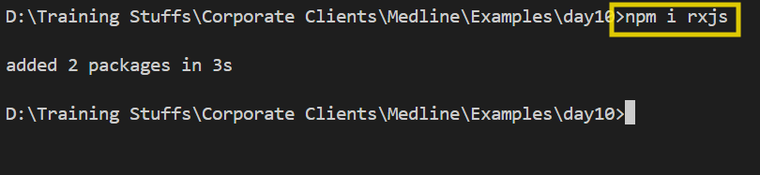

How to create observables

let myObs = new Observable( (observer) => {   
 observer.next(“Emit 1”); // success value  
 observer.error(“Emit error”) // error values & no more data is emitted   
 observer.complete(); // to notify its done & no more data is emitted  
} );

myObs.subscribe( {   
 next: (value) => {…. } , error : (error) => {… }, complete: () => {… }  
});

Note: change the package.json to have “type”:”module” to use modern import syntax

package.json

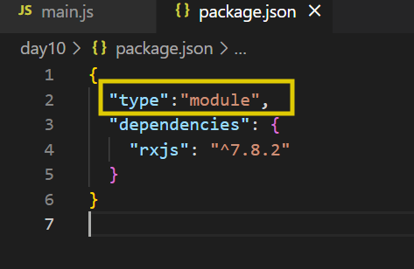

main.js

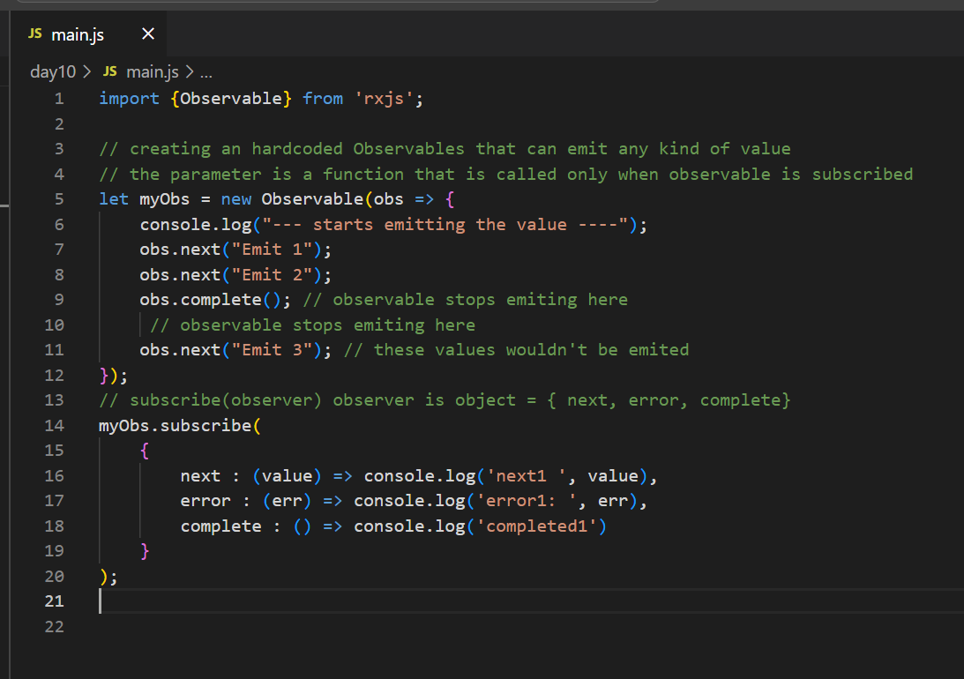

Output:

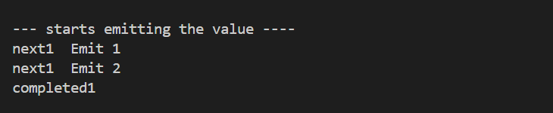

Operators:

Manipulate the data emitted by observables before they react the subscribers

map()

filter()

catchError()

Subject: To share the same data to multiple subscribers

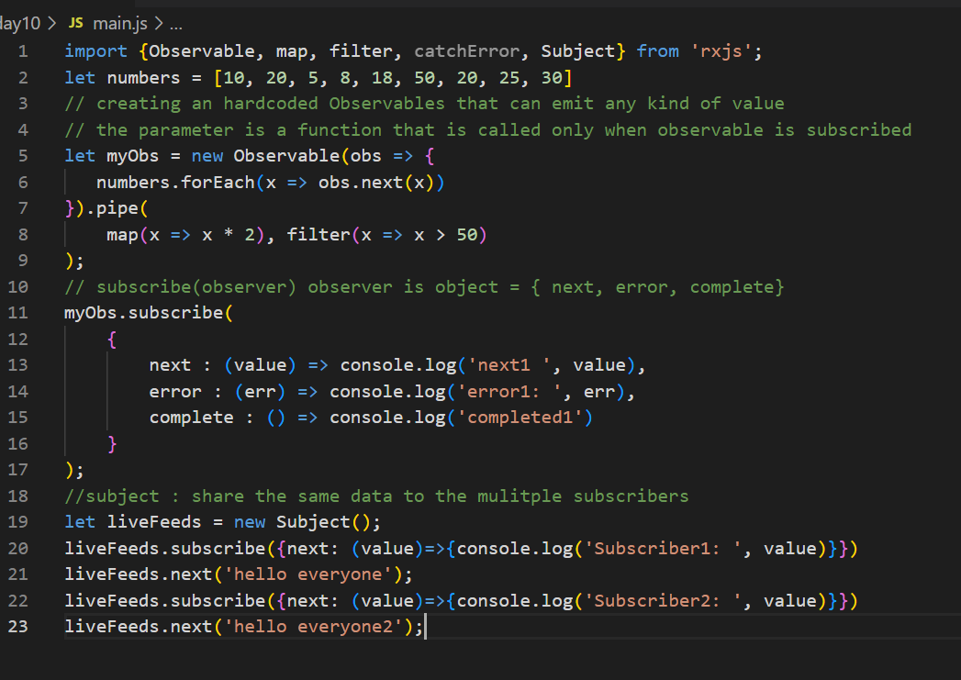

Angular Framework: It is used to develop single page applications

Components: These are reusable UI’s which you can see, these are independent that you can develop and then integrate with other components to create a complex UI

Two technologies angular use for developing the applications

1. HTML
2. Typescript

npm install @angular/cli

ng --version >> 19

ng new app-name

Summary

ng new my-app --no-standalone --routing=false

npm start >> ng serve

ng serve --port=4201

Angular CLI: ng generate component component-name

[or]

ng g c component-name

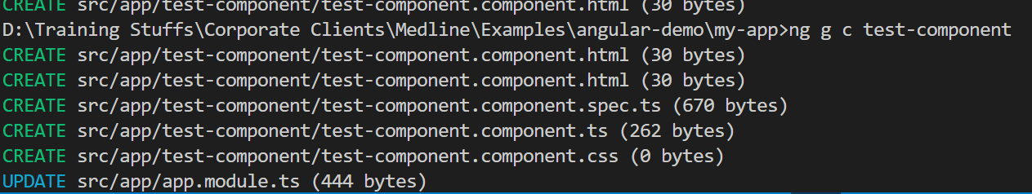

Add the test-component to the root component

app.component.html

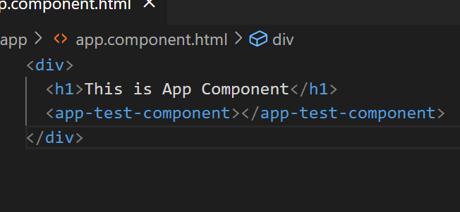

Output:

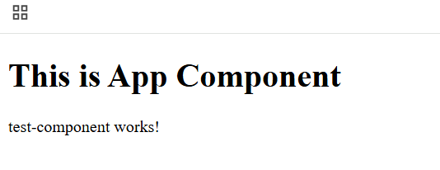

How to display different types of data like simple type, complex type

demo.component.ts

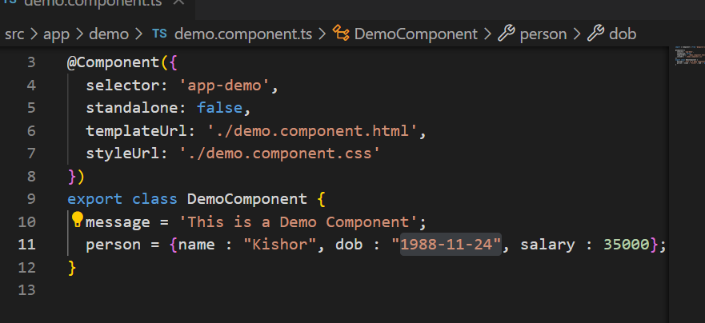

demo.component.html

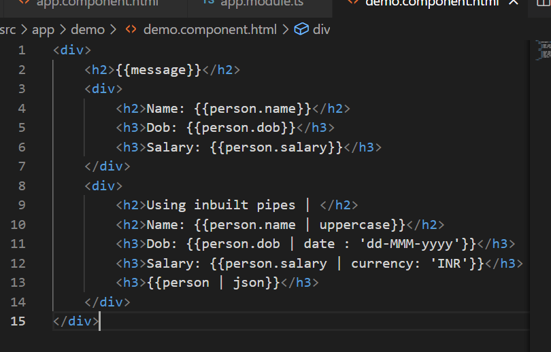

Output:

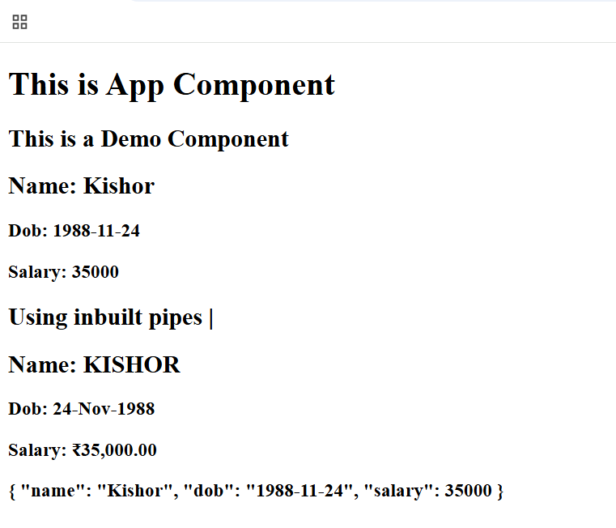

Pipe: These are mainly use for transformation, we have inbuilt pipes like

* uppercase, lowercase, date, currency, json

Custom Pipe: We can create our own pipes in angular that would do some job when you use its name

ng generate pipe pipe-name or ng g p pipe-name

Note: Once you generate the pipes it must be part of AppModule to recognize, the command automatically updates the app.module.ts

name-formatter.pipe.ts

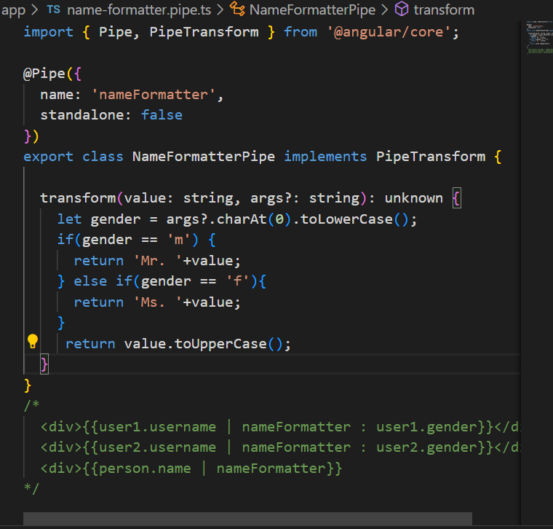

demo.component.ts

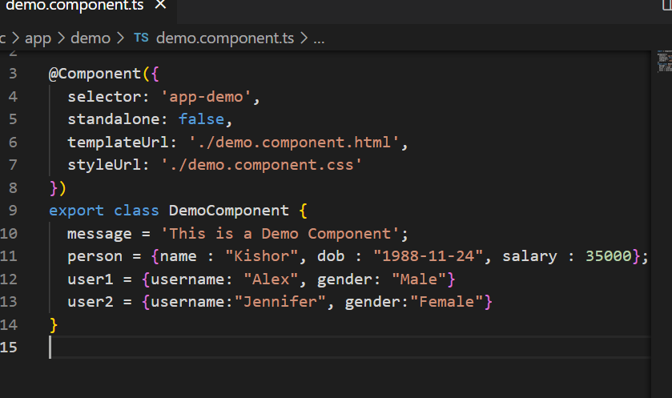

demo.component.html

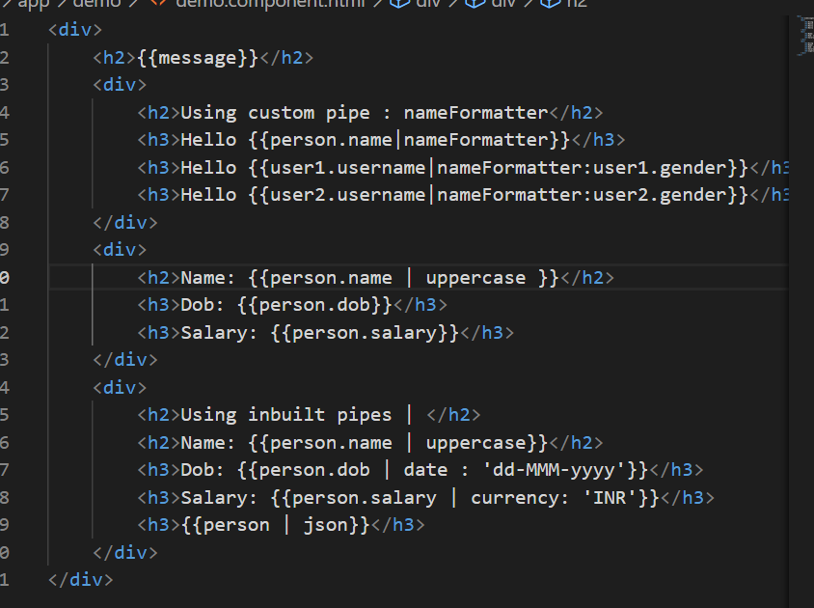

Output:

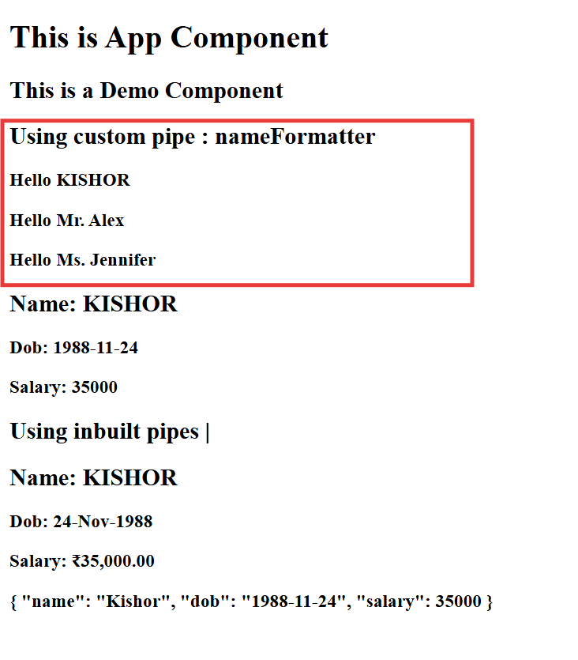

Databinding:

When you want to share the data from the view to the component or vice versa you need to do a data binding, there are following types of data binding

1. Interpolation {{ }}}: Here the data present in the component class shared to view
2. Event binding (eventName): Here the data present in the view is shared to the component class
3. Property binding [ ]: Here the data present in the component class shared to the view, similar to interpolation, but this is mainly used to update the DOM property
4. Two way data binding [(ngModel)]: Here the data flows in both the direction, it will be in sync, but you need to import FormsModule to support the ngModel

Event Binding & Property Binding

TS

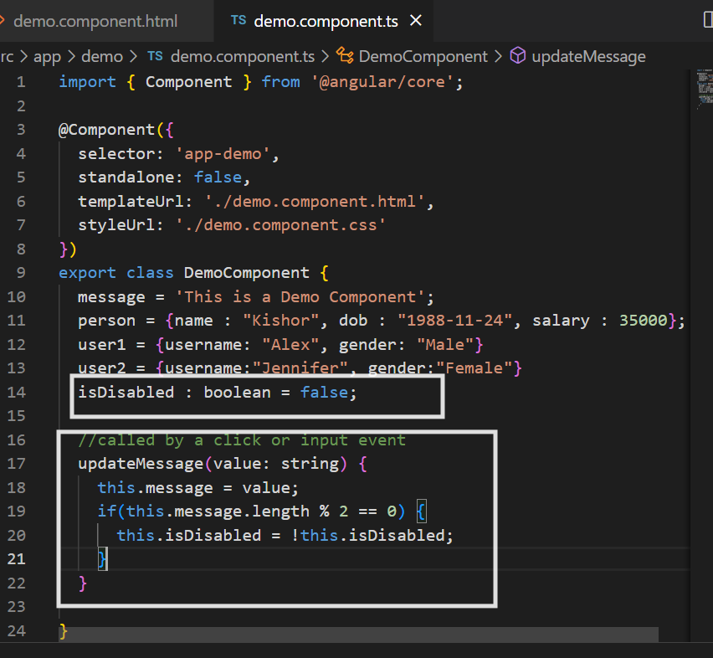

HTML

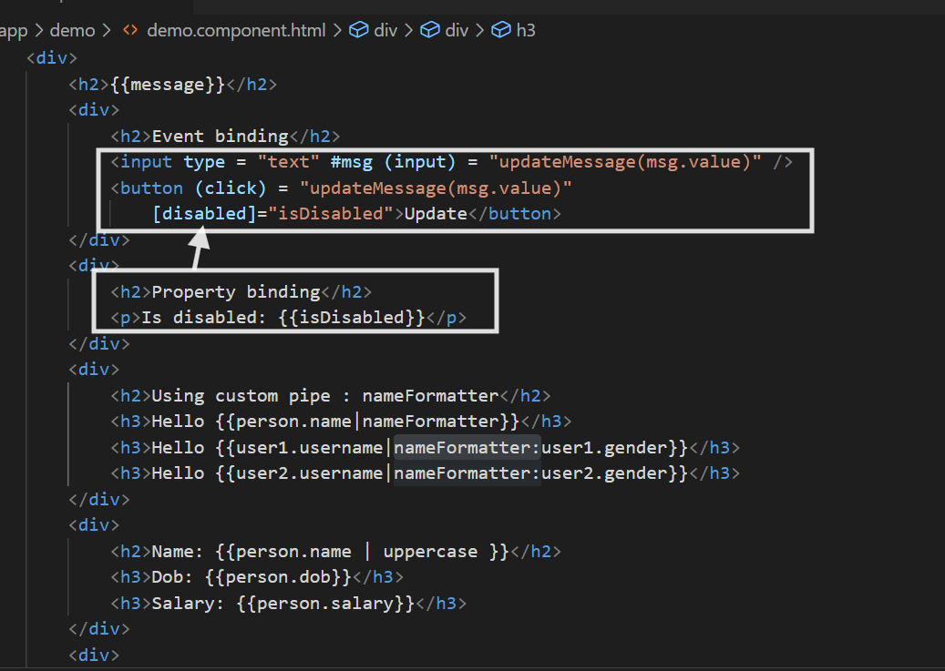

Output:

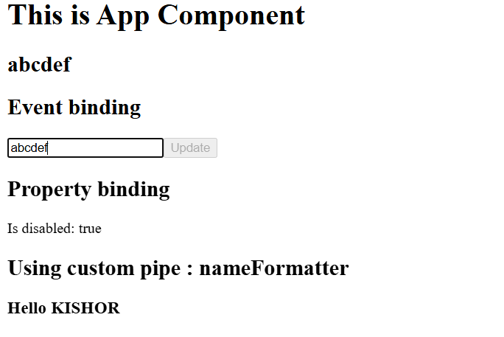

Two way data binding

[(ngModel)]: it shares data from view to component class & vice versa, but it works only if you add FormsModule in the app.module.ts

If you use [(ngModel)] in the html element without importing FormsModule

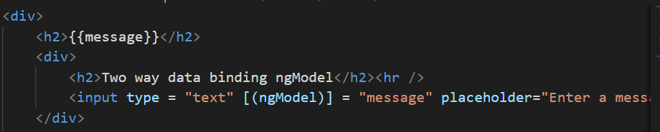

You get below error

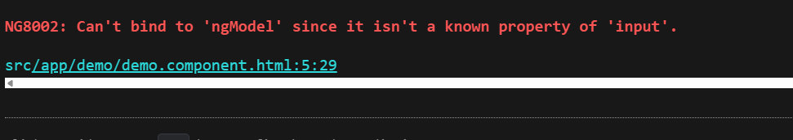

Importing the FormsModule from @angular/forms

app.module.ts

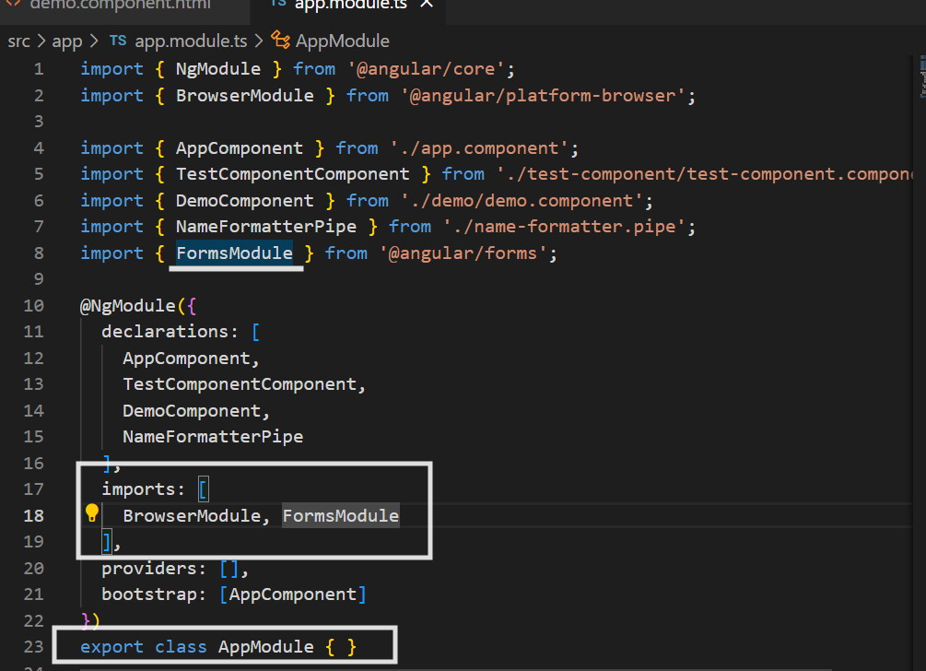

Output:

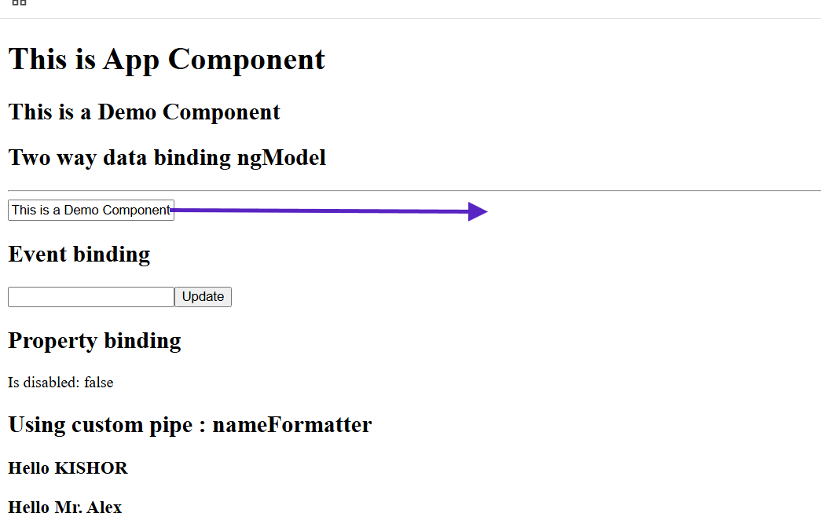

Notice the input box already has the value of message variable

Class & Style binding

Suppose a component has a css style value or a property to add/remove a class then you can use style or class binding

<p [style] = “myStyles”>Hello World</p>

myStyles = { color : blue }  
addClass = true / false;

<style>  
 .text-danger : red;  
</style>

<p [class.text-danger] = “addClass”>Hello World </p>

You have a separate css file to specify the classes.

demo.component.css

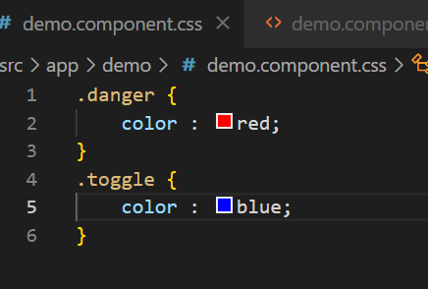

HTML

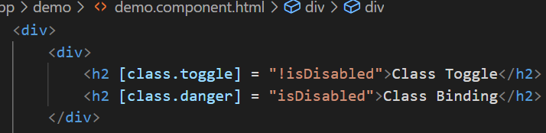

Output:



Since you are using !isDisabled the Class Toggle content adding the style

Style binding

TS

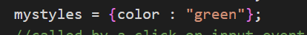

HTML



Output:



Summary:

Created pipes : ng g p pipe-name : logic must be inside a transform() method

Inbuilt pipes : currency, date, uppercase, lowercase

Bindings - interpolation {{ }}, property binding [ ], event binding ( ), two-way data binding [()], class binding [class.className], style binding [style]

Note: class, style binding are part of property binding itself

Directives in Angular

Directives are kind of instructions to the DOM element to have some extra behavior, we have following directives

1. Component directive: @Component and you can use <component-name>
2. Attribute directive: ngModel, ngStyle, ngClass
3. Structural directive: *ngFor, *ngIf, *ngSwitchCase

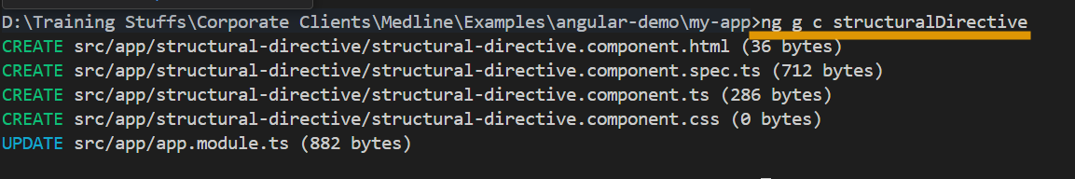

*ngIf: It is a conditional based directive which helps to render the DOM elements when condition is true or condition has a value, undefined properties evaluates to false

<div *ngIf = “username”>  
 Hello {{username}}  
</div>

<div *ngIf = “status”>  
  
</div>

ngSwitch: it is used to apply multiple conditions and render a component or an HTML element when the option is true.

ts

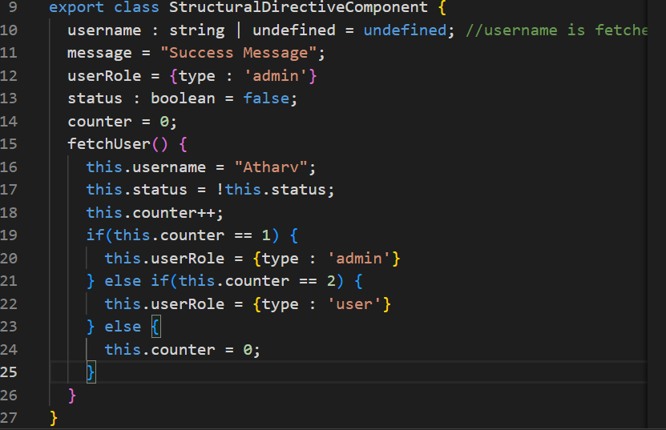

HTML

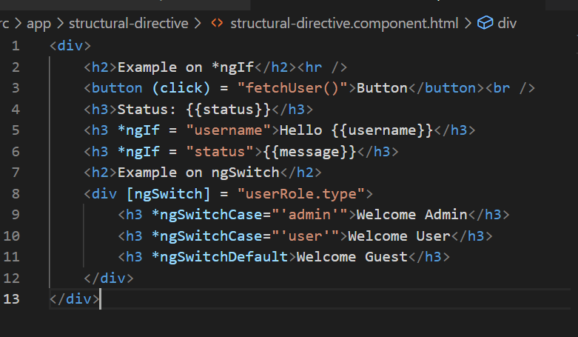

Output:

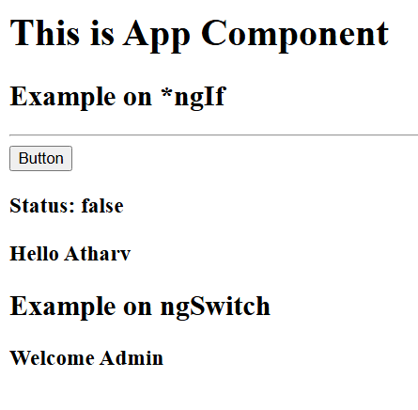

*ngFor: It is used to iterate over the array elements, helps to dynamically create HTML elements

<div *ngFor = “let item of items”>{{item}}</div>

TS

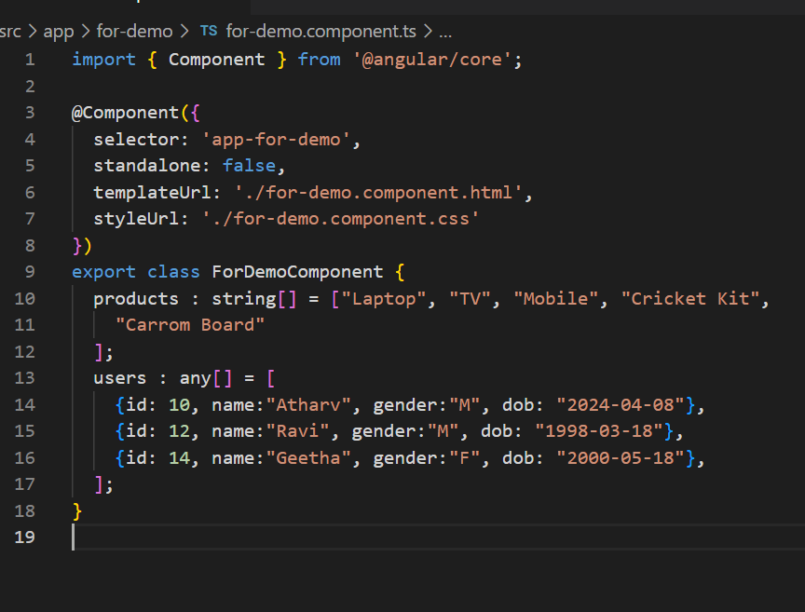

HTML

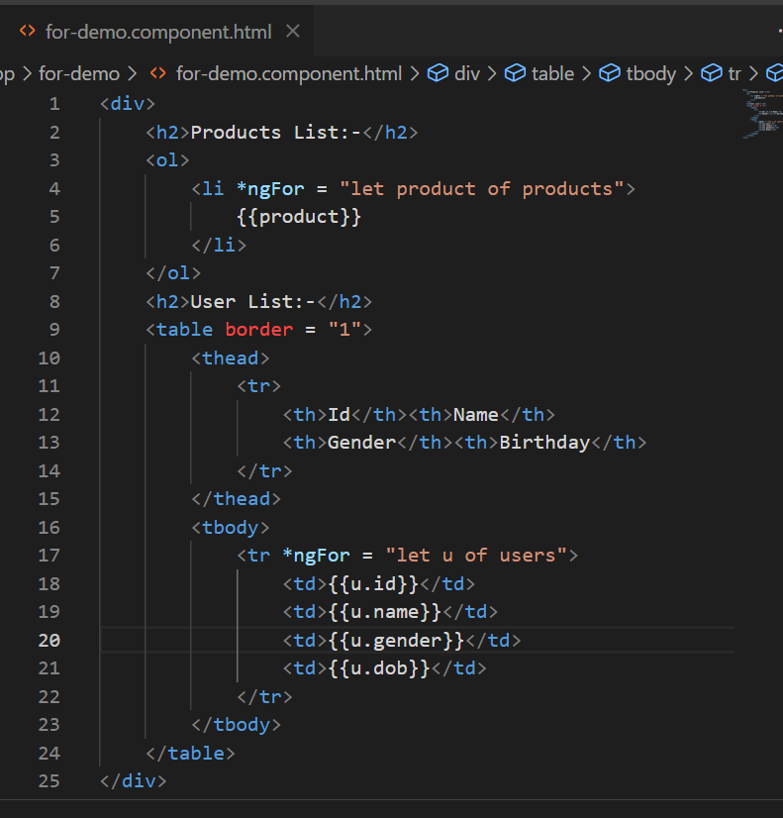

Output

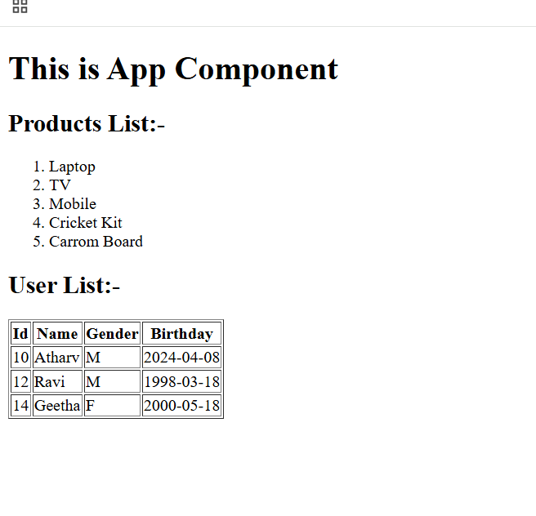

View Encapsulation:

It is to avoid leakage of CSS from a child component to parent or parent to child component, using view encapsulation CSS leakage can be avoided, once you build the application all the CSS will be wrapped into a single css file

By default Angular uses ViewEncapsulation when you apply CSS for each component because of that CSS doesn’t leak to other components, there are 3 types of ViewEncapsulation

1. Emulated - default one - that is supported in all the browsers even in legacy browsers
2. ShadowDom - each component will have its own CSS with a host element
3. None - no view encapsulation done for the styles

TS

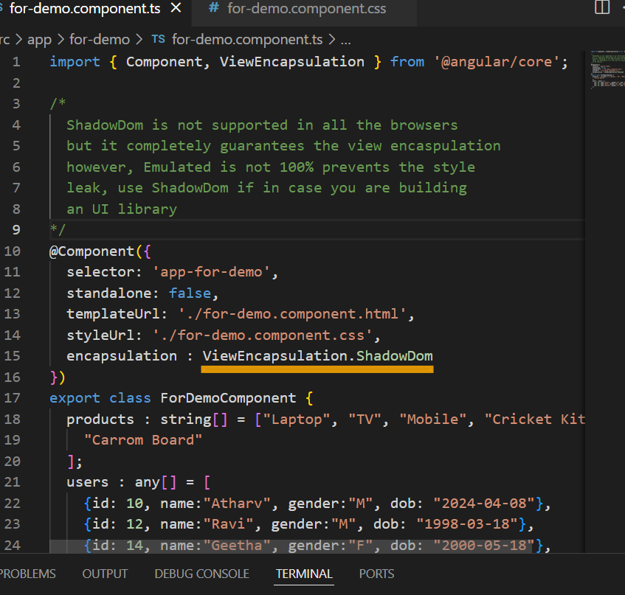

Output:

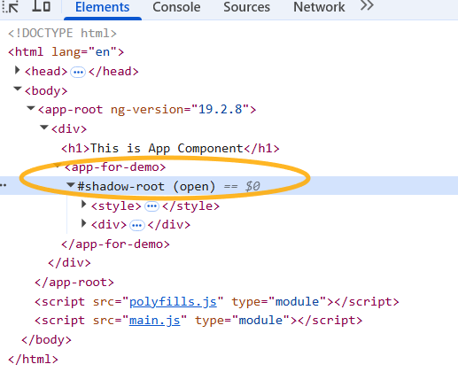

Changing the encapsulation to None i.e, ViewEncapsulation.None will leak the styles from app-for-demo to app-root

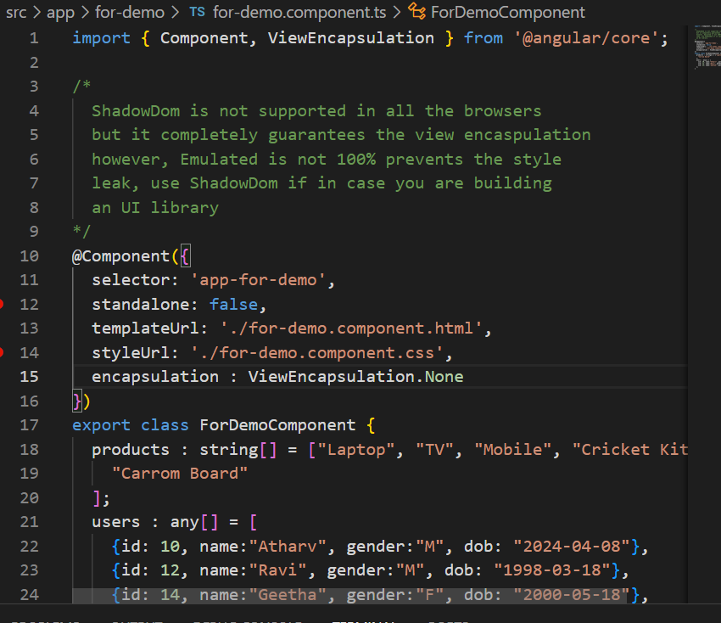

Output:

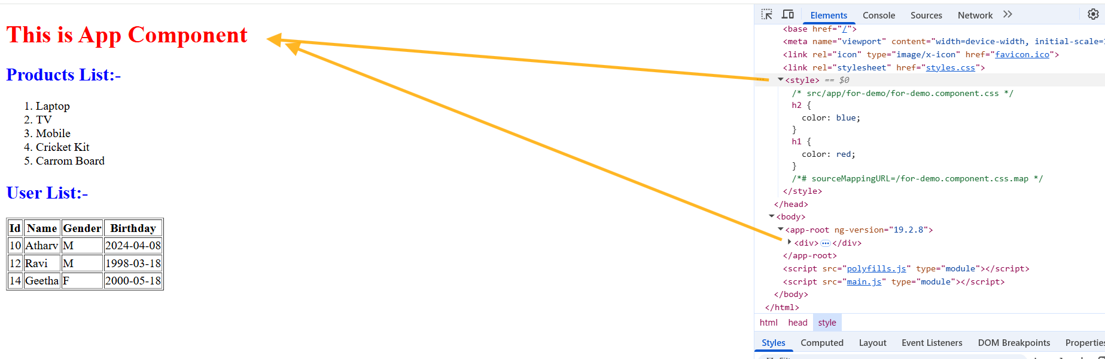

Notice the h1 color is red which is defined in the for-demo component,

Pure & Impure pipes

By default pipe is pure, however you can use pure: false to create an impure pipes

Change detection:

it is one of the mechanism angular uses to sync the result based on the changes happening in the code, it runs when the component is updated & also when the view is updated i.e., twice to keep the things in sync.

For Pure pipes the change detection runs only once when the component data is updated, but for impure pipes it runs for both the updates (component & view)

Impure Pipes: the transform() function called even if some other data of a component is updated, & its called twice

Pure pipes: the transform() function is called only if the data that is transforming is updated, however it is called only on the first phase (component updates) & in second phase (view updates) it is not called

Pipe

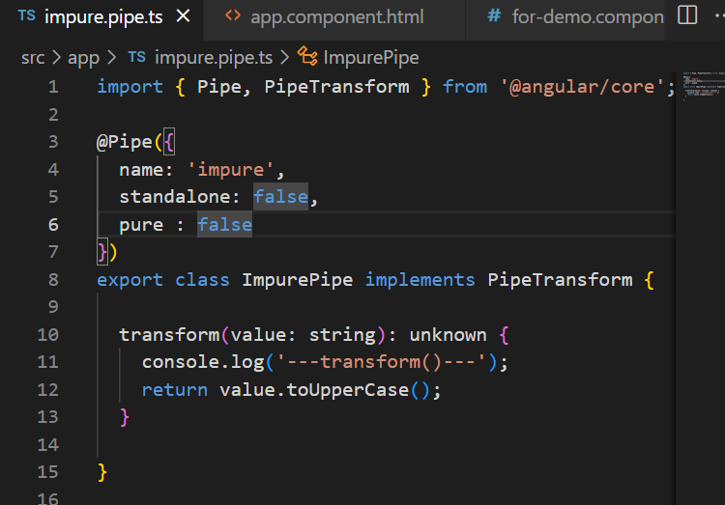

component

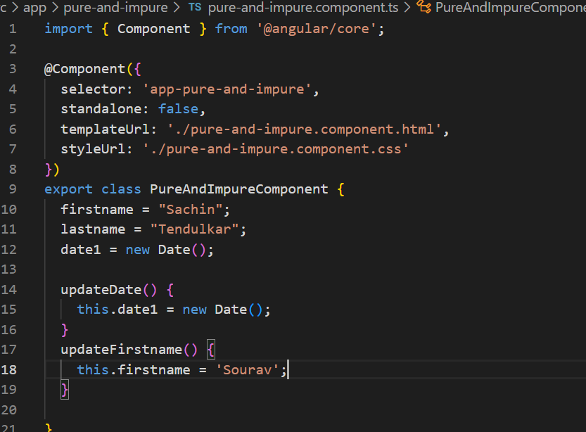

HTML

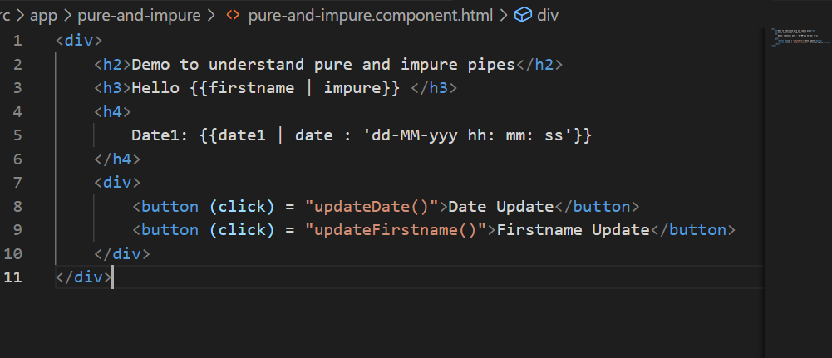

Output:

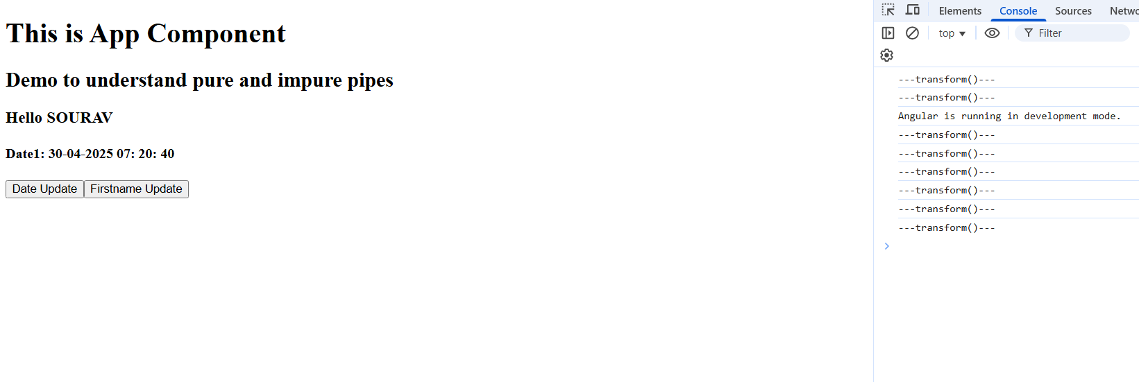

Notice the transform() getting called twice by the change detection for impure pipes

Note: using impure pipes can impact the performance hence you must use it carefully

Note: By default pipes are pure

Pipe precedence

| will not always have a higher priority, you must know the pipe precedence to understand whether the transform is applied correctly or not, else you get an unexpected output.

{{ 10 > 5 ? ‘hello world’ : ‘thank you’ | uppercase}}

This will give an unexpected output because pipe is always applied on thank you not on hello world

You must wrap the entire expression on which you want to apply pipe

i.e.,

{{ (10 > 5 ? “hello world” : “thank you”) | uppercase }}

Precedence without wrapping condition in ()

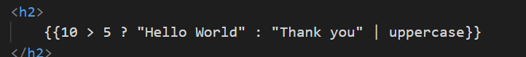

Output:



Precedence that works properly when condition is wrapped in ()

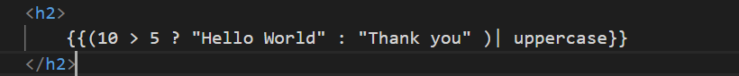

Output:



Custom Directives

When you want to create your own directive and use it in your app which must do some job on the Dom

To generate directive you must use

ng g d directive-name

Note: The directive will be auto-declared in the NgModule of app.module.ts

Generating the directive

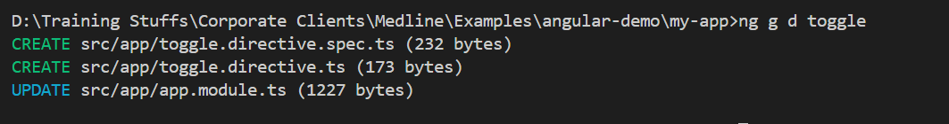

toggle.directive.ts

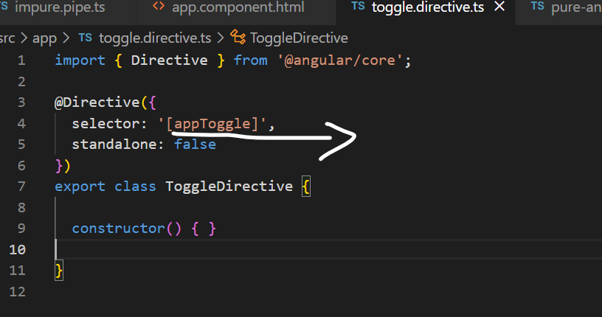

you can use that selector in any HTML element and automatically perform some Operations based on the events.

ex: <button appToggle>Button</button>

You can change this name to ClickMe or any other names when any event occurs on this button.

<video appVideo>

<source src = “…” />  
</video>

Now when you place mouse you want to auto-play the video & pause when you move out the mouse

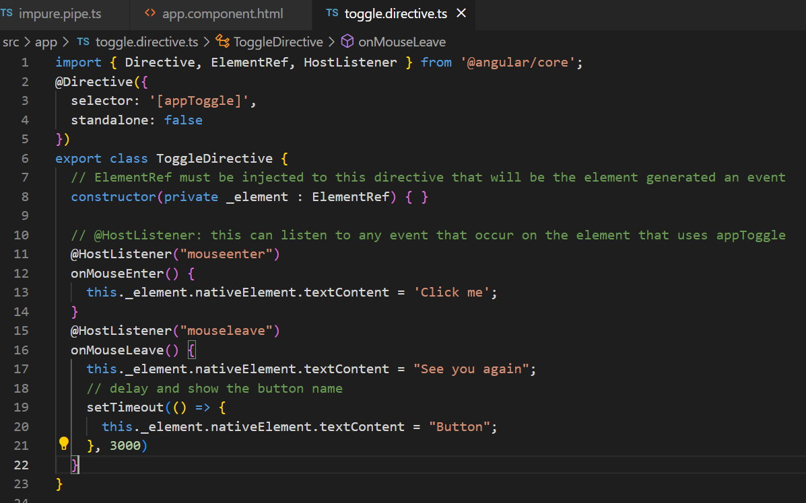

app.component.html

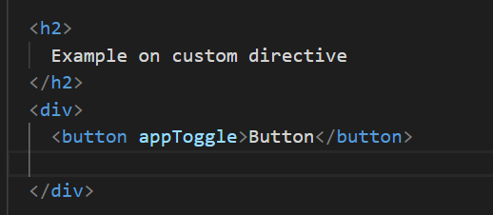

Output:

Button changes to click me when placed mouse on it

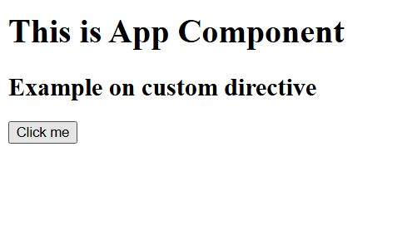

Toggle video play & pause

app.component.html

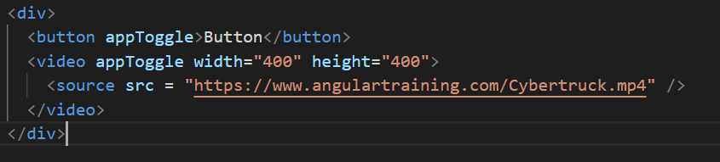

toggle.directive.ts

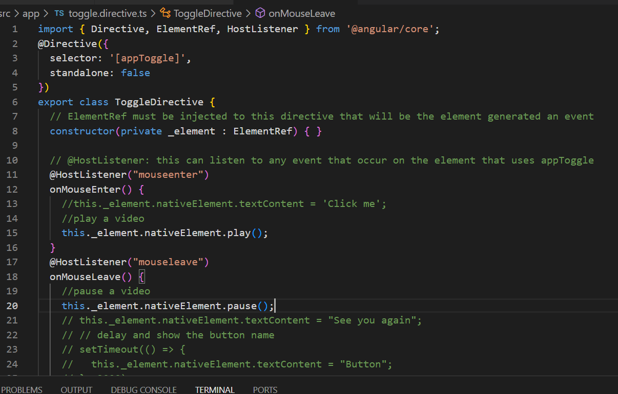

Once you place mouse over a video it plays & pauses when you leave the video

How to configure 3rd party styles in angular

Important Note: Always download the libraries and add the path in the angular.json file, don’t use CDN link, if you add the path in angular.json the downloaded library also built as a part of build file when you build the application

How to install bootstrap.css

npm install bootstrap --save

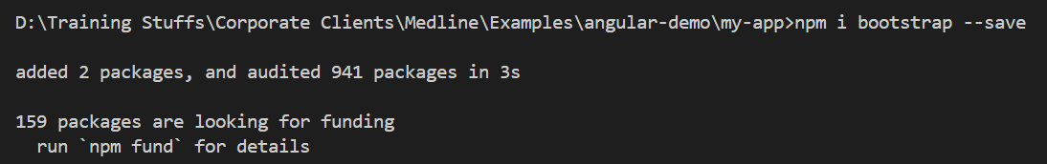

update styles.css

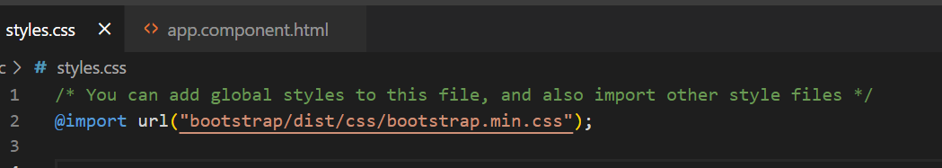

@Input & @Output decorator

These are used to share the data between the components from parent to child & vice versa

@Input(): This is used written in the child component to read the values from the parent component

Parent component must use the child component selector and pass the value using property binding syntax

parent.component.ts:

item = “laptop”;

parent.component.html

<child [itemName] = “item”></child>

child.component.ts

@Input()  
itemName = “”;

app.component.html

<app-parent></app-parent>

Example:

ng g c parent  
ng g c child

app.component.html

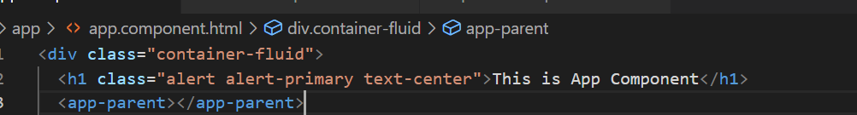

parent.component.html

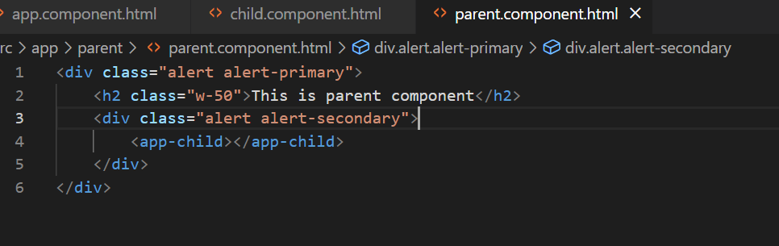

Final code to share the data between parent to child

child.component.ts

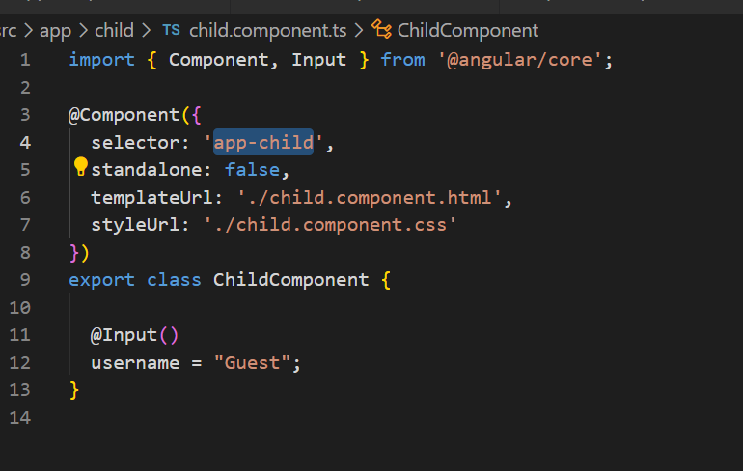

child.component.html

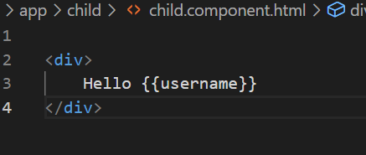

parent.component.ts

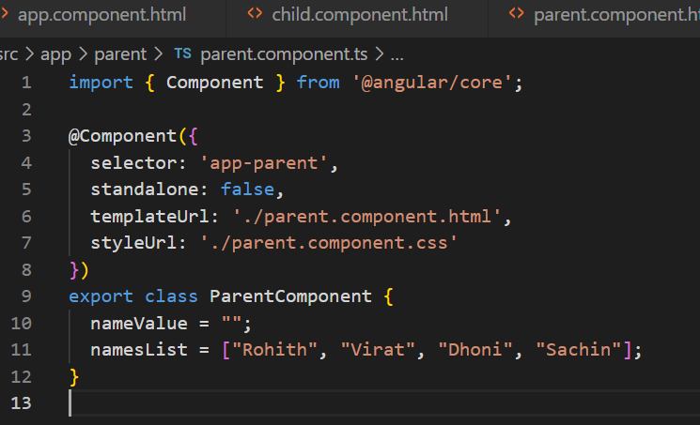

parent.component.html

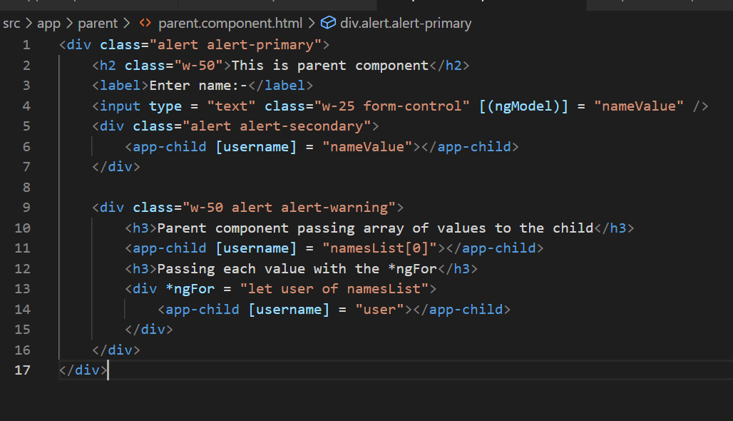

Output:

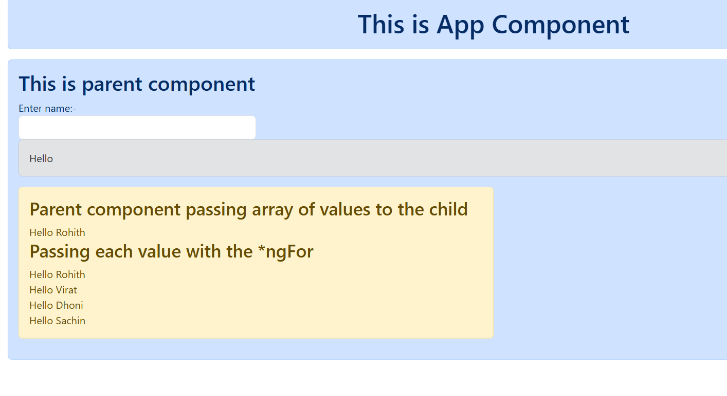

Customization we can do for the @Input() decorator

@Input({required = true}): parent component must pass data to the child component  
username : string = “Guest”;

parent.component.html

<app-child></app-child> <!-- error -->  
<app-child [username] = “nameValue”></app-child> <!-- works fine -->

transform: This is used to transform the value you are passing to the property having @Input()

you must create a function that is outside the component & use it in the @Input(transform: fun_name)

child.component.ts

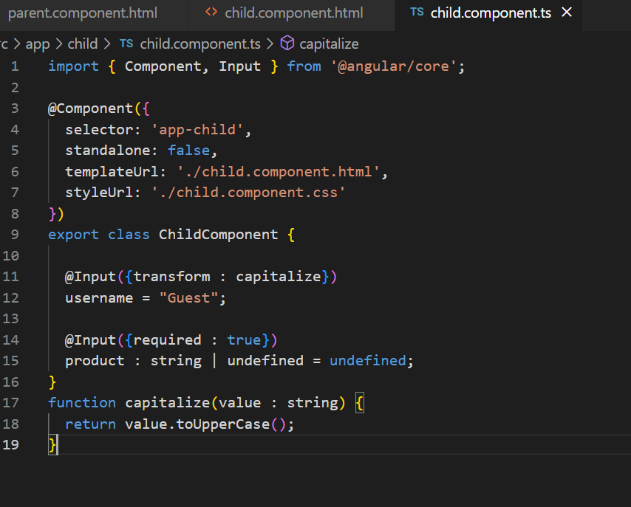

child.component.html

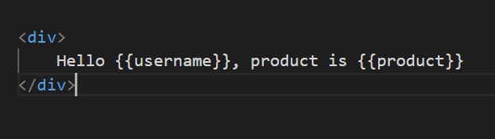

parent.component.html

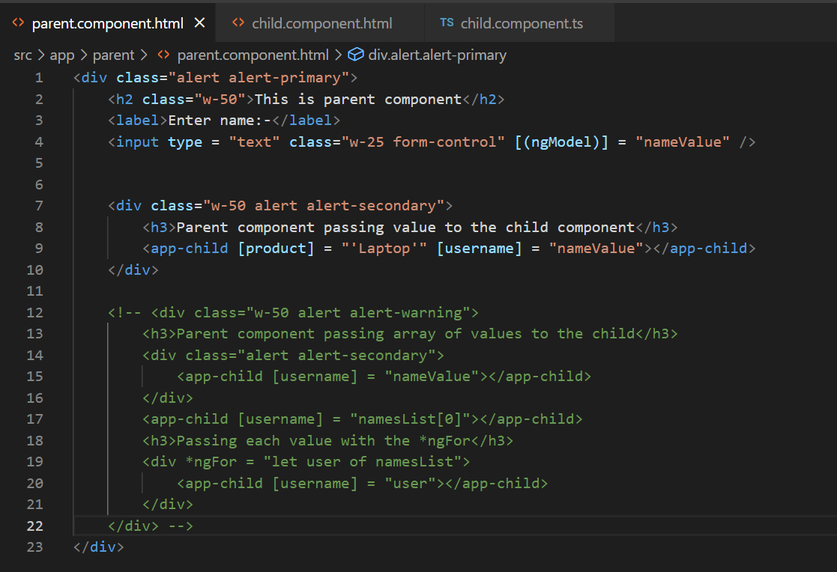

Output:

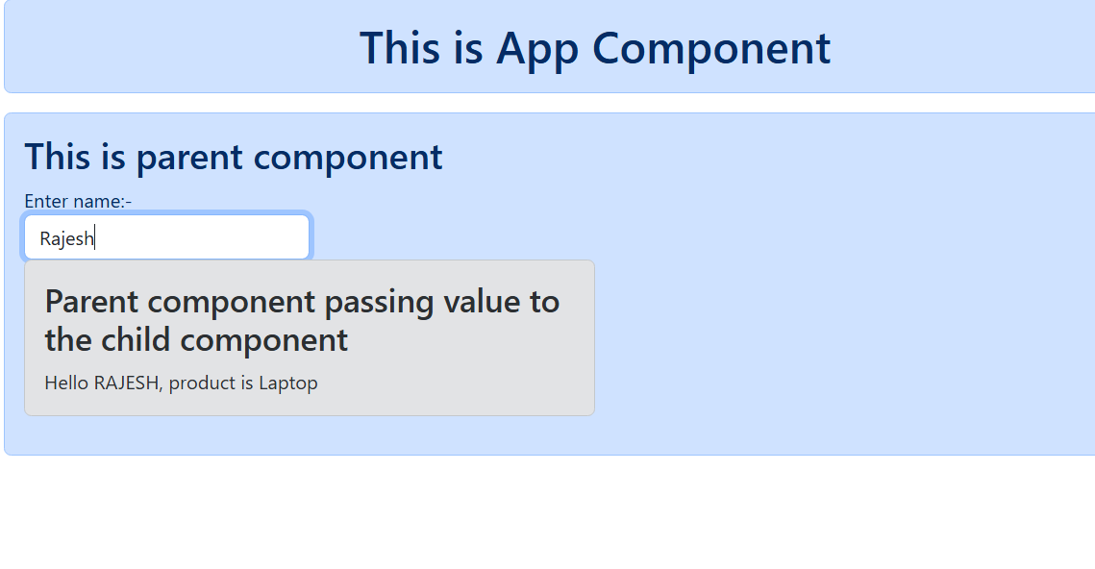

@Output()  
It is used to share the data from child to parent component, here the child component must emit the data using EventEmitter object and $event is the variable that stores the emitted data which you can assign to the parent component.

child.component.ts

@Output()  
numberEmitter : EventEmitter<number> = new EventEmitter<number>();  
handleClick() {   
 this.numberEmitter.emit(250);  
}

parent.component.ts

childValue : number = 0;  
handleData(value : number) { }

parent.component.html

<app-child (numberEmitter) = “childValue = $event”></app-child>  
or  
<app-child (numberEmitter) = “handleData($event)” />

Create 2 components

ng g c parentTwo

ng g c childTwo

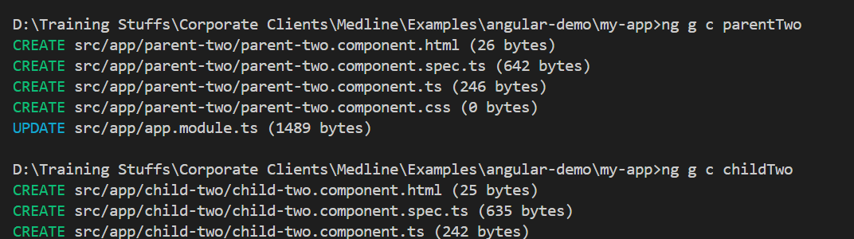

Add the parentTwo in the app.component.html

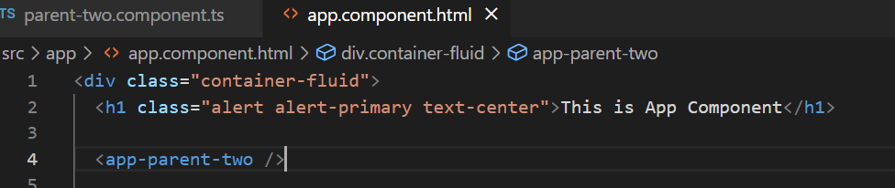

Steps to perform

1. In the child component ts file create an EventEmitter that emits some counter
2. In the child component html file call the function to emit the value
3. In the parent component ts file create a variable that gets the value from the child component
4. In the parent component html file use (event) binding syntax that triggers when event emitter emits the value

child-two-component.ts

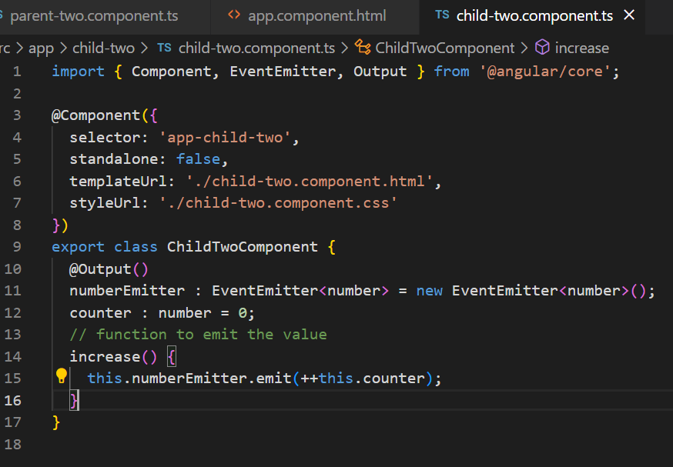

child-two.component.html

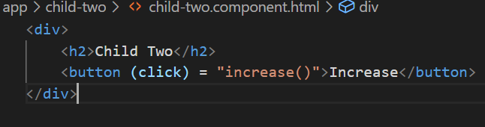

parent.component.ts

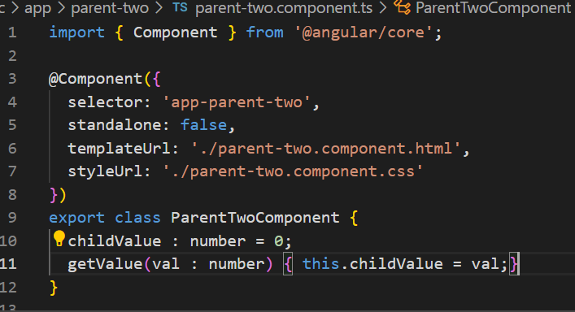parent-two.component.html

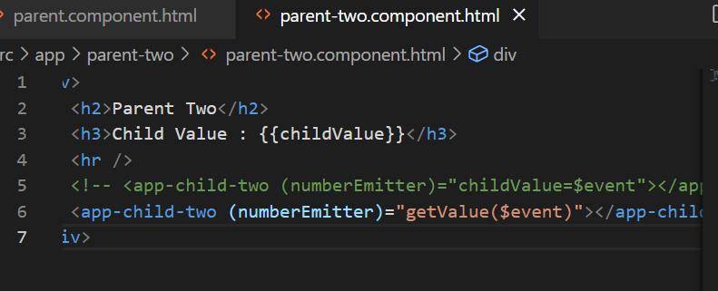

Output:

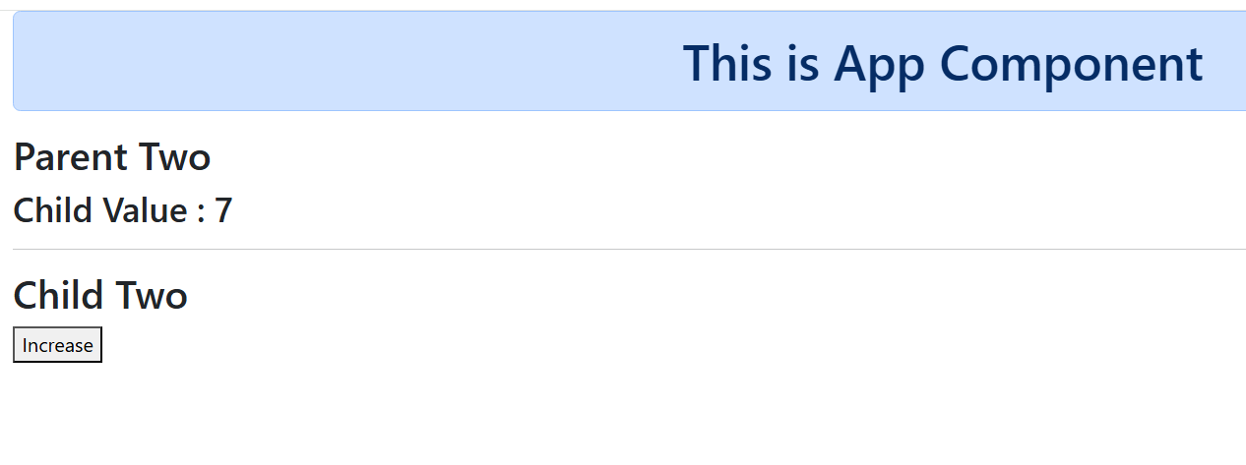

Content Projection

It enables the insertion or projection of HTML content from a parent component to the child component template.

<ng-content> is the placeholder that can render the projected content.

child.component.html (app-child)

<ng-content></ng-content>

parent.component.html(app-parent)

<app-child>  
 <h2>Some Title</h2>  
</app-child>

Now the content of <h2> is passed to the <ng-content> of child component

parent2.component.html(app-parent2)

<app-child2>  
 <h1 text>Some headings</h1>  
</app-child2>

<app-child2>  
 <p desc>Description</p>  
</app-child2>

child2.component.html

<ng-content select = [text]></ng-content>  
<ng-content select = [desc]></ng-content>

Example

ng g c parent3

ng g c child3

app.component.html

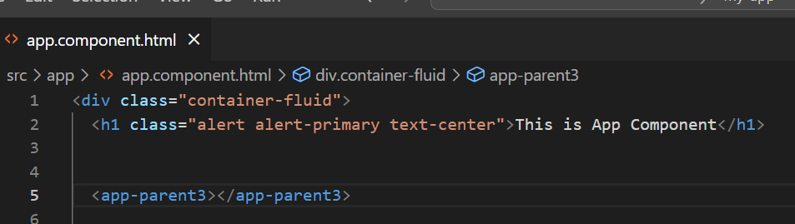

child3.component.html

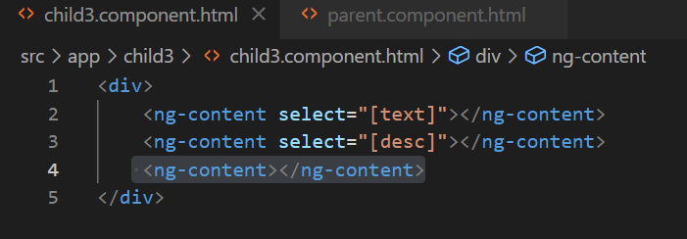

parent3.component.html

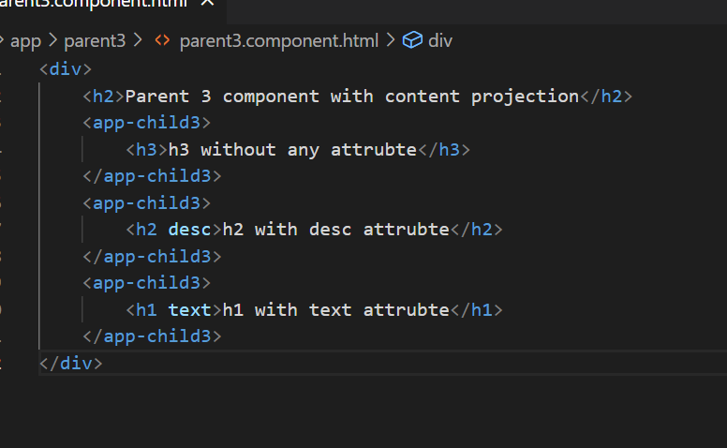

Output:

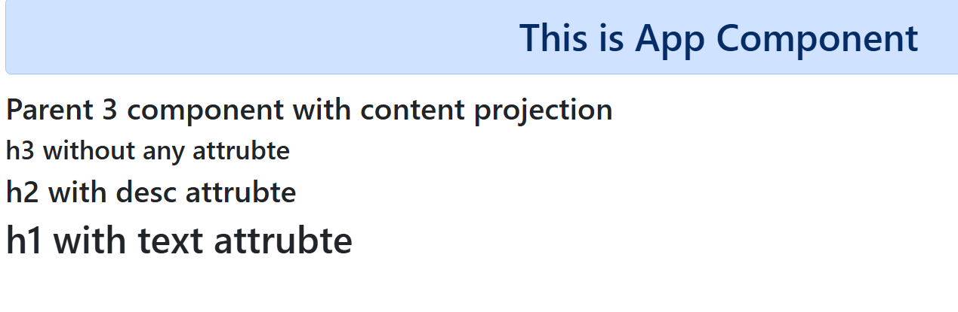

Real time example

1. Questions
   1. Option 1
   2. Option 2
   3. Option 3
   4. Option 4

Component Life Cycle Hook

These are sequence of steps that happen between the components creation & its destruction, in angular we must implement the interfaces that have the life cycle methods which are automatically called by the angular

Note: Understand the life cycle methods sequence & the utilize it in your project

List of life cycle hooks

|  |  |  |
| --- | --- | --- |
| Interface | Methods | Summary |
| OnInit | ngOnInit() | Called once the component is constructed, after constructor() |
| OnChanges | ngOnChanges(SimpleChange) | Called when @Input() property changes, you can get its previous & current value |
| OnDestroy | ngOnDestroy() | Called when component is destroyed |
| DoCheck | ngDoCheck() | Called every time the component is checked by the change detection |

There are other methods which are related to the updates in the components or view

* ngAfterContentInit - called when the content is initialized
* ngAfterContentChecked - Runs every time the component content has been checked for the changes
* ngAfterViewInit - runs after the component view is initialized

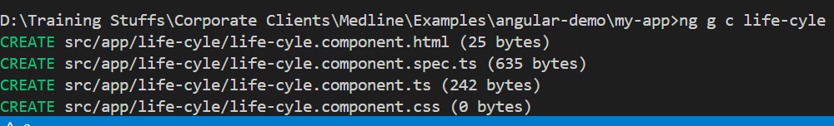

Add this to the root component

app.component.html

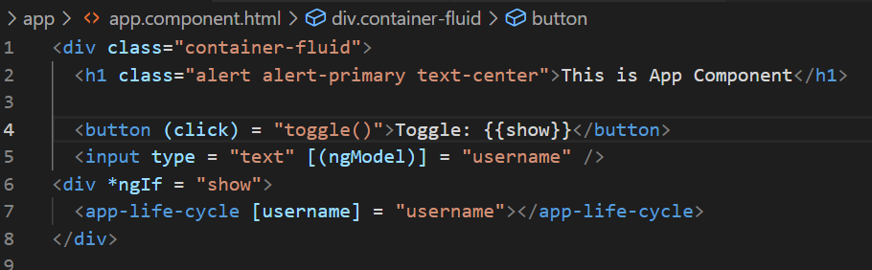

app.component.ts

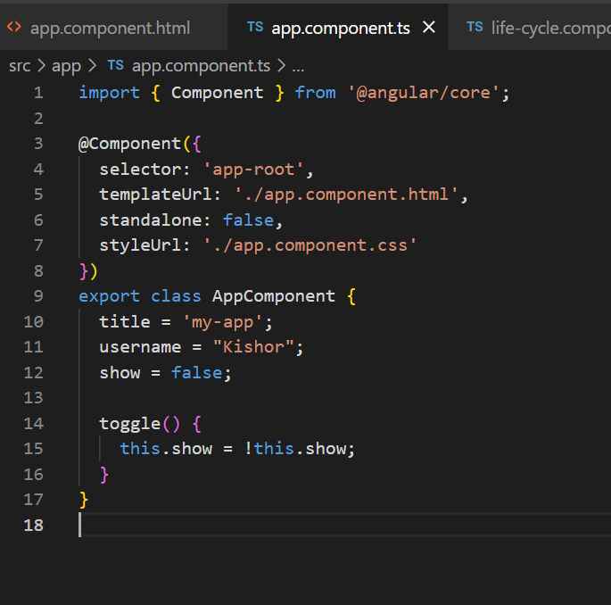

life-cycle.component.ts

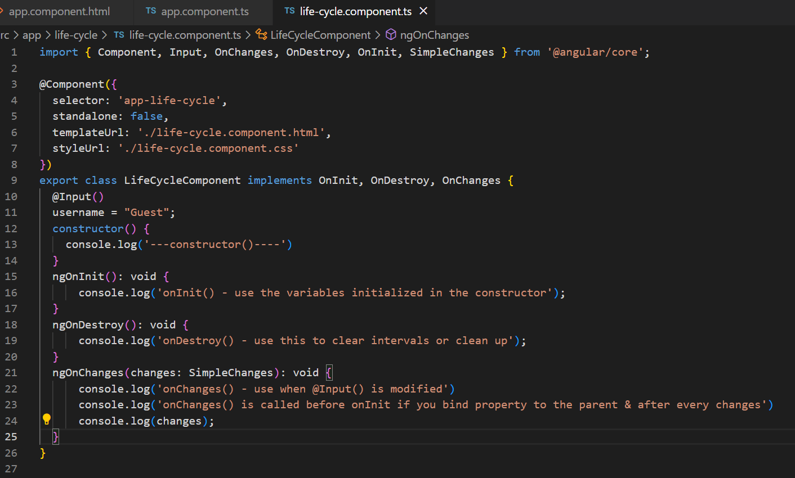

Output:

ngOnChanges() is called before ngOnInit() if @Input is used

ngOnChanges() is called on each change in the @Input()

destroy() is called when the component is removed.

Angular Forms & Validations

1. Template Driven Forms - you handle form control data & validations in HTML with the help of two way data-binding - [(ngModel)]
2. Model Driven Forms - you handle form data & validations in the component class - ReactiveForms

tdf-demo.component.ts

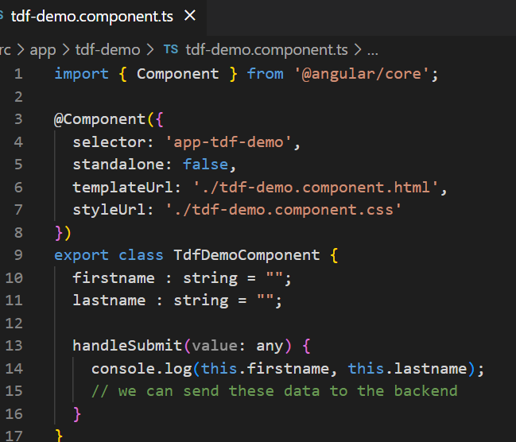

tdf-demo.component.html

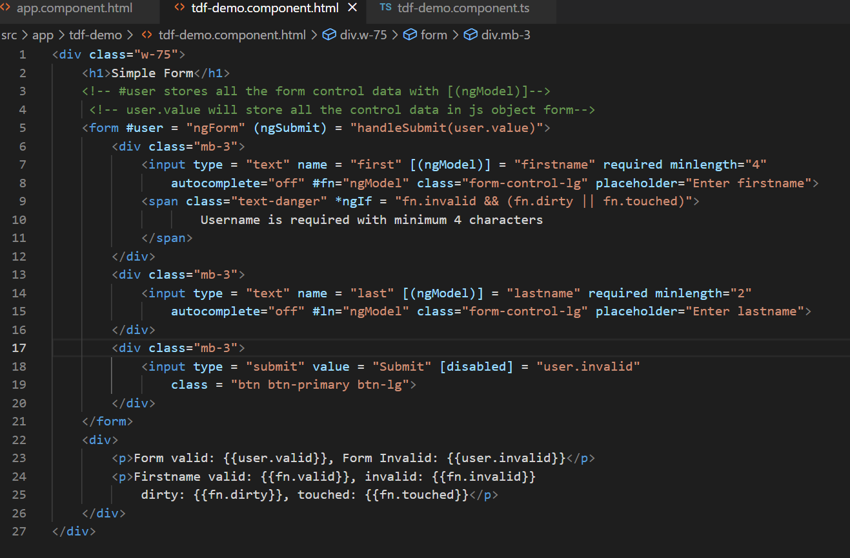

Output:

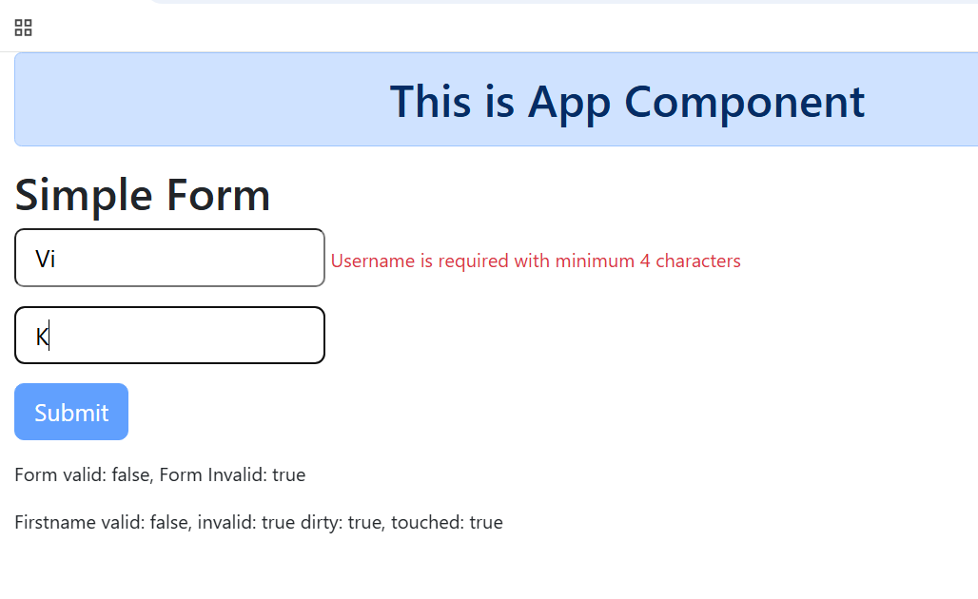

Model Driven Form or Reactive Form

Here the form control data will be entirely handled in the typescript code, even you can create validator’s in the typescript code, this makes the form more dynamic in nature compare to template driven

ex: you want to pop up some fields while entering values to some other field this needs control of forms within the code

Note: ReactiveFormsModule must be imported in NgModule, to use the ModelDrivenForm

Note: For TemplateDrivenForm you must import FormsModule

app.module.ts

import { FormsModule, ReactiveFormsModule } from '@angular/forms';

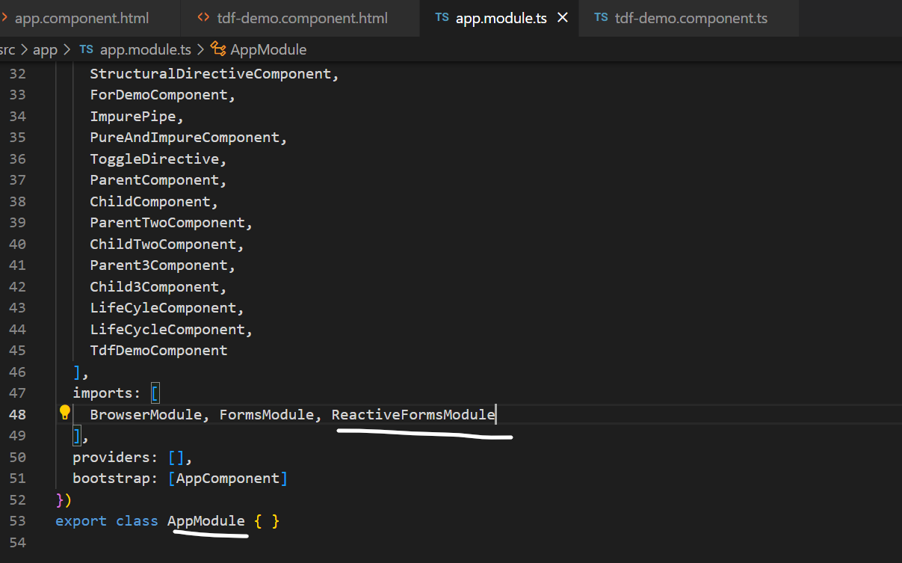

Generate the component mdf-demo

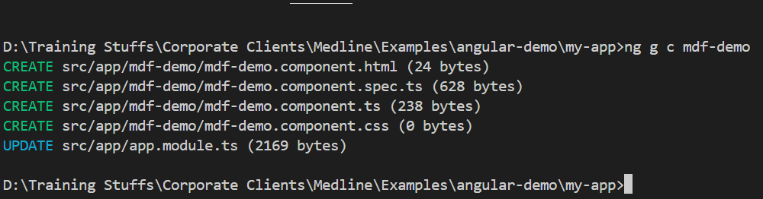

FormBuilder: It is one of the service that helps you to create from-controls in an easier way, you must use this object with the help of inject(FormBuilder)

builder = inject(FormBuilder);

mdf-demo.component.ts

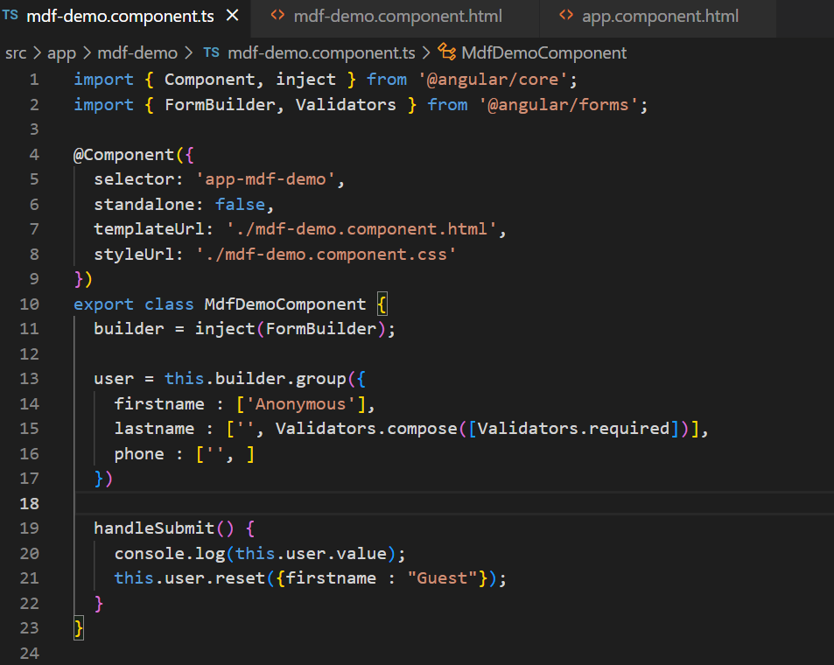

mdf-demo.component.html

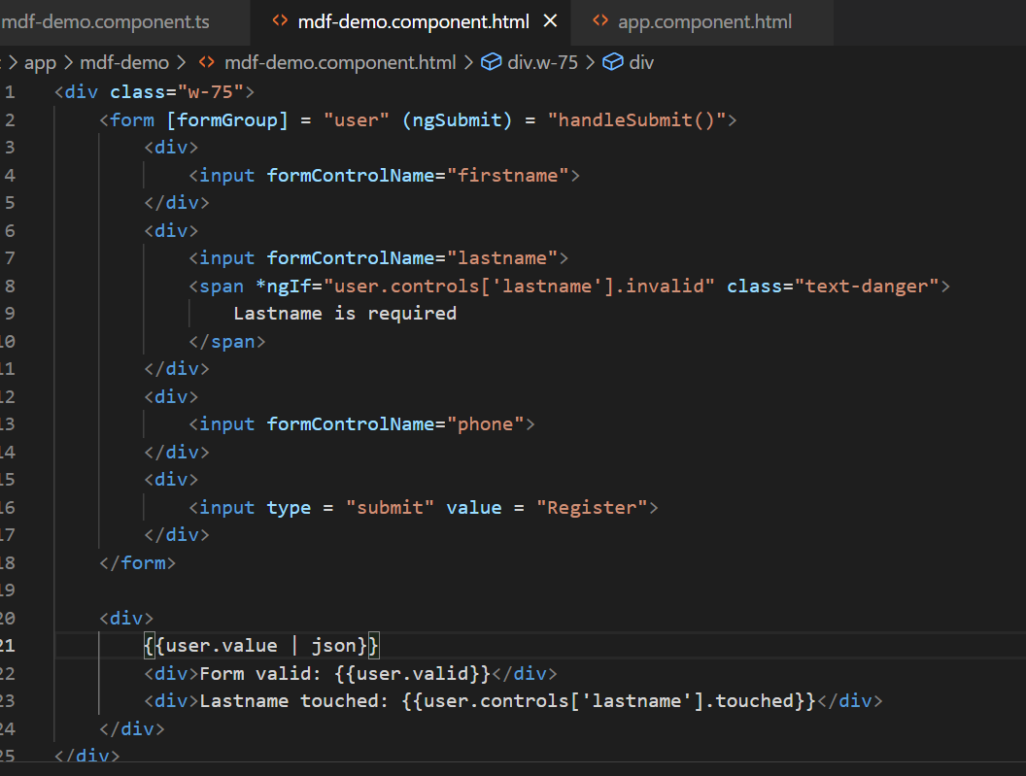

Output:

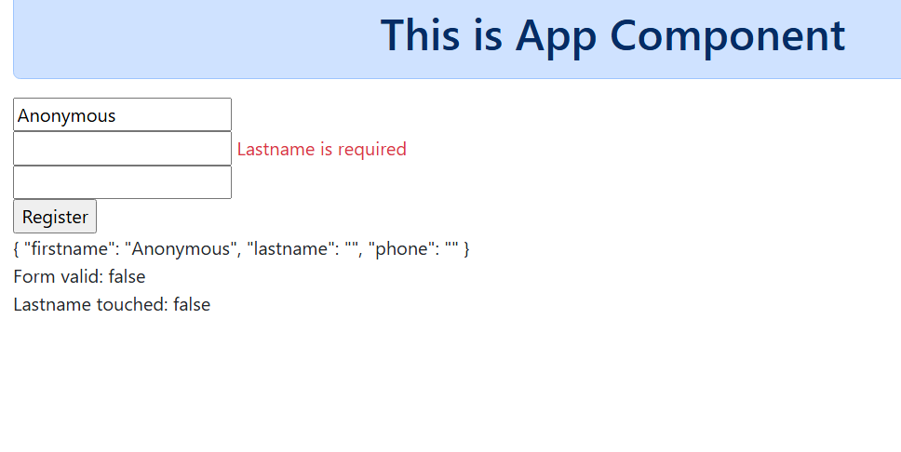

Angular Dependency Injection(DI) & IOC

IoC (Inversion of Control): Object creating & managing is taken care by the framework, IOC is a container to maintain the objects and these objects are delivered to other object which need them, this process of delivering an object to another object is called as Dependency Injection

Angular use different types of Injector system

1. Root injector - injecting the object that is available throughout the application
2. Component injector
3. Module injector

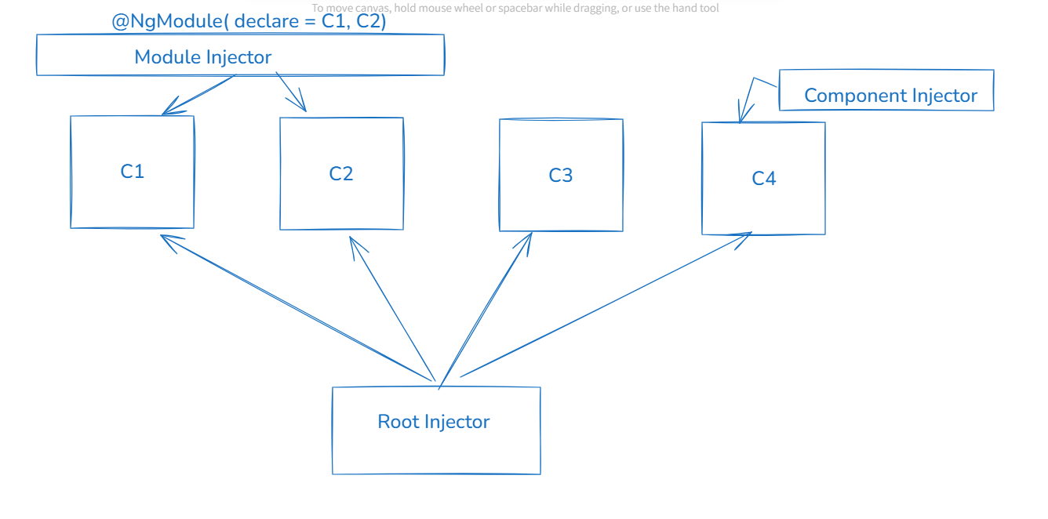

All these systems use same kind of DI providers, below are some of the providers angular use

@Injectable({  
 providedIn : ‘root’ // UserService is available throughout the application  
})  
class UserService { …. }

@Component({

})  
class UserComponent {  
 service = inject(UserService); // UserService is supplied to the UserComponent  
}

Angular Service: These are reusable classes which can have the logics that are not part of the components (view related logics, form handling logics)

You can use Angular Service to write logics like accessing the backend or logging

Angular provides a command to generate the service class

i.e., ng generate service service-name [or] ng g s service-name

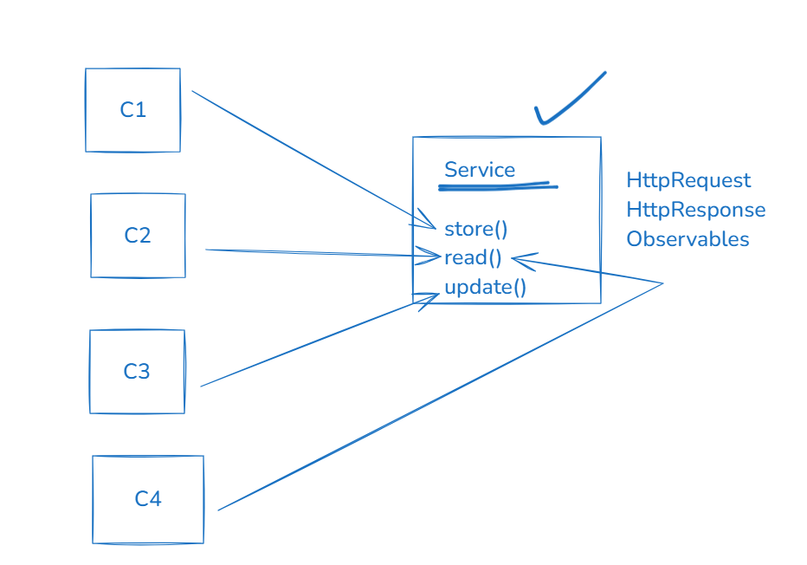

Create a DI scenario for UserListComponent that will access the UserService which will have Observables that can emit some fake user data, UserListComponent must subscribe to get those data & unsubscribe to stop getting the data from observable

Steps

1. user.ts: store some fake user objects in an array and export it & also create a User type so that Observables can emit that type of data

ex: export const USERS = [ {….}, {…}, {…} ]

1. UserService: create a method that will have Observables & emit the user from the above array, emit the value for every 1s using setInterval or interval method of rxjs
2. UserListComponent: subscribe to the Observables and unsubscribe to stop getting the values

user-mock.ts

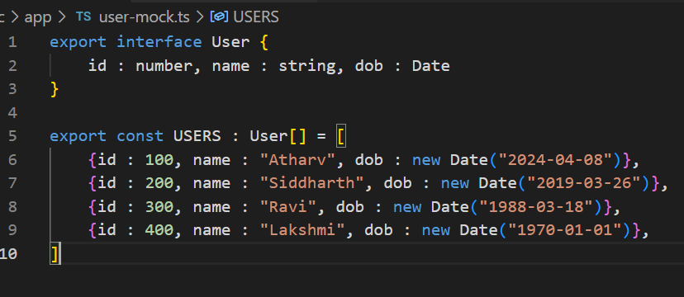

Generate the service class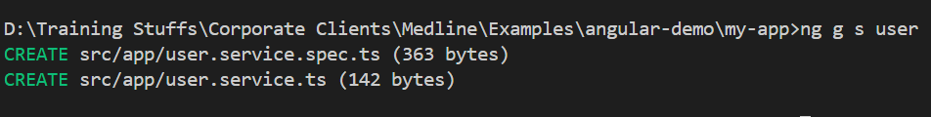

user.service.ts

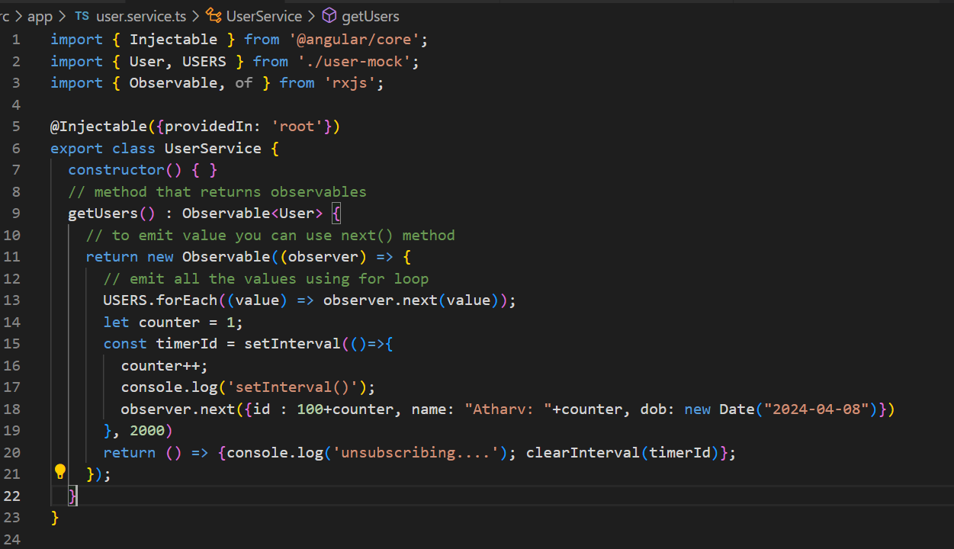

user-list.component.ts

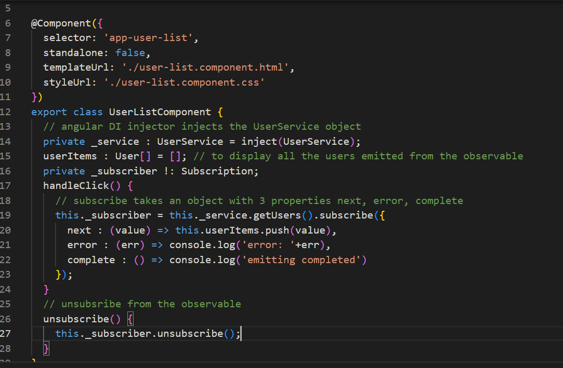

user-list.component.html

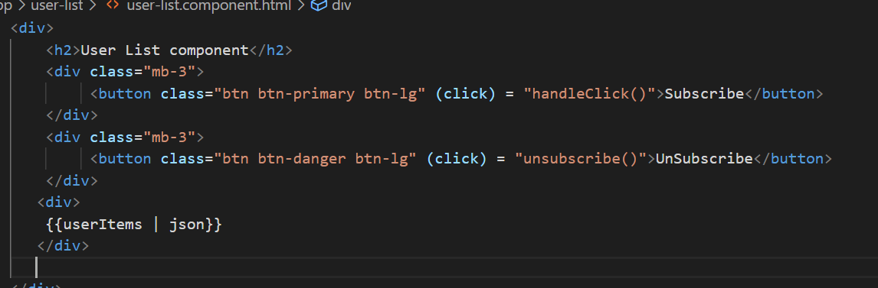

Output:

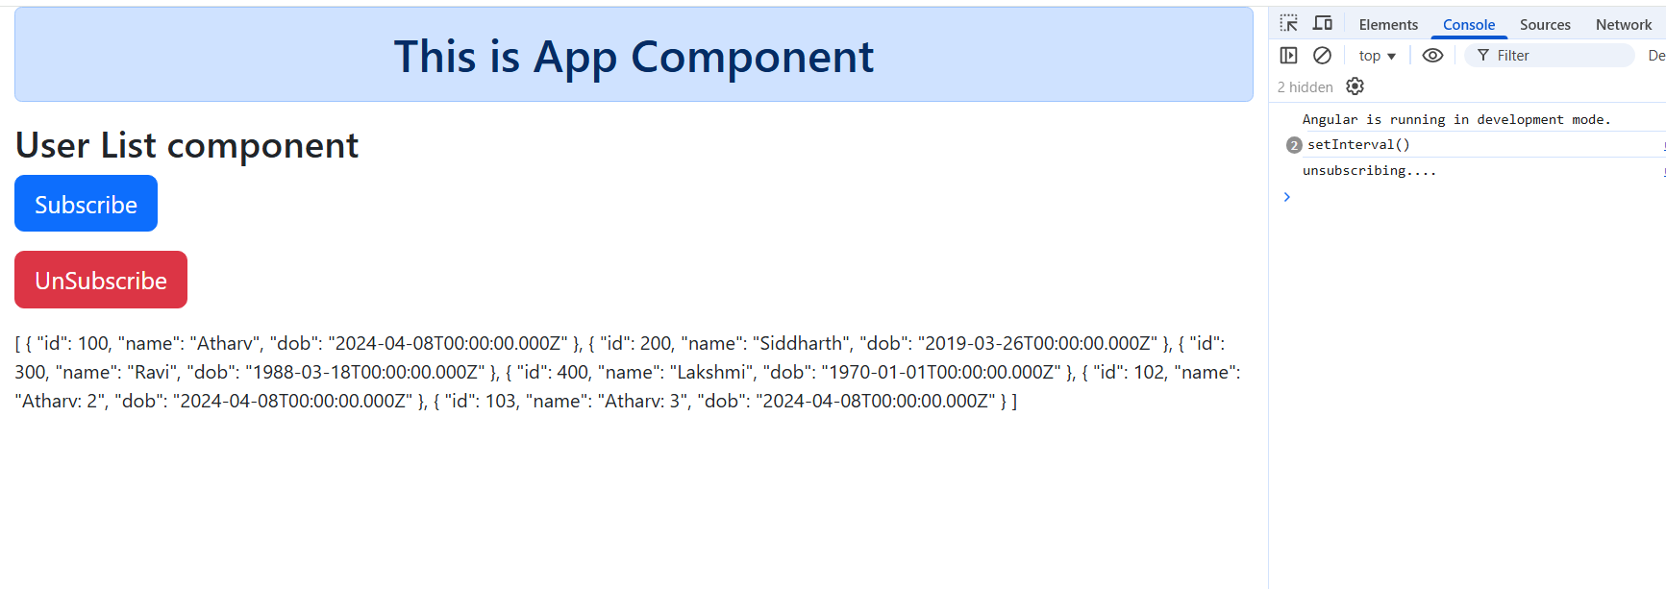

Promises

Promise can perform asynchronous operations just like Observables but it completes once it gets the values, you can make use this async/await as well in case of promises

Note: we can use promises and observables together, and also you can use Promises inside the observables if you want to achieve async/await mechanism

user.service.ts

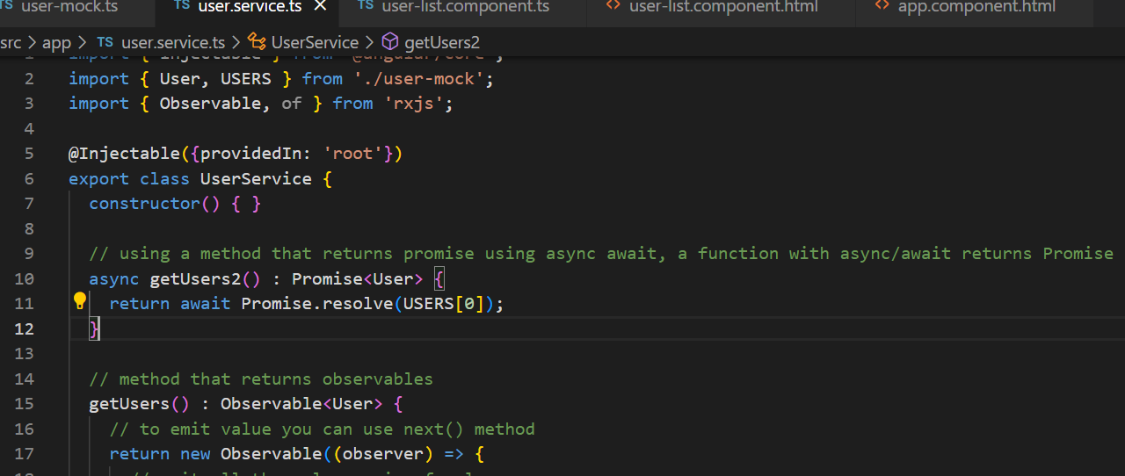

user-list.component.ts

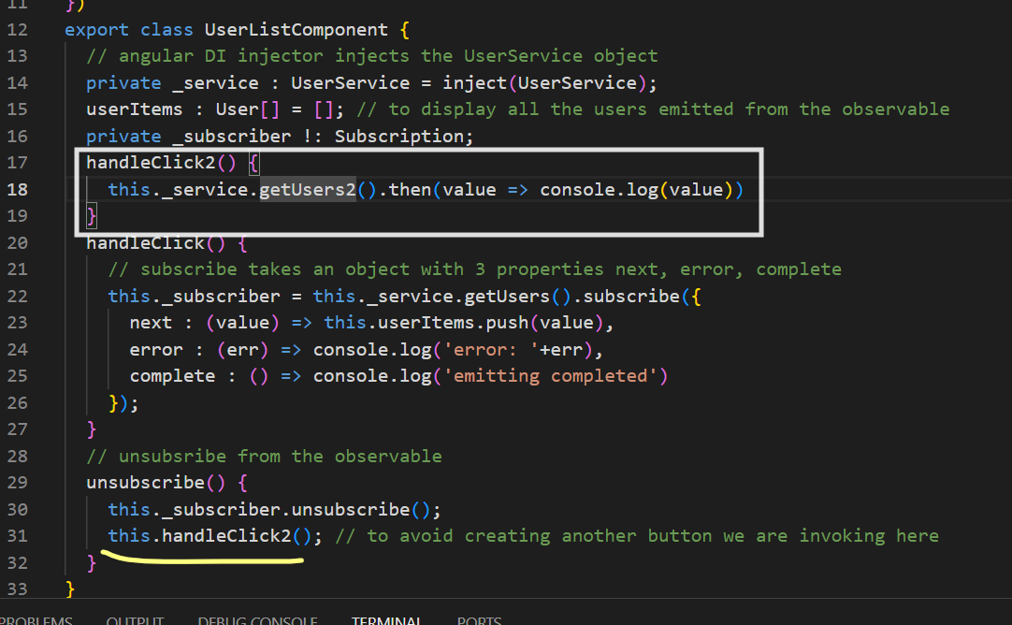

HTML storage objects can be used in angular

1. localStorage: Will be available even after the browser is closed
2. sessionStorage: Will be available till you close the browser or clear using program

Both object has common methods to store, remove or read

* setItem(key, value): // value must be always string, if JS object convert to JSON
* getItem(key); // returns a string
* removeItem(key); // removes the key & value

Scenario: Create a todo list that adds a task & retrieves the task from the session or local storage

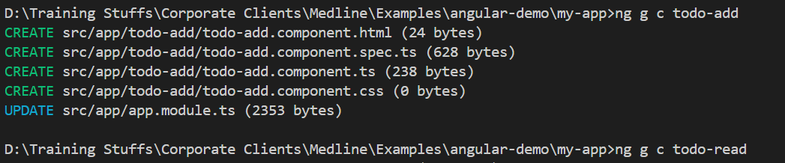

Generate a service that maintains the todo tasks in the storage

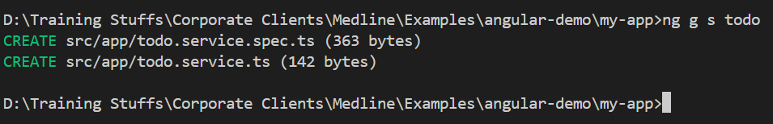

Add the add and read todo components in the root component

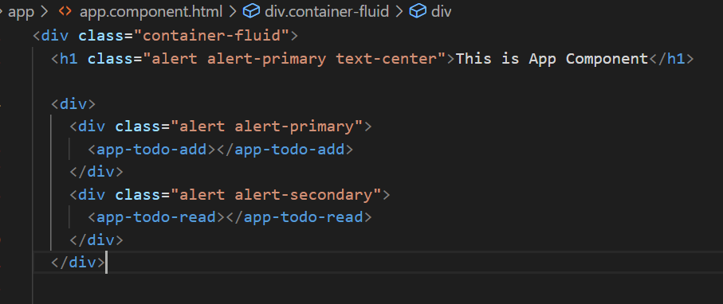

Requirement

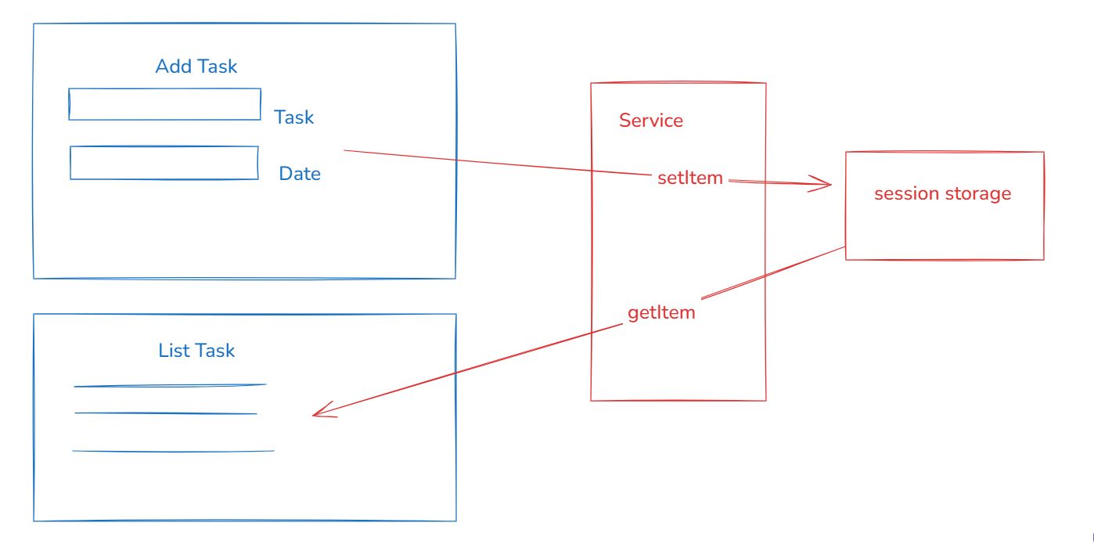

In the service we can create save & fetch methods to store & retrieve the todo

Use this below code in the service to add the todo task in the sessionStorage

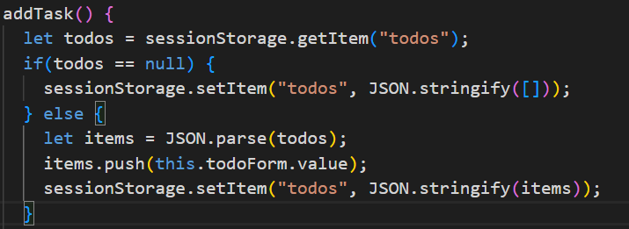

Similarly create getTasks() function in the service which would read all the todo tasks from the session and component would display all those tasks.

HttpClient:

It is an object that will help you to make HTTP requests to the backend service, it provides http methods to perform various operations like

* get(url) : Observable<T>
* post(url, data) : Observable<T>
* put(url, data): Observable<T>
* delete(url, data) : Observable<T>

Angular takes care of creating & delivering the HttpClient object, however you must mention the provider of HttpClient i.e., HttpClientModule (deprecated), you must use provideHttpClient() Angular 14+ on wards

Before Angular 14

@NgModule({  
 providers : [HttpClientModule] // so that HttpClient can be injected any where  
})

Angular 14+ onwards

@NgModule({  
 providers : [HttpClientModule] // its deprecated, use this till Angular17

providers : [provideHttpClient()] // this must be used if its not a standalone, for standalone the @NgModule file wouldn’t be there, use this from Angular17+ onwards  
})

Once you mention the provider you can inject the HttpClient in the service class

private _http : HttpClient = inject(HttpClient) ;// HttpClient instance will be supplied

_http.get(“http://ip:port/api”)

_http.post(“url”, data)

Steps to interact with the backend

1. Install json-server using npm install -g json-server
2. Create a json file with some JSON data
3. Run the json-server to watch the json file
4. From angular you can send HTTP requests using http methods

Installing json-server

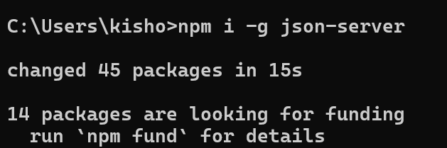

Creating the json file

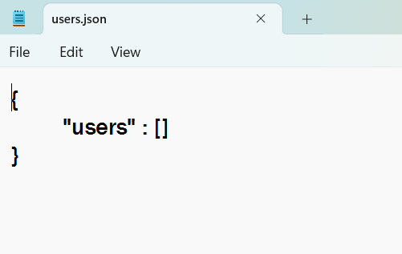

Run the json server to watch users.json file

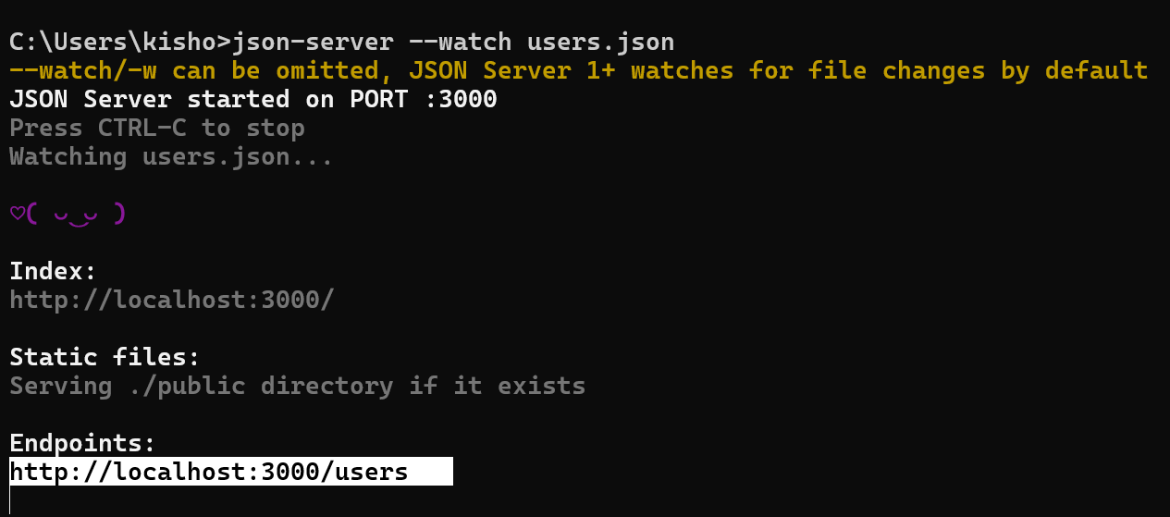

Note: Here the url having localhost:3000/users is because of the key users inside the users.json file

Now angular / any client programs can make an HTTP request to this end point

How to use HttpClient in angular

1. configure provideHttpClient() in the app.module.ts if its not a standalone project, if its standalone you need to configure this in app.config.ts
2. Inject HttpClient in the service class

Configuring the providehttpClient in the @NgModule.providers of app.module.ts

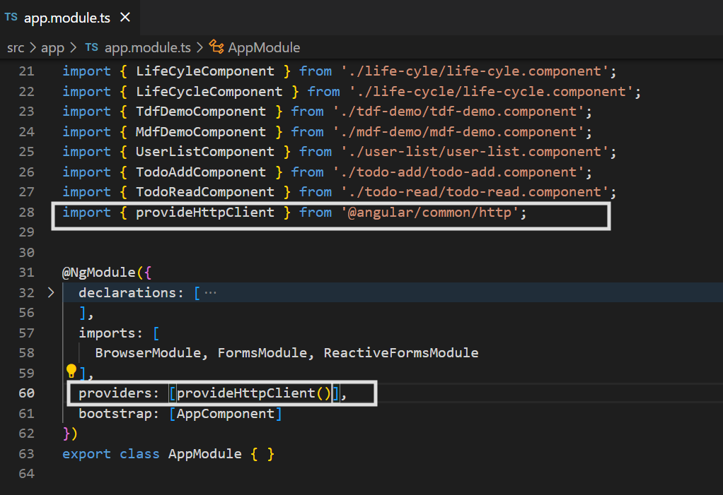

Implement the service class that can store, update, delete and read the user details

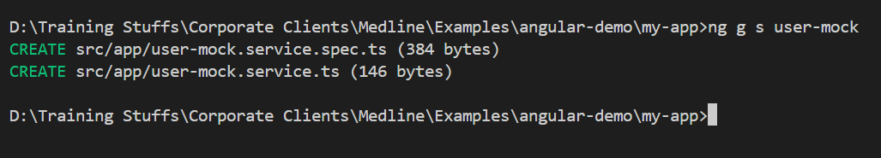

user-mock.service.ts

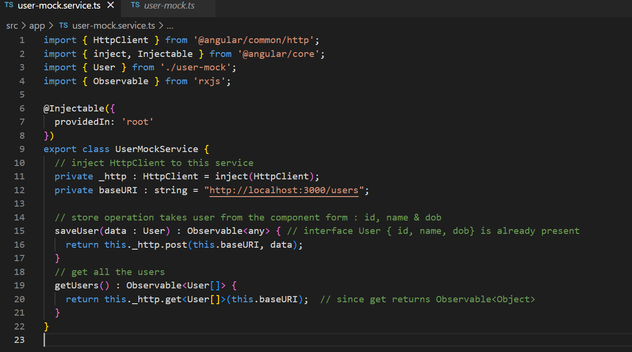Create a user-store component

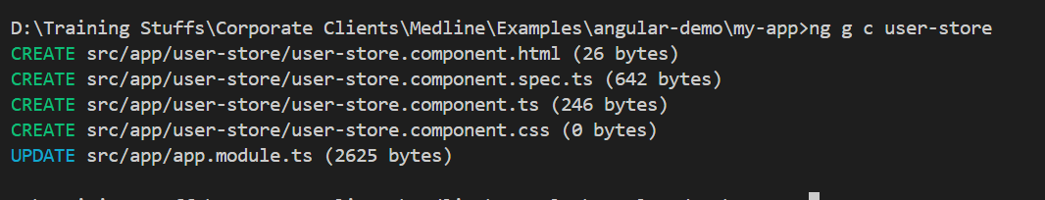

Add this to the app component

app.component.html

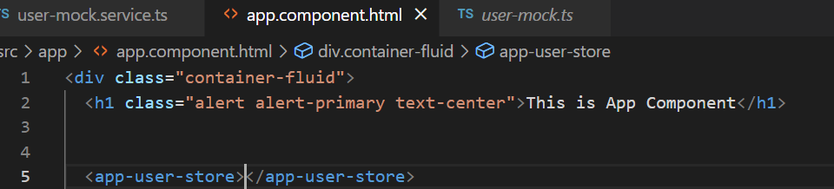

user-store.component.ts

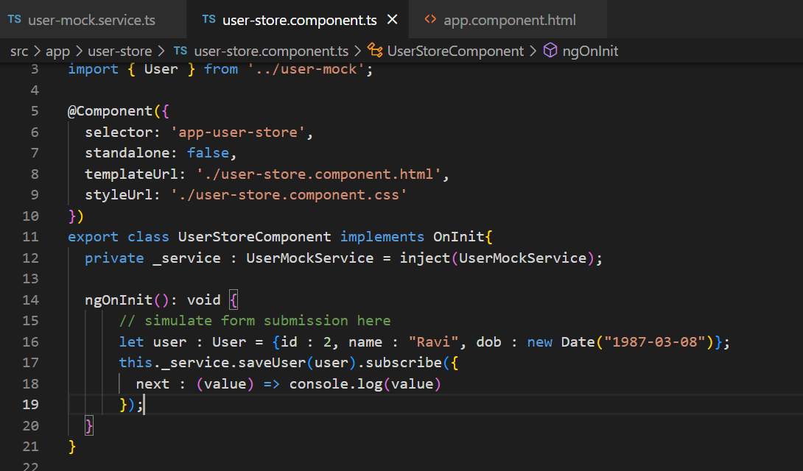

Note: We are not creating a form to save time, we are just simulating the data and passing to the saveUser

Create a user-read component and display all the data

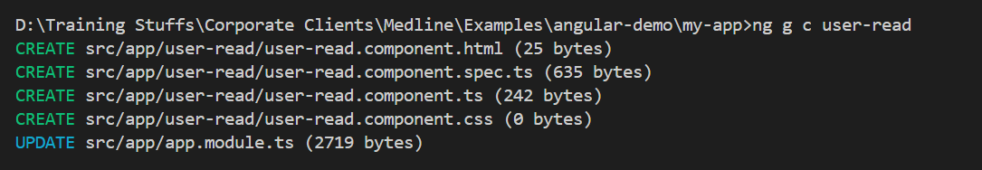

Update the user-read component in the root component

app.component.html

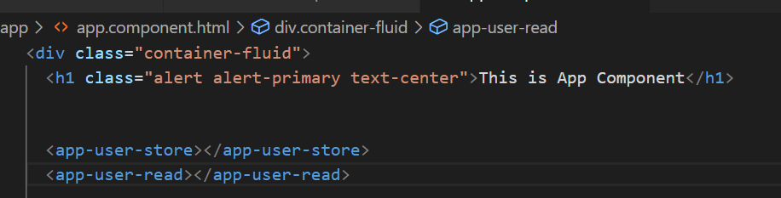

user-read.component.ts

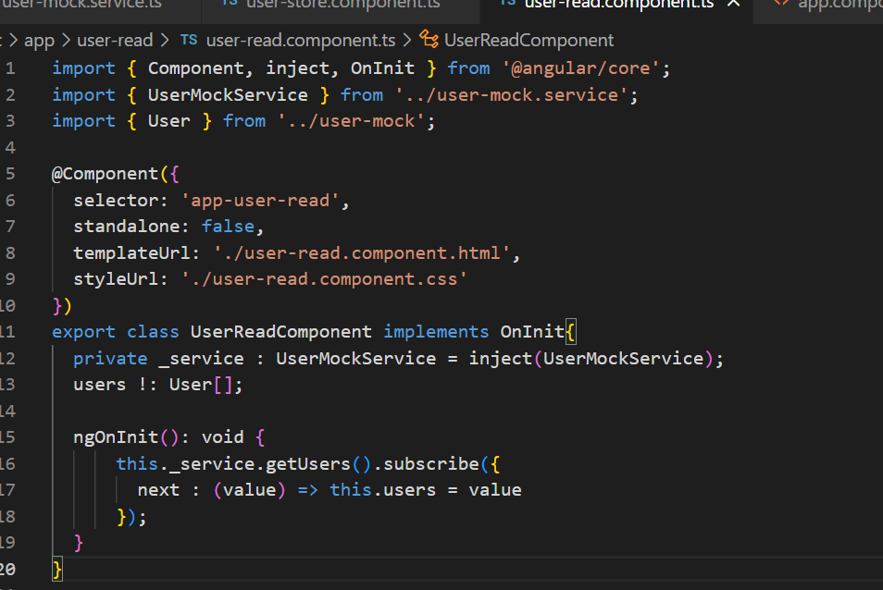

user-read.component.html

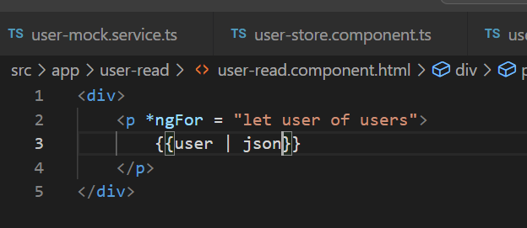

Output:

